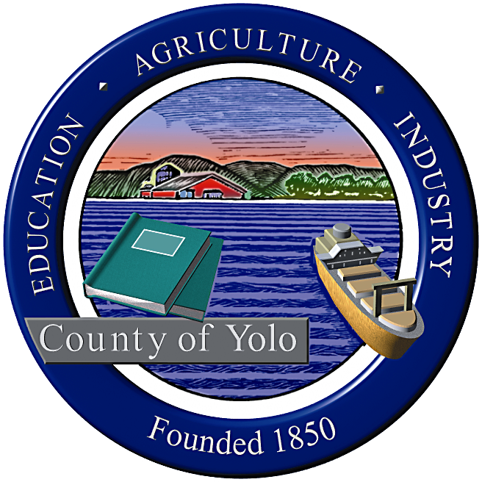

County of Yolo Patricia Wong
LIBRARY COUNTY LIBRARIAN
_______________________________________________________________
226 Buckeye Street
Woodland, CA 95695
(530) 666-8005
www.yolocountylibrary.org

LIBRARY ADVISORY BOARD
CHAIR: Rebecca Fridae
VICE-CHAIR: Sharon Hallberg
MEMBERS: Nora Brazil, Joe DeAnda

MINUTES

FEBRUARY 11, 2009

Present: Rebecca Fridae, Chair; Sharon Hallberg, Vice-Chair, Joe DeAnda, Nora Brazil, Sandra Rodriguez representing Supervisor Jim Provenza. Staff: Patty Wong and Jim Rosaschi.

December 10, 2008 Minutes were moved for approval by Sharon Hallberg and seconded by Nora Brazil and unanimously approved by those present.

New members representing Supervisor Jim Provenza and Joe DeAnda representing the City of West Sacramento were recognized and introduced to the group.

Member reports:

Sharon Hallberg discussed representing the LAB at the California Library Association’s Day in the District and visiting Lois Wolk in her Vacaville office and Mariko Yamada in her Sacramento office and being a member of the Library team working on Telling Your Community Story, an online course for rural libraries modeled after the Public Library Association focus on encouraging community awareness through library marketing. Hosted by the California State Library, this six-week endeavor features weekly opportunities to network with other rural libraries in CA to discuss ways to engage the community. Other members of the team include Mel Russell (Archives), Heather Bratt (Yolo Reads, Adult Literacy) and Patty Wong. The Davis Friends’ book sale raised $8000 for library programs and services. The wall in front of the bike racks has been removed with no more bike thefts or other incidents. The $250 reward posted by the Library/Friends lead to some tips on those responsible for the thefts but did not result in prosecution. Mother Goose on the Loose is more popular than ever with more than 70 families in attendance and has moved to a second day; many parents and children are coming twice. Read Around Yolo bags of books are popular with book discussion groups in Davis and in the county. Heather Bratt and Deatra Cohen (Davis Teen Services Librarian) are working together to support English practice adult groups at the branch.

Nora Brazil discussed the English conversation group and its value to the community. The Friends elected a new Board. First 5 Yolo efforts in Davis through the Yolo County Library has resulted in targeted programming with Spanish bilingual story time and parenting workshops at Marguerite Montgomery Elementary for a series of six workshops on Tuesdays beginning 2/24. Parents will take the Unitrans bus to the Stephens Davis Branch Library to learn how to get there and will tour the library, get registered for library cards, learn about the Internet and other library services and will return. Library materials acquisitions are shifting from cassette to CD.

Rebecca Fridae informed the group of the new slate of officers at the Winters Friends of the Library with Lisa Nalbone and Tom Neely as co-Presidents. Francisco Alarcon offered Winters parents and families a chance to explore poetry in a bilingual presentation sponsored through First 5 Yolo and the Yolo County Library’s Families Reading Together program. Winters Friends fundraised $5 donations by posing with a cut out of President Barack Obama to commemorate the Inauguration. Winters Friends host a number of events to raise awareness and funds for the Library.

Jim Rosaschi shared Margaret Crawford’s report as she was unable to attend. Mother Goose on the Loose continues to draw record numbers of diverse community families. The Turner Community Library’s 8th Annual Poetry Slam will be held on 4/24 and 6 p.m. hosted by Channel 10’s Angel Cardenas (a graduate of River City High School). Andrew Russell will make arrangements for food. Early Learning for Families and First 5 Yolo support a number of preschool visits to the library. We will continue focusing on library orientation and tours with all 2nd and 5th grades from Washington Unified School District.

Old Business: Annual Friends meeting has been set for May 2 at Knights Landing from 9 a.m.- 12 noon. Supervisor Jim Provenza will be asked to give an address. Rebecca Fridae, Nora Brazil and Sharon Hallberg will organize the event. Need a Save the Date electronic notice and then printed invitations. Light refreshments. Meeting focus: honor outstanding volunteers, share ideas, discuss issues, report on what they do – program show and tell. 9 a.m. – 12 noon. Include all Friends leadership including Archives.

The interim vacancy for District 5 still exists due to the illness of Marie Surad. Esparto Friends have been invited to apply and suggest names to Supervisor Chamberlain’s Office.

Library Budget Update: The serious budget deficit countywide and the impact of the State will have implications for service at Yolo County Library. The first is the four-day furlough proposed by a Spring Break closure of four days at each of four locations: Davis, Esparto, West Sacramento and Winters. The three remaining branches offer the only public access to resources in their respective communities and staff is shifting to accommodate the need while other staff takes XTO or extra time off. Davis, WS, and Winters will be closed April 6-9, reopening that Friday, April 10 for weekend service. Esparto will be closed April 13-16, reopening April 17 for weekend service. The closures are staggered to still maintain library service in some part of the county. There is some concern from the public and staff is working with Beth Gabor to handle public information and marketing aspects of the closure. Other impacts for the library for 2009 include a second round of furloughs and possible reduction of hours in most locations. Fiscal reductions can be managed through staff scheduling moving towards a single shift instead of two shifts per day and working an eight-hour day in each location as opposed to ten-hour schedules that require two shifts of staff.
County Librarian’s Report was distributed to all.

Actions: Rebecca Fridae appointed to represent LAB working with Chair Mary Stephens De Wall on 2010 100th Anniversary celebration

Next meeting: April 22, 7:00 p.m.
Following meeting date is changed as well due to conflicts with graduation:
June meeting will be held on June 17, 2009
Discussion about moving LAB meeting location to other sites to learn about branches- To be determined at next meeting.

Handouts distributed through LAB: Reading Isn’t Fundamental by Alan Kazdin and Carlo Rotella (Hallberg); Classification Study overview – powerpoint (Wong); Proposed budget issues and potential schedule changes (Wong).

Respectfully submitted,

Patty Wong

