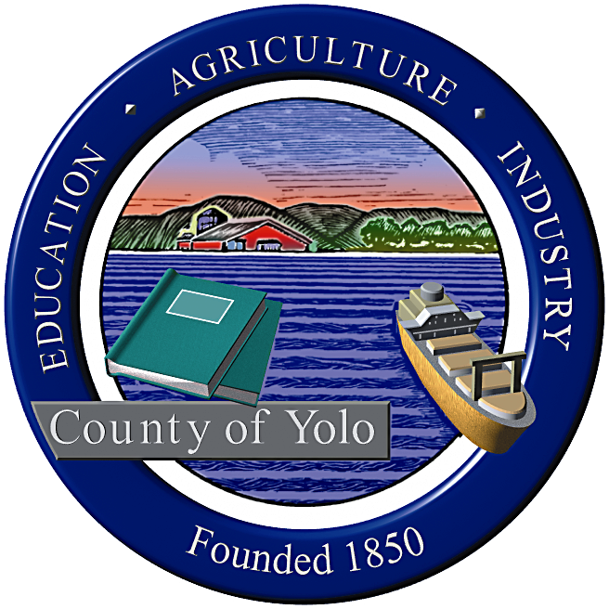

County of Yolo Patricia Wong
LIBRARY COUNTY LIBRARIAN
_______________________________________________________________
226 Buckeye Street
Woodland, CA 95695
(530) 666-8005
www.yolocountylibrary.org

LIBRARY ADVISORY BOARD
CHAIR: Rebecca Fridae
VICE-CHAIR: Sharon Hallberg
MEMBERS: Nora Brazil, Joe DeAnda

COUNTY LIBRARIAN’S REPORT
January-February 2009
February 11, 2009

New members: A warm welcome to incoming Board member Joe DeAnda representing the City of West Sacramento. Mr. DeAnda fills the position formerly held by Alan Candee. Another welcome to Supervisor Jim Provenza who fills the vacancy of Supervisor Mariko Yamada, now at the Assembly.

Budget Update: The budget for Yolo County faces serious setbacks that has consequences for the Library even though for the most part, we are not funded by the General Fund. The County projects a shortfall of $3.5 million before the end of the fiscal year and possibly $22.5 million next year (or 1/3 of the General Fund Budget). Each sister county Department budget reduction affects the Library. The reduction this fiscal year has resulted in a furlough of 32 hours or 4 days for FT staff and prorated for permanent PT staff. The Library will close 4 days over Spring Break (schedule attached). The impact of the State is still unknown so projections are not available, but the outlook is not positive. The Library will need to prepare a list of priorities for service provision and make recommendations for reductions when considered next fiscal year. Input from the Library Advisory Board will be critical in making these informed decisions.

We continue to seek ways to increase revenues where feasibly possible. This would include creating easier methods for customers to pay the fines and fees through e-commerce and in the future, accepting payments at self-service checkout systems. E-commerce will be in place before the end of the fiscal year. Diversification of funding will continue to be a priority.

Key Activities:

ALA – Presidential Initiative co-chair
Quarterly meetings: branches, IT
Grants implementation
Classification Study RFP Interviews and selection

1. Building Updates:

West Sacramento: Public Art draft plan to Board late February. MOU in concept in County Counsel’s office – review of parking and schedule and funding are part of next steps. Construction is ahead of schedule.
Winters: Meeting with Pat Lewis to discuss hours and operation issues in preparation for change in MOU. County IT testing 8e6 filtering system successful. Construction moving along. Public art call to take place in March 2009.

Davis: Siting of temporary location underway. County to piggyback on existing RFP contract with automated handling system through Sacramento Public Library honoring costs from November 2008. Measure P op-ed/marketing piece planned for late February/early March.

2. Winters Capital Campaign: New Campaign focus on grant applications and small events. Total reduced to $250,000 and will fund collections and equipment.

3. South Davis: Bookdrop installed. IT issues to be worked out.

4. Grants Update:
First 5 grants – First 5 Yolo funding may be in jeopardy due to State budget allocations. More than 800 children received bilingual storytime in Winters and Esparto communities. Plans to expand Davis First 5 focus to Marguerite Montgomery to present parenting workshops to Spanish speaking families. Plans for storytimes and parenting workshops at Yolo (Cache Creek Continuation High School) for teen parents in planning.
IMLS – Homework/after school hours center in negotiation to be held offsite at Holy Cross Elementary in Bryte area through summer. Dale Gilliard and Cheryl Chapel will work with Cathy Lorda to monitor progress.
Early Learning for Families Grant – Plans for Yolo and Knights Landing storytimes in place. ELF programs at AFT have touched almost 2000 since inception in 2008.
Digital Storytelling Grant – several stories in progress. Deadline extended for six months. More funding available for extension.

