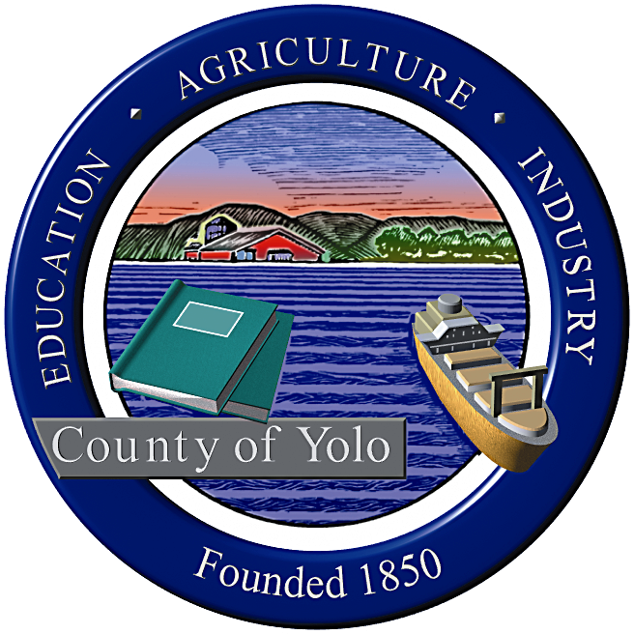

County of Yolo Patricia Wong
LIBRARY COUNTY LIBRARIAN
_______________________________________________________________
226 Buckeye Street
Woodland, CA 95695
(530) 666-8005
www.yolocountylibrary.org

LIBRARY ADVISORY BOARD
CHAIR: Rebecca Fridae
VICE-CHAIR: Sharon Hallberg
MEMBERS: Nora Brazil, Joe DeAnda

COUNTY LIBRARIAN’S REPORT
March-April 2009
April 22, 2009

Acknowledgements and Recognition: A special thank you to Katherine Henderson and John Ferrara who both have stepped down from their respective positions on the Library Advisory Board representing Districts 5 and 4, after a number of years. Katherine will continue her good work in teaching and John will continue his work in as State senate staff as well as a member of the Davis School Foundation Board. We wish them the best in their various endeavors and appreciate their years of dedicated service and insight.

Budget Update: Spring Break furlough: the four day closure at Davis, West Sacramento and Winters and alternately at Esparto took place with little incident. We are hoping to accomplish any future furlough needs during the winter break or during planned closures due to the movement of the libraries in preparation for the opening in interim or new facilities. The ability of staff to fund regular service at Knights Landing and Yolo resulted in a significant article in the Sacramento Bee.

The budget was discussed at the 4/21 Board of Supervisor meeting impacting several County positions and services. County HR has created Job Search, an online point of contact and resources for those seeking employment, to assist employees and community members who have been displaced. The Library has contributed resources and database information to Job Search.

Key Activities:

ALA – Presidential Initiative co-chair: Libraries: The Heart of All Communities
Meet with Friends Presidents
Women’s History Luncheon
First 5 Yolo Family Focus Forum
CLA/CALTAC/CSLA Legislative Day
III Public Library Directors Forum
Staff Meeting Day
Archives Legislation

1. Building Updates:

West Sacramento: Construction is ahead of schedule. Furniture and equipment in purchasing, IFB for opening day collection, focus on October 3 or 24 for grand opening with soft opening anticipated. First project to be completed. Public art to be installed following construction. Call for art due 6/1/09.
Winters: Grand opening slated for November. Possible weeklong series of events – special evenings with District, Friends, City, Steering Committee, etc. culminating in a Friday afternoon barbeque with high school and district – same day as a home game.

Davis: Temporary location focused on two sites. Design in final stages. Op-ed piece in Davis Enterprise focusing on Measure P and thanks to Davis residents. Smaller steering committee group to review furniture, fixture and equipment selections.

2. Winters Capital Campaign: Campaign underway – Winters Friends of the Library to apply for two grants using 501 (c ) 3 status to Genentech/Roche and Wintun Tribe.

3. Grants Update:
Getting Involved: California State Library invited 50 public libraries to participate in a two day training focusing on crafting a system approach to recruitment and retention of volunteers, bringing a team of staff and local experts. Recipients will be working with VolunteerMatch.org. Representatives include: Patty Wong, Chris Crist, Heather Bratt, Cheryl Chapel, Gina Duncan (County HR) and Peggy Epstein (Volunteer). May 5-6.
Opportunity Online: Through CSL – working with the Gates Foundation in 9 states, CA public libraries with less than 1.5 Mbps of Internet connectivity are invited to apply for a matching grant to increase bandwidth. The Gates Foundation will match connectivity charges for two years if the library provides sustainable support. Yolo and Knights Landing branches are eligible.
First 5 grants – First 5 Yolo funding targeted through Proposition 1D. Implications mean a choice of three outcomes: 1. 5% reduction in annual allocation. 2. No change but reduction to 4 more years rather than 6 years of funding. Or 3. Reduction by 10% or more and possible elimination. Site visit 4/23.
More than 1000 children received bilingual storytime in Winters, Esparto, Davis, Yolo, Knights Landing and Davis communities.
Dia de los Ninos: CSL - $500 reimbursement grant to bring first time Dia de los Ninos celebration to Esparto Branch April 25. RISE and other partners to attend. Book giveaway, bilingual storytime, tour of the library and library card drive, Ballet Folklorico and arts and crafts.
IMLS – Homework/after school hours center in negotiation to be held offsite at Holy Cross Elementary in Bryte area through summer. Toni Mendieta hired for IMLS LA III lead. Recruitment for second additional help LA to assist. Crista Cannariato (interim Branch Manager at Turner) and Cheryl Chapel to coordinate.
Early Learning for Families Grant – Plans for Yolo and Knights Landing storytimes implemented. ELF programs at AFT have touched almost 2000 since inception in 2008. Outcomes evaluation from Virginia Walter (UCLA) on 5/12.
Digital Storytelling Grant – CSL- several stories in progress. Deadline extended for six months. Grant application for additional $5000 to complete program completed.

4. CALTAC Training for new and returning LAB members recommended. YCL sponsors memberships for all members except for elected official.

5. Adult Literacy Update: English practice groups to expand to other county areas. Next Literacy Advisory Committee to meet 5/27. Outreach to Probation focus results in more support to Correction Officers and Juvenile Hall needs assessment.

6. HR Update:

Vacancies and recruitments:
Library Circulation Supervisor (pending due to retirement)
Librarian III (Turner, due to retirement)
Library Assistant I/II/III (Davis, promotional only, full time, due to retirement)
Library Assistant I/II (IMLS, extra hours only)
Library Assistant I/II/III (held for attrition)
Program Manager (extended to December 2009 – part time position currently filled by contract with Jim Rosaschi)
Assistant County Librarian (vacant since December 2008 – outcome based on recommendation by Classification Study)

Classification Study: to be completed in mid June 2009. Position Description Questionnaires completed for all regular staff. Employee Committee in place and conducting research on best practices.
Retirements: Two year enhancement on PERS service – strong incentive for those eligible – implications for continued service.

7. YoloLINK Strategic Plan Document – review and ACTION needed

8. Meeting Room Policy – review and ACTION needed
9. MOU adoption: City of West Sacramento, Winters Community Library – information only

LIBRARY IN THE NEWS

It continues to be an exciting and creative time for the Yolo County Library, and a pleasure to work with a great staff and a talented team of community advocates.

