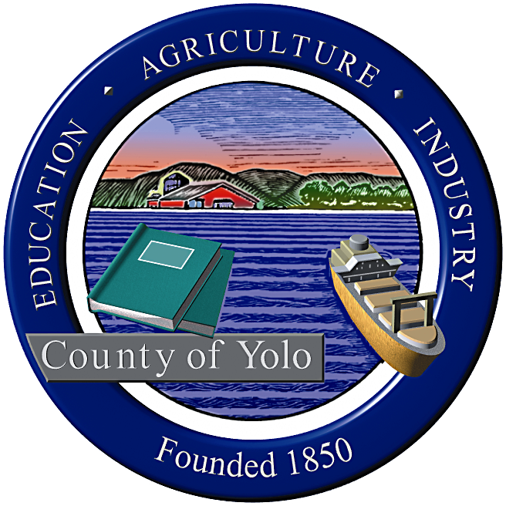

County of Yolo Patricia Wong
LIBRARY COUNTY LIBRARIAN
_______________________________________________________________
226 Buckeye Street
Woodland, CA 95695
(530) 666-8005
www.yolocountylibrary.org

LIBRARY ADVISORY BOARD
CHAIR: Rebecca Fridae
VICE-CHAIR: Sharon Hallberg
MEMBERS: Nora Brazil, Alan Candee, Margaret Crawford, John Ferrera, Katherine Henderson, Marie Surad-Miller

COUNTY LIBRARIAN’S REPORT
September-October
October 8, 2008

Thank you: A hearty thank you with great appreciation to Supervisor Mariko Yamada and her Deputy Andrea Jones for their years of extensive service as the Board of Supervisors liaison to the Library Advisory Board. We are very sad to see Supervisor Yamada and her outstanding Deputy leave Yolo County service, but are very pleased that their hard work and support for democracy, community building and of course libraries, will be recognized in the State Assembly. Congratulations and once again, thank you for Mariko Yamada and Andrea Jones for their exemplary service with the Library Advisory Board.

Budget Update: The budget for Yolo County is once again plagued by economic shortfalls due to the downturn in the economy. The positive end of this spectrum is that we do not rely on California State Library funds for the most part except for the California Library Literacy Services funding. The California State Library provides a small part of funding through the Public Library Fund and Transaction Based Reimbursement. With the projected reduction expected from the State, the total loss is approximately $10,000 for FY 2008-09. The General Fund provides for two positions – the County Librarian and the .75 FTE Library Assistant in the County Archives. We are maintaining both positions on the roster and filling one of those positions with part-time staffing.

On the positive note, the UMS contract for the recovery of fines and fees in place since July 11 has generated a total of $14,075 in returned materials and fines/fees paid as of 9/25/08.

Key Activities:

Partnerships with DESS and Health Department
Yolo Reads! Sacramento Rivercats endorsement and search for Yolo Reads! Advisory Group
Yolo County Children’s Alliance Strategic Planning Process
Space saving in County Archives
YoloLINK 211 research
Los Rios Community College – good neighbor plans for collaboration
Courier changes
Technology Plan – three years

Other meetings/activities of interest:
Davis 2 x 2
General Plan

Building Updates:

West Sacramento: Draft MOU passed unanimously by City of West Sacramento for ongoing support of Library operations with additional staffing and Sunday hours. Public Art planning process to begin on October 8 with initial meeting. Groundbreaking a great success with more than 150 in attendance. Ongoing close partnership with City of West Sacramento, with great appreciation for the efforts of Assistant City Manager Carol Richardson.

Winters: Sarah Jewel and Janice Koch to assume co-leadership of Capital Campaign. Interim Superintendent of Winters Joint Unified School District is Pat Lewis. The Library is working closely with County IT and the School District and Yolo County Office of Education (operated Winters JUSD network) on Internet access issues. Kickoff celebration a great success with more than 50 in attendance.

Davis: Working on staff areas and automated handling in design. Sorting design to focus on barcodes only at this time. Next Steering Committee meeting to take place on October 30.

South Davis: Joint meeting of Library staff and Nora Brazil to determine next steps in equipment purchase, setting up operations, more discussion with District leadership and development of MOU with County for library operations on Davis Joint Unified School site.

LAFCO Study: Preliminary data has been provided to LAFCO for their use in a comprehensive Library report due by the end of the year.

TECHNOLOGY PLAN: This three-year plan will provide the basis for budgeting, equipment maintenance and acquisition, and setting priorities for goal development. It is required for our e-rate application process with a plan in place necessary by December 2008. It will be reviewed annually.

Technology update: Security gates purchased for Esparto. Online library card registration set up in place; implementation pending. Ecommerce pending addition of new software to initiate confidential settings in accepting payments online.

MVLS:
Yolo County Library is an official member of Mountain Valley Library System, a consortium of public, special and academic libraries in north Central California. It receives funding from the California State Library through CLSA legislation to support reference services and transaction based reimbursements and training and staff development. Over the course of time, with changing information needs of customers, reference services have shifted from a personal interaction to a combination of virtual and physical activities and many requests for reference from larger resource rich organizations has been significantly reduced. The need for dedicated reference staff is no longer necessary and for financial economies, Plans are in motion to integrate resources and organizational infrastructure with North Bay Cooperative Library System and North State Library System.

October 13 Staff Training Half Day: Staff development is important to maintain strong customer service skills, improve systemwide communication and encourage staff feedback and camaraderie. We plan a half day staff development program on October 13, beginning at 8:30 with refreshments and working from 9-12 noon, opening the branches from 2-6 p.m. Speakers include Sharon Jensen and Dirk Brazil from County Administration, featured staff presentations, and a customer service workshop from HR with Gary Engel, County Training Coordinator. The second date is scheduled for March 30, with a full closed day

Grants Update:
First 5 grants – Evaluation criteria set with First 5. Cris Velasco and Nina Lorenzi are working on the first parenting needs assessment with Winters parents on October 15 and will work in bringing bilingual storytimes and parenting workshops to all six other library locations after January 2009.
IMLS Medal of Service– We receive word this month that we were not awarded a 2008 Medal but encouraged to apply again. Many thanks to Congressman Mike Thompson and to chief of staff Elly Fairclough for nominating Yolo County Library for such a prestigious honor.
Early Learning for Families Grant – We were awarded this $25,000 grant to provide early literacy services in West Sacramento, Yolo and Knights Landing.
California State Library –Digital Storytelling program – training took place on September 24. Individualized training for staff and community will take place on October 9 and 10.

