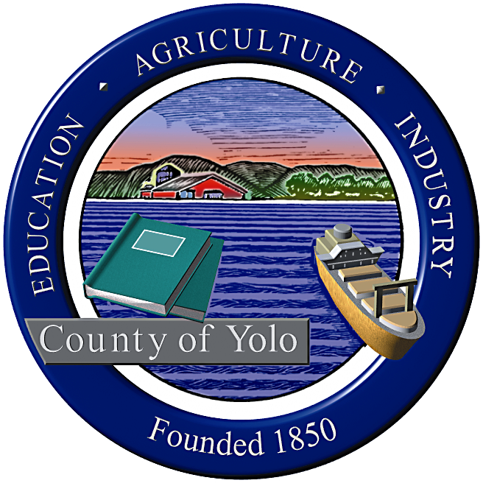

County of Yolo Patricia Wong
LIBRARY COUNTY LIBRARIAN
_______________________________________________________________
226 Buckeye Street
Woodland, CA 95695
(530) 666-8005
www.yolocountylibrary.org

LIBRARY ADVISORY BOARD
CHAIR: Rebecca Fridae
VICE-CHAIR: Sharon Hallberg
MEMBERS: Nora Brazil, Alan Candee, Margaret Crawford, John Ferrera, Katherine Henderson

COUNTY LIBRARIAN’S REPORT
November-December 2008
December 10, 2008

Thank you: A hearty thank you with great appreciation to Assistant County Librarian Mae Bolton for her near seven years of extensive service performing support responsibilities to the Library Advisory Board and the many Friends groups throughout Yolo County. Congratulations to Mae on her retirement. We wish her happiness and health on her new journey. The Board will be honoring Mae on 12/16 at the Board of Supervisors meeting and staff will be hosting a reception for Mae on 12/18 from 1-3 p.m. at Central services.

Thank you also to Alan Candee for his many years of services as a Library Advisory Board member representing the City of West Sacramento. We have appreciated his insight on library operations as a Sacramento Public Library branch manager and his passion for the work. We will miss his good humour and candor and hope to enlist his helpful ideas on some future Library Advisory Board project. Supervisor Mike McGowan is collecting names of interested West Sacramento residents to fill this vacancy.

Budget Update: The budget for Yolo County faces serious setbacks that has consequences for the Library even though for the most part, we are not funded by the General Fund. The County projects a shortfall of $3.5 million before the end of the fiscal year and possibly $19 million next year. The impact of the State is still unknown so projections are not available, but the outlook is not positive. The Library will need to prepare a list of priorities for service provision and make recommendations for reductions when considered next fiscal year. Input from the Library Advisory Board will be critical in making these informed decisions.

We continue to seek ways to increase revenues where feasibly possible. This would include creating easier methods for customers to pay the fines and fees through e-commerce and in the future, accepting payments at self-service checkout systems. E-commerce will be in place before the end of the fiscal year. Diversification of funding will continue to be a priority.

Key Activities:

Annual Review with Sharon Jensen
ALA – Presidential Initiative co-chair
California Library Association Annual Conference
SJSU SLIS Librarians for Tomorrow speaker
Policy Committee – priorities and responsibilities distributed to members
Grants administration and implementation

Other meetings/activities of interest:
Davis 2 x 2 – 12/12
General Plan – adjustment
Tech Plan approval – 12/9
Classification Study RFP

Building Updates:

West Sacramento: Public Art planning process continues. MOU in concept in County Counsel’s office – review of parking and schedule and funding are part of next steps. Some interest in requesting programming support from the City following the IMLS grant conclusion in 2011. Slab poured, paving for parking to begin in December. WFOL using City Hall as meeting center. Furnishings discussion close to completion.

Winters: Campaign to work closely with Winters Friends of the Library at Holiday Festival. Campaign will refocus in January with plans for application for additional funds from Rumsey Band and several small events. Monthly conference call with WJUSD Superintendent Pat Lewis and City Manager John Donlevy. County IT testing 8e6 filtering system to see if compatible with suggested design to offer filtered and unfiltered Internet access during open hours; students would access the filtered Internet through the Library card coding – all others would access unfiltered Internet as is currently provided by the Library to all customers. Slab poured. Larger beam signing (Internal celebration) taking place on 12/10, 4 p.m.

Davis: Design phase in planning mode with City of Davis support. Will require some removal of trees to accommodate largest children’s expansion. Initial studies of automated handling system installation, bike parking and staffing areas are in process. Determination of project phasing and relocation or remaining on site during construction remains in discussion. Relocation will take less time but there will be costs allocated by lease or renovation. Phasing and remaining on site will add 3-6 months to the project timeline and may be a safety issue. Dirk Brazil will inquire with Bill Emlen and work with Ray Groom to identify potential real estate possibilities.

South Davis: Bookdrop selected and ordered. Installation to take place at Marguerite Montgomery shortly after delivery. Meeting to be scheduled to discuss MOU language.

LAFCO Study: LAFCO final report regarding sphere of influence provided to LAFCO Commission on 12/8 with no extraordinary findings. Library District boundaries remain the same, Yolo County’s borders, without the City of Woodland which maintains its own municipal library.

TECHNOLOGY PLAN: This three-year plan will provide the basis for budgeting, equipment maintenance and acquisition, and setting priorities for goal development. It is required for our e-rate application process with a plan in place necessary by December 2008. It will be reviewed annually.

Technology update: Internet pipeline is maximized. Central Services staff pipeline converted to work through County IT with significant increase in bandwidth and access speed. Branches still experience some limitations in speed and loading. County IT is waiting for A T and T contract which would enable direct intervention to alleviate limitations on access.

Staff Development: Patty Wong, Heather Bratt, Jean Lucas, Cheryl Chapel and Becky Frame attended the California Library Association. Heather focused on training and adult literacy events, Cheryl and Jean focused on programming, adult reference, services to diverse populations and technology exhibits. This was Becky Frame’s first CLA conference and she attended the trade show. Patty Wong attended the State Librarian’s Breakfast, the County Librarians meeting, and the trade show.

YoloLINK: 75 copies of 2008/09 version will be available. Some interest from Advisory Group for strategic visioning process, ongoing fiscal support, and making the database responsive to community requests. New features on donations and volunteering. Kim to work with YoloLINK staff.

Yolo READS: Continued meetings with Woodland Public Library’s Literacy staff. Logo development underway. Strong interest in creating a joint use approach to publicity where literacy is described and customers make the appropriate depending upon residency. Patty to work with Heather. Administrative and other support supplied by PT library assistant.

Grants Update:
First 5 grants – Bilingual storytime initiated at Winters and Esparto. Parenting workshops started at Winters. Plans for scheduling and recruitment/hiring at other locations in the works. First quarter report well received. Copies available for your review.
IMLS – Recruitment and hiring and training to begin soon. Dale Gilliard and Cheryl Chapel will work with Cathy Lorda to monitor progress.
Early Learning for Families Grant – Bus transportation for participating families and preschoolers negotiated and plan to initiate has begun this month.
Digital Storytelling Grant – several stories in progress.

Human Resources Update:

Due to Mae Bolton’s retirement, the following recruitment/selection duties are as listed:

Librarian I – Jay lead
Library Assistant – Kim/Patty/Sara
Page – Patty completing
YoloLINK - Patty

Classification study – issued on 12/1 on libraryconsultants.org and County’s BidSync; due 12/30/08

Patty has assumed formal HR responsibilities and will communicate directly to County HR. Chris Crist will handle making sure that the scheduling needs for branches are filled.

