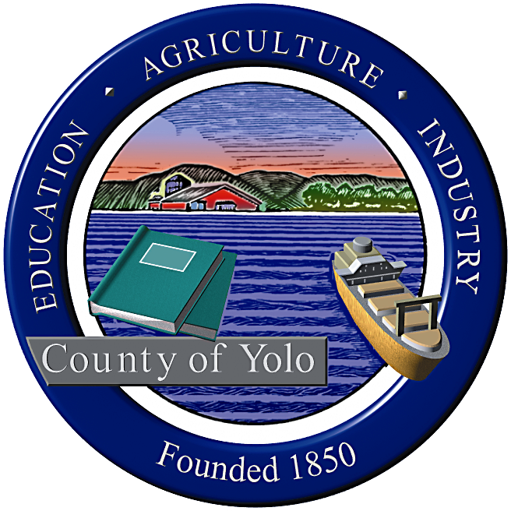

County of Yolo Patricia Wong
LIBRARY COUNTY LIBRARIAN
_______________________________________________________________
226 Buckeye Street
Woodland, CA 95695
(530) 666-8005
www.yolocountylibrary.org

LIBRARY ADVISORY BOARD
CHAIR: Rebecca Fridae
VICE-CHAIR: Sharon Hallberg
MEMBERS: Nora Brazil, Alan Candee, Margaret Crawford, John Ferrera, Katherine Henderson

COUNTY LIBRARIAN’S REPORT
January-February 2008
February 13, 2008

Budget Update: Impact of California State Budget and preparations to mitigate exposure.

County Librarian Reception: A special thank you to the Library Advisory Board for their very warm and welcoming reception on January 26. This was a wonderful introduction to our community and a chance to meet many library supporters.

Building Updates:

West Sacramento: Mae Bolton working with Dale Gilliard and Terry Vernon (General Services) on temporary relocation plans. West Sacramento Library Team (Patty Wong, Chris Crist, Sandra Briggs, Ray Groom – General Services) meeting biweekly with ANOVA Architects to keep project on schedule. West Sacramento Branch staff regularly involved in process. Initiation of opening day collection as priority. Meeting with Debra Luff, Dean, Los Rios Community College – West Sacramento Campus and Carol Richardson, City of West Sacramento.

Winters: Winters Steering Committee decided upon color palette. Library staff working with interior designers on details. Capital Campaign Committee established to focus on fundraising for shortfall and opening day collection. Meeting with NTD Stichler and all partners to review budget. Next meeting for the Steering Committee is March 12.

Davis: Architecture proposals received. Review and interviews to be conducted with Friends/City of Davis/community input. Staff interviewed and hired for position. Staff proposal for some South Davis presence/programming in the works.

Day in the District: Library Advisory Board member Sharon Halllberg and I met with Assemblymember Lois Wolk on January 25, accompanied by individuals representing Solano County and the City of Benicia Public Library. Focus of our discussion included updates on the West Sacramento and Winters building projects and the Davis vote/implementation plans, the impact of State reductions in Public Library Funds and Transaction Based Reimbursements. Wolk has a keen interest in the building activities and literacy.

The County Librarian also met with Senator Mike Machado on February 1. Machado is also interested in the building projects, particularly Winters, and in making sure that the joint use effort is welcoming to all customers, especially older adults who might find a high school campus intimidating.

The County Librarian met with Assemblymember Doug LaMalfa’s staff via telephone.

Board of Supervisors Strategic Priorities process: The County Librarian met with other County Department Heads and the Board of Supervisors to discuss challenges and opportunities for 2008 to better inform their process for setting priorities for the future.

Other meetings/activities of interest:

Individual meetings with Policy Committee and staff and tours of branches
Development of Management Team
Meetings with CAO and Department Heads
Friends of the Esparto Regional Library – Annual Meeting
Winters Friends of the Library – new officers
Friends of the County Archives
Meetings with Building Project Partners
Yolo County Children‘s Alliance Council

National Medal of Service nomination: The Library has been nominated by Congressman Mike Thompson for a National Medal of Service award through the Institute for Museum and Library Services. This is an annual national award open to all museums and libraries – only 5 museums and 5 libraries are chosen through a juried process each year. The award is $10,000 and national recognition. Support letters, quotes and photographs are sought to support this effort that is due on 2/15/08.

Human Resources: General staff meeting set for March 31 to honor long time staff members including 35 years young Cathy Lorda (West Sacramento) and a number of 10 year veterans. Regular part-time recruitment schedule established with County Human Resources.

Technology: Demonstrations planned for ecommerce activities. Kim Sheppard working on online library card registration to debut in July 2008.

Library in the News:

Peggy Rollins (Davis, Children’s Coordinator)
Solano Magazine – Children’s Books, Summer Reading Plans
YoloLINK – magnets to advertise service
Plans for County website
Public Relations plan for updating community on building programs and status

Meet and Greet:
Meet with each member of the Library Advisory Board (key questions)

