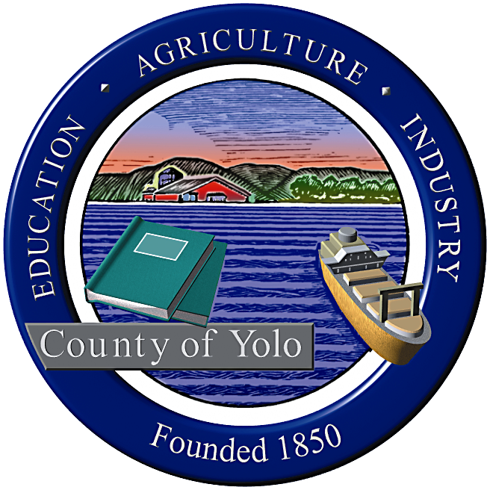

County of Yolo Patricia Wong
LIBRARY COUNTY LIBRARIAN
_______________________________________________________________
226 Buckeye Street
Woodland, CA 95695
(530) 666-8005
www.yolocountylibrary.org

LIBRARY ADVISORY BOARD
CHAIR: Rebecca Fridae
VICE-CHAIR: Sharon Hallberg
MEMBERS: Nora Brazil, Alan Candee, Margaret Crawford, John Ferrera, Katherine Henderson

COUNTY LIBRARIAN’S REPORT
July-August
August 13, 2008

Budget Update: Priorities in spending include focus on building projects, security gates for Esparto, self check systems for Davis, Winters and West Sacramento, investigation of RFID and automated handling systems at Davis and West Sacramento and implementation of fine and fee recovery system. Yolo County Library now sells flashdrives, earbuds and lanyards.

Key Activities:

UMS – fine and fee recovery system in place since July 11

General Plan

Grand Jury Report and response

Construction bids and bond sale

Receipt of IMLS notification of three-year grant for AFTurner Branch

Initiation of credit card activity for Winters Capital Campaign and payment at branches

Partnerships with DESS and Health Department

Technology Plan – three years

Other meetings/activities of interest:

Training from Office of Emergency Services – review of emergency plans

Web training with Beth Gabor, County Public Information Officer

West Sacramento 2 x 2

LAFCO study

Building Updates:

West Sacramento: We are working on hours of operation, aiming for 54 hours per week with additional staffing and Sunday hours. Construction bids came in well under cost estimates. Construction can begin as early as August 15. Groundbreaking plans with City of West Sacramento, County, and Friends aimed for mid-September. Designs and plans to be placed on County website.

Winters: Sarah Jewel to assume co-leadership of Capital Campaign. Construction bids well under cost estimates. Final FFE (Finishes, furnishings and equipment) decisions made today with architects and staff. Designs and plans to be placed on County website. Randall Cox new facilities lead at Winters Joint Unified School District. Dale J. Mitchell announced his departure as Superintendent of WJUSD. The Library will continue to work closely with the School District, through the Library Advisory Coordinating Committee to assist with recommendations for operations. The LACC consists of two School representatives, one County library staff member, the City of Winters representative for the LAB, one Friends member, and one at-large member appointed by the Supervisor for the district, as well as the County Librarian.

Davis: Staff met with City of Davis to discuss expansion into adjacent areas near Library and to consolidate bicycle parking. Bond sale took place on 8/6/08 at interest rate less than anticipated with considerable savings to the County.

South Davis: There is strong interest from the Board to use some of the savings realized by the lower bids to explore South Davis service. There are some human resources details to be worked out for work to initiate at Marguerite Montgomery Elementary. Next steps will include estimation of funding available, resources and staffing needs, and timelines with the School District.

County Website: A Web Committee has ably assisted Kim Sheppard in preparing a renewed look at the Library’s representation on the Yolo County website. www.yolocounty.org

Human Resources:

Positions currently unfilled:

Project Manager (Management Team)
Library Assistant II (AFT West Sacramento)
Library Assistant II (Archives)

YoloLINK Library Assistant Keri Hill has left employment with the County to pursue a role in counseling in the Sacramento area. Mae Bolton recently conducted two sets of interviews – Library Assistant – to build up the great need for temporary substitute staff in the branches and for support for Adult Literacy and Library Specialist – to replace the vacancy in YoloLINK. Jennifer Morrissey-Myatt, Toni Mendieta and Susan Frame have been capably supporting the YoloLINK work during this transition.

Staffing development and updates:

Jennifer Morrissey-Myatt, Library Assistant II for Interlibrary Loans, is pursuing her MLIS and entering her first year of library school at San Jose State University this fall. She received a $1980 tuition and fee reimbursement grant through the California State Library’s Public Library Staff Education Program (PLSEP).

In late June/early July, Jennifer Morrissey-Myatt, Cheryl Chapel, Librarian II at AFTurner Branch, and Crista Cannariato, Librarian II at Davis Branch, represented Yolo County Library at the American Library Association Annual Conference along with the County Librarian. The County Librarian spoke at 5 events through the conference, including one preconference.

Malinda Baker, lead Library Assistant III at Esparto and Toni Mendieta, Library Assistant II at Winters and Esparto, will be representing Yolo County Library, at the upcoming Association of Rural and Small Libraries (ARSL) Annual Conference to be held in Sacramento in September 2008. Both Malinda and Toni will receive scholarships to attend the conference, courtesy of the California State Library. Librarians from all over the country will tour the Esparto and Clarksburg Branches as part of the featured ARSL tours.

Human Resources retreat: Patty Wong and Mae Bolton will be meeting to create a strategy for focusing on staff development, workforce planning, recruitment and retention, classification and compensation study, teambuilding within the Management Team and Policy Committee and other human resource issues.

Technology: Staff examining various self check systems, security gates, automated return handling systems, and other technological means to enhance customer service. Service enhancements will include ability to pay use of credit cards to pay fines and fees due to Winters Capital Campaign and upcoming online library card registration.

Grants Update:
First 5 grants – Bilingual storytime and parenting workshops will be offered in all seven facilities throughout Yolo County Library. Cristina Diaz and Nina Vaca-Lorenzi, lead staff for the successful Winters library model funded with a 2007 First 5 Grant to the Friends of the Winters Library, will coordinate the program. The Library is actively recruiting for bilingual staff in the other six locations to implement storytimes.
IMLS Grant – Grant notification in July brings $133,624 over a three year period from September 2008-September 2011 for family literacy and homework help services to West Sacramento.
Early Learning for Families Grant – California State Library – we received word on August 8 that Yolo County was awarded $25,000 to expand family literacy services in the County. Services will include expansion of Mother Goose on the Loose programming and parenting workshops conducted in Spanish, Russian (as needed) and English in West Sacramento and bilingual storytimes and parenting workshops in Yolo and Knights Landing.
California State Library –Digital Storytelling program – successfully awarded – will focus on the Capay Valley and work in the Esparto community. The Library will be working with RISE to identify key community members to record their stories and oral histories through this stand alone workstation. Recordings will be used in library programs, school curriculum and intergenerational services, and will be added to the County Archives collection.
IMLS Medal of Service pending – expected late September 2008.

MVLS:
Yolo County Library is an official member of Mountain Valley Library System, a consortium of public, special and academic libraries in north Central California. It receives funding from the California State Library through CLSA legislation to support reference services and transaction based reimbursements and training and staff development. Over the course of time, with changing information needs of customers, reference services have shifted from a personal interaction to a combination of virtual and physical activities and many requests for reference from larger resource rich organizations has been significantly reduced. The need for dedicated reference staff is no longer necessary and for financial economies, plans are in motion to integrate resources and consolidate organizational infrastructure with North Bay Cooperative Library System and North State Library System.

Library in the News:

AFTurner – new books in the Library – continual coverage from staffer Elise McCallan
8/12 article in Davis Enterprise on Yolo County Library
Press release on IMLS grant to AFTurner

Next steps:
Meet with each member of the Library Advisory Board (key questions)

