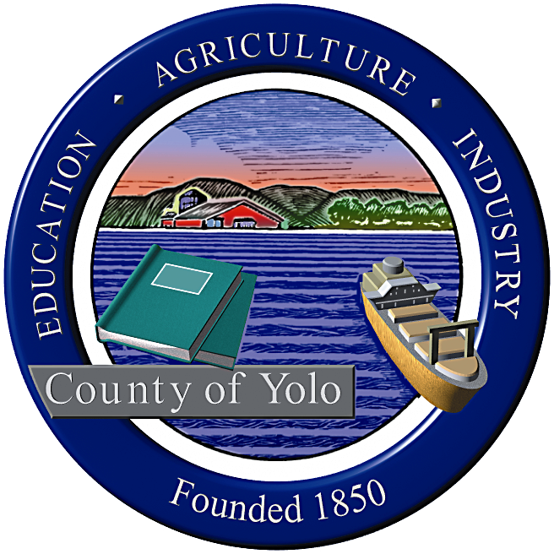

County of Yolo Patricia Wong
LIBRARY COUNTY LIBRARIAN
_______________________________________________________________
226 Buckeye Street
Woodland, CA 95695
(530) 666-8005
www.yolocountylibrary.org

LIBRARY ADVISORY BOARD
CHAIR: Rebecca Fridae
VICE-CHAIR: Sharon Hallberg
MEMBERS: Nora Brazil, Alan Candee, Margaret Crawford, John Ferrera, Katherine Henderson, Marie Surad-Miller

MINUTES

OCTOBER 8, 2008

Present: Alan Candee, Margaret Crawford, Sharon Hallberg, Rebecca Fridae, Marie Surad-Miller, John Ferrera, Katherine Henderson, Nora Brazil. Also present were Jim Rosaschi, Andrea Jones, Mariko Yamada, Patty Wong, and Mae Bolton.

WELCOME/INTRODUCTIONS

APPROVAL OF MINUTES June 18, 2008
A motion to approve the minutes was made by Nora Brazil and seconded by John Ferrera.

ACKNOWLEDGEMENTS AND RECOGNITION
The LAB recognized Andrea Jones and Supervisor Mariko Yamada for their support of the Library. This is their last meeting and both will work for the State. Supervisor Yamada was elected to the State Assembly and will represent the 8th District. LAB members stated that they appreciated all that both had done for the Library.

REPORTS FROM MEMBERS
Arthur F. Turner
Katherine Henderson reported that the groundbreaking for the new Arthur F. Turner Library was nicely done. The continuous moving power point presentation was a nice touch. A large number of West Sacramento representatives attended and with shovels in hand, they trekked across the street to the groundbreaking. Sharon Hallberg took lots of pictures.

Alan Candee noted that the library staff loves their interim library site. He announced that his Sacramento Public Library, Walnut Grove, held a sleepover for eight and nine year olds with Nature’s Critters. The group included eight boys and eight girls. His branch will hold a book talk with M. David Stirling, former member of the California State Assembly and author of the book “Green Gone Wild: Elevating Nature above Human Rights,”

Margaret Crawford talked about RAY (Reading Around Yolo), the new program for book clubs, which features 10 books of the same title placed in a bag which is checked out to patrons.

Stephens Davis
Nora Brazil attended the groundbreaking ceremonies in West Sacramento and Winters. The Davis Friends book sale is this weekend. The children’s program, Mother Goose on the Loose, is very popular with an attendance of 83 at the last session. Staff member Vicki Klein is a very popular attraction at children’s programs.

The next Davis Steering Committee meeting will be held on October 20, 2008. The County Library has been working with LAB member Nora Brazil, who is also the librarian at the Margaret Montgomery Elementary School, to provide County library service in South Davis. The first step will be to obtain a book drop for the site. The next step will be to develop a MOU. The project will be on the agenda of the next Davis 2X2 meeting. Currently the group is working on shelving and how to create a lease plan for Young Adult collection. The staffing plan is complete.

Esparto
Marie Surad-Miller reported on the start of the Digital Storytelling grant at Esparto. Her house guest was one of the first to be interviewed. Patty Wong described the Digital Storytelling grant as providing opportunities for community members to record special moments in their lives as Californians for posterity. The grant includes a computer workstation and $10,000. Jon Durst, President of the Friends of the Esparto Regional Library, will help with the setup. Stories from 25 Esparto residents, each 3to 5 minutes in length, will be recorded. The Library is collaborating with RISE on this project. The stories will be placed in the branches for circulation and in the Archives for their historical significance.

FERL (Friends of the Esparto Regional Library) will return to printing its own newsletter which will be translated into Spanish. The planned Teen dance has been put on hold due to a conflict. The Harvest Dinner will be held on November 2. The children’s Christmas shopping spree will be held on December 14.

Winters
Rebecca Fridae reported that the building kick off ceremony for the construction of the new Winters Library was held on September 17. The Capital Campaign has been put on hold for a while. The Friends have begun their membership drive and they are planning their holiday festival. They will hold a raffle for holiday trees with gift cards.

The Library and the Friends shared a booth at the Winters Community Festival/Festival de la Communidad which was held on Saturday, September 28 and gave away lots of books to youth attending the festival. They also distributed the Friends new bookmark which highlights upcoming events. The festival was very well attended.

LIBRARY BUDGET UPDATE
County Librarian, Patty Wong, reported that the Library’s budget is not as critical as other departmental budgets but we do have reason to be concerned. Only two positions, the County Librarian and a vacant 0.75 Library Assistant II position in the Archives/Records Center, are funded by the General Fund. The Library managed to retain both positions but cannot fill the vacant position.

The California State Library announced that for the first time there will be a 10% reduction in the Literacy grant awards. The Library should also receive an additional 5% reduction which will include TBR (Transaction Based Reimbursement).

Since the library contracted with UMS (Unique Management Systems) in July, $14,000 has been collected in fines and fees. Our customers say that the UMS notices are very friendly. We anticipate a 50 to 75 per cent return rate.

The library is working on developing an e-commerce package with our automation vendor, Innovative Interfaces.

COUNTY LIBRARIAN’S REPORT/UPDATE

- Building Updates:
- Winters: There are some concerns in the Winters MOU about filtering. The Library is working with the Yolo County Office of Education to provide both filtered and unfiltered computers at the same time. Student ID’s should be able to start the filtering session. Envisionware is a product capable of handling this situation. The Library will decide if this is the way to go.
- West Sacramento: Los Rios Community College District has offered to contribute translation services and the placement of staff in the new County library in West Sacramento. The Library will work with the City of West Sacramento to develop a MOU which will include the $250,000 for materials Public Arts process.
- Winters Capital Campaign: $40,000 has been raised so far.
- South Davis Service: The Library is working with Nora Brazil to plan for library service in South Davis by setting up a book drop at the Marguerite Montgomery School as a first step.
- LAFCO Study: For the first time LAFCO (Local Agency Formation Commission) will produce a report on the Library.
- Technology Plan: A motion was made to approve the Technology Plan in concept.
- MVLS Consolidation: MVLS (Mountain Valley Library System), NBCLS (North Bay Cooperative Library System), and NSCLS(North State Cooperative Library System) are working on consolidating the three systems into one regional system. This will engender many benefits for each of the library systems members.
- October 13 Staff Training Half Day: CAO Sharon Jensen and Dirk Brazil, Deputy County Administrator, spoke on the goal setting process. Other topics included the budget, reports by staff, presentation of the Spirit Award, staff recognitions, and a presentation by Gary Engel, Human Resources Manager, Employee Development and Training, on “Working Together”.
- Grants Update: The Library is currently working on four grants: IMLS (Institute of Museum and Library Services) Congressionally Directed grant funded at $133,624 for three years, a First 5 Grant funded at $33,224 per year for seven years, a second year ELF (Early Learning with Families) grant for $25,000, a second year Literacy grant fo$34,500
- Other Library News:
- The Library is partnering with DESS to present story times in Russian and Spanish.
- Library staff attended a Health Department managers meeting to tell them about the services the Library has to offer.
- Staff will visit the Parole Department’s monthly meetings to tell parolees about library services.
- The River Cats are interested in finding sponsors for Yolo Reads.
- Archives is investigating compact shelving which will provide 40% more shelving space for its growing collection of 600,000 items. The compact shelving would be installed in phases, taking into account that Central Services is expected to move in five years.
- There is a renewed interest in establishing YoloLINK as a 211 function. Sacramento’s 211 invited YoloLINK to contract with them to provide 211 services. Staff would be trained in referrals and counseling. The Library is looking into this.
- Negations are down to a reasonable amount with the Courier Service. The Library will meet with them to discuss services such as the discontinued stops and twice a day services. The Library is the backbone of the Courier Service.
- The Library will work with the City of West Sacramento to develop a MOU. It will include $250,000 for materials and the Public Arts process, which began tonight.
- Security gates will be purchased for Esparto.

ASSISTANT COUNTY LIBRARIAN’S REPORT/UPDATE
- Staff Development:
- Malinda Baker, Toni Mendieta, and Mae Bolton attended the Association of Rural and Small Libraries (ARSL) annual meeting along with library staff from libraries throughout the nation. Workshops and speakers made presentations on topics of interest to small and rural libraries.
- YoloLINK is in the process of updating the database in preparation for producing a printed version. The Library is also in the process of recruiting for a YoloLINK coordinator.
- Recruitment is needed to fill regular staff positions in addition to substitute positions. Specifications for the Program Manager position are being written.
- The Library is working with HR to plan a Classification and Compensation Study. Job classifications are out of date, do not contain career ladders for advancement, and salaries need to be comparable to other libraries in the area.
- The Library hours and services bookmark has been updated.
- Read Around Yolo is a program developed to fill a need for adequate numbers of books for book clubs. 10 copies of the same book are packaged in a bag and the bag is available for check out.
- Yolo Reads is looking for individuals to serve on a Literacy Services advisory group. LAB members were asked to submit the names of individuals that might be interested.

NEW BUSINESS
- Supervisor Yamada remarked that the Area 4 Agency on Aging Survey is trying to change the culture and attitudes on aging. The Library is one of 22 drop off and pick up points for a survey that the Agency has developed. The survey is also available online. Individuals 60 or older are asked to fill it out. The information gathered from the survey will help form the basis of how the agency funds the district.
- Sharon Hallberg stated that the CSLA (California School Library Association) will hold its annual conference on November 20-23 in Sacramento. Admission to the conference exhibits will be free on Thursday, November 20.

Alan Candee moved that the meeting be adjourned. The motion was seconded by Katherine Henderson. The meeting adjourned at 9:15 p.m.

NEXT MEETING: December 11, 2008

AGENDA Topics for December meeting:
Budget Update; Building updates on Winters, West Sacramento, and Davis Library Projects.

Submitted by:

Mae Bolton

