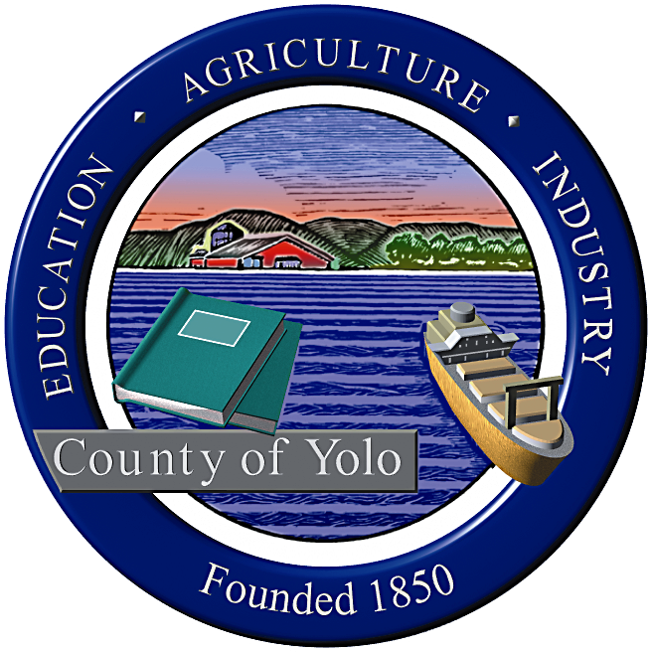

County of Yolo Patricia Wong
LIBRARY COUNTY LIBRARIAN
_______________________________________________________________
226 Buckeye Street
Woodland, CA 95695
(530) 666-8005
www.yolocountylibrary.org

LIBRARY ADVISORY BOARD
CHAIR: Rebecca Fridae
VICE-CHAIR: Sharon Hallberg
MEMBERS: Nora Brazil, Alan Candee, Margaret Crawford, John Ferrera, Katherine Henderson

MINUTES

APRIL 9, 2008

Present: Alan Candee, Margaret Crawford, and John Ferrera. Absent: Rebecca Fridae, Sharon Hallberg, Nora Brazil, and Katherine Henderson. Also present were Marie Surad, Ray Groom, Sheila Groom, Andrea Jones, Patty Wong, and Mae Bolton.

WELCOME/INTRODUCTIONS
Marie Surad was introduced as a potential new Library Advisory Board member representing District 5 which includes Esparto. She is a member of the board of the Esparto Friends.

APPROVAL OF MINUTES December 12, 2007
Due to the lack of a quorum:
- The February meeting was not held.
- At the April 9, 2008 meeting, the December 12, 2007 minutes were held over for approval at the June meeting.
- Notes form the April 9, 2008 meeting minutes attached.

REPORTS FROM MEMBERS
Arthur F. Turner
The City of West Sacramento agreed to fund library operations for $250,000 per year. The City will also fund an opening day collection. The Friends have not been asked so far how they would like to see their $50,000 spent. Alan Candee said that the Esparto Friends can give the West Sacramento Friends ideas from their experiences with a new library.

COUNTY LIBRARIAN’S REPORT/UPDATE
- Naming Process: West Sacramento: Ray Groom, Director of General Services, discussed the process for the naming of the library and asked the Library Advisory Board members whether or not they want to make a name change. He began by saying that naming the library is a community driven process. Staff is not involved in the process. All suggestions will go to the Board of Supervisors. The County tends to refresh a name when a new building is constructed to replace an older building.

The following discussion took place on the naming:
- Margaret Crawford said that Arthur F. Turner gave the County the property and that there would not have been a library if not for him.
- Ray Groom stated that the City of West Sacramento is a partner in this venture and is funding half of the project.
- Alan Candee said that the Turner name has no meaning for many in West Sacramento. Many new people have moved to the City and he feels that the name should be identified with the City.
- Ray Groom: The name can be changed and spaces within the building, such as a meeting room, can be dedicated to a person.
- Andrea Jones pointed out that in Davis the Blanchard Room in the library is recognized by the Community. West Sacramento was not a city when the library was built.
- John Ferrera deferred to the West Sacramento Board members and community. He thought that some space in the library should be reserved for Turner.
- Ray Groom said that the dedication plaque could include a statement that the library was formerly the Arthur F. Turner Library.
- John Ferrera said that if the name is changed, there should be a compelling reason for doing so.
- Margaret Crawford pointed out that the children in Broderick and Bryte have no way of getting to the Library.
- Andrea Jones said that the library will be located in a transit hub and there may be something that can be done.

- Building Projects
Winters: Operating agreement will go to the Board of Supervisors in May.
West Sacramento: Operating agreement will go our soon.
Davis: NTD was selected as the architect. The bid came in lower than expected. The Library plan to work with the Marguerite Montgomery Elementary School on summer programming has been put on hold. There were suggestions to place a book drop or deposit program in businesses in South Davis.

- Branch Updates
Yolo: The branch’s roof suffered damage from two fallen trees.
Clarksburg: 8.5 open hours that has been staffed by volunteers will be staffed by County Library staff. The volunteers will either become staff or continue to volunteer while working with County staff.

- Library Courier Costs: A settlement was reached and the Library will pay approximately $40,000 per year for courier services. The delivery schedule will continue in the same vein.

- Board of Supervisors – Goal Setting: County goals will remain mostly the same. County Departments will tailor their goals to support County goals.

- Nomination for National Medal for Museum and Library Service
Rep. Mike Thompson nominated the Yolo County Library for this award which includes national recognition and a visit to the White House.

- General Staff Meeting, March 31: A General Staff meeting is held twice a year to provide staff enrichment. This year 42 staff boarded a bus and visited branches through the county. They were given the history of each branch and its community in addition to receiving tours of the branches.

- Meet and Greet
Legislative Day will be held on April 16. A program/orientation will be presented at 8:00 a.m. An appointment has been made with Assembly Member Lois Wolk and other appointments with Yolo County representatives will be made.

ASSISTANT COUNTY LIBRARIAN’S REPORT/UPDATE
- National Library Week and Read Off Your Fines Program: The “Read Off Your Fines” program and other library programs and displays will be held during National Library Week, April 14-18. The “Read Off” program will allow youth to read off fines owed the library for overdue books that have been returned. The aim of the program is to bring youth who have overdue fines back to the library.
- Literacy Services Update: A new Literacy Coordinator, Heather Bratt, has been for the .5 FTE position. A tutor training workshop in collaboration with the Woodland Public Library was held on March 29.
- Personnel: Keri Hill was selected to fill the Yolo Link coordinator position.

NEW BUSINESS
- John Ferrera reported that he recently attended a CASA (Court Appointed Special Advocates for Children) event made him realize that the library has services that it can offer the organization and its clients.
- The board acknowledged the work of Sandy Briggs and wished her the best in her tenure as Library Director of the Woodland Public Library. Yolo County Library hopes to work collaboratively with WPL in the future.

The meeting adjourned.

NEXT MEETING: June 11, 2008

AGENDA TOPICS FOR FEBRUARY MEETING: Budget Update; Update on Winters, West Sacramento, and Davis Library Projects; Library Courier Costs.

Submitted by:

Mae Bolton

