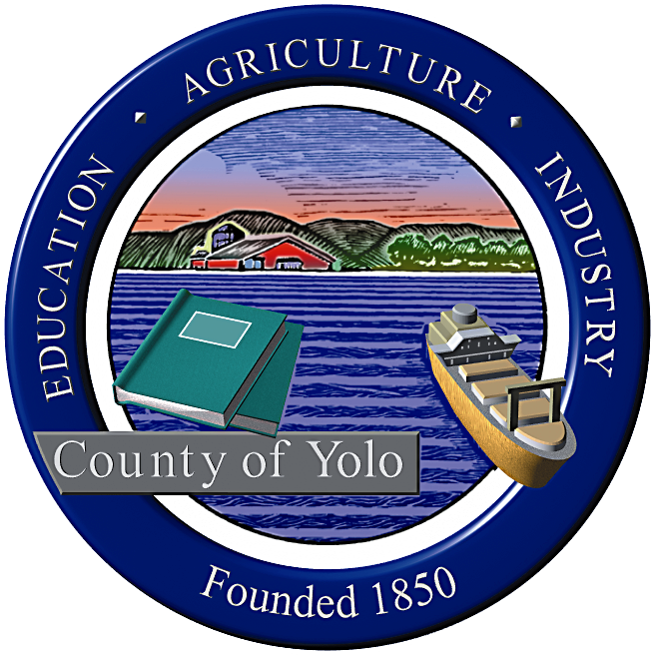

County of Yolo Patricia Wong
LIBRARY COUNTY LIBRARIAN
_______________________________________________________________
226 Buckeye Street
Woodland, CA 95695
(530) 666-8005
www.yolocountylibrary.org

LIBRARY ADVISORY BOARD
CHAIR: Rebecca Fridae
VICE-CHAIR: Sharon Hallberg
MEMBERS: Nora Brazil, Alan Candee, Margaret Crawford, John Ferrera, Katherine Henderson, Marie Surad

MINUTES

AUGUST 13, 2008

Present: Alan Candee, Margaret Crawford, Sharon Hallberg, and Rebecca Fridae, Marie Surad. Absent: John Ferrera, Katherine Henderson, Nora Brazil. Also present were Jim Rosaschi, Andrea Jones, Patty Wong, and Mae Bolton.

WELCOME/INTRODUCTIONS
Marie (Rie) Surad was introduced as the new Library Advisory Board member representing District 5. She is a member of the Board of Trustees of the Friends of the Esparto Regional Library (FERL). One of her projects on the FERL board is to have students representing the middle school and high school attend FERL meetings and report back to the students. Rie is also hosting an Armenian student from the country of Georgia.

APPROVAL OF MINUTES June 18, 2008
Sharon Hallberg pointed out that the spelling of “principle” should be changed to “principal”, the next meeting date is August 13, and the information on the Courier Service will be become a separate paragraph indicating the decrease in fees. The minutes were approved with the above changes.

REPORTS FROM MEMBERS
Arthur F. Turner
Margaret Crawford reported that the staff is happy at the new temporary library in West Sacramento. The branch received a second year ELF (Early Learning with Families @ Your Library) grant. This will enable the branch to continue outreach activities through preschool and “Mother Goose on the Loose” programs. The Youth Advisory Committee will resume meeting this fall.

Alan Candee reported that the Book Club continues to meet, even though they have changed their meeting location to Round Table Pizza. He also stated that Yolo Reads and the branch are collaborating with the Yolo County Department of Social Services to reach West Sacramento residents in need of literacy services. Alan’s branch library in Sacramento began showing movies in the library. The branch is also featuring a bug display and the Sacramento Sheriff’s organization donated $2,000 to the branch.

Davis
Sharon Hallberg reported that the Davis Library circulated over 10,000 items in one weekend. There have been a number of thefts and break-ins in the parking lot. Free SAT and PSAT preparation classes will be offered. College essay classes will start in September. Davis will expand its preschool program into a year round program.
She also stated that the branch is looking into whether or not an automated return system using RFID (radio frequency identification) is feasible and noted that the library might get some resistance in Davis to installing the RFID tags used in automated return systems because some community members feel that this takes away a person’s individuality. This segment of the community will need some help and education. Patty Wong assured the Advisory Board that the library will work with vendors and other libraries to obtain more information and to see how they address the fear that someone can intercept a frequency and find out what another person is reading.

Winters
Rebecca Fridae stated that the Friends held an amazing music program which raised over $300. The summer Shakespeare in the Park and the story time programs were very successful. The bids for the construction of the building came in lower than expected. Everyone is looking forward to the groundbreaking for the new library in September. Winters Joint Unified School District Superintendent, Dale Mitchell, has resigned to take a job in San Diego.

LIBRARY BUDGET UPDATE
The library’s new cost recovery service, UMS (Unique Management Services), has collected in materials and fines/fees paid a total of $2500 in three weeks. The program and overdue notices are tailored to the library. So far there have been few complaints. Most people are returning library material and paying their fines faster.

COUNTY LIBRARIAN’S REPORT/UPDATE
The County Librarian’s written report was passed out. A Library Advisory Committee Survey conducted by the County Administrator’s Office, was completed and submitted by Chair Fridae and Patty Wong. The library will sell flash drives for $5.00 (512 mb) and $10.00 (1 gig) ear buds for $2.00 and lanyards and ear buds as a package for $2.00. The priority for spending will be buildings followed by security gates for Esparto. The Library is negotiating with the City of West Sacramento for funding operations.

The County’s General Plan will go before the Board of Supervisors on August 16. The Library’s portion has increased from one paragraph to a page. In response to the Grand Jury report, forms and a telephone message machines have been placed in the Yolo and Knights Landing branches.

The library was awarded an IMLS (Institute of Museum and Library Services) grant for family literacy and community outreach, a First 5 grant to serve ages 0-5, and an ELF (Early Learning with Families) grant. These grants will enable the library to work with other agencies to expand resources so that we can reach out to more people.

- Building Projects:
Construction bids for both Winters and West Sacramento’s Arthur F. Turner branches came in under bid. The Board of Supervisors would like to see the remainder of the funds used for operations.
- Winters: Will proceed with Capital Campaign. One suggestion is to set up an endowment similar to Esparto’s. Sarah Jewell will assume the duties of co-chair of the Campaign. The Library Advisory Coordinating Committee, which was established in the building project MOU, will begin meeting.
- Davis: The Davis bond sale came in at 5.19%. It will close on August 27 and the library can start collecting on it in January. We will need to think about phasing at Davis and how to keep the building open during construction. We have been given the green light to reconfigure parking and the location of the bicycle racks.

The Library is working with Nora Brazil to plan for library service in South Davis by setting up a book drop at the Marguerite Montgomery School as a first step.

Technology Plan
The Library has to develop a Technology Plan every five years in order for the California State Library to evaluate funding. We would like to include everything we are doing in this area. The Advisory Board was asked to review and email their response to the report to Mae Bolton. We will rewrite the report and take it to the Board of Supervisors in November. According to Jim Rosaschi, the plan is in metamorphosis and we have plenty of time to make changes. The Advisory Board approved the report in concept and giave the Library permission to move forward. It as noted that ongoing servicing and maintenance by staff should be included.

LAFCO (Local Agency Formation Committee)
LAFCO looks at efficiencies in government and what a government agency does. So far, LAFCO has never produced a Yolo County report but is now working with County staff to write a report.

ASSISTANT COUNTY LIBRARIAN’S REPORT/UPDATE
- Read Around Yolo is a program which packages new book titles in a bag for book clubs to check out and use during their meetings. The project was developed by the Davis staff.
- Yolo Reads! has been selected as the name for the Adult Literacy Program. Focus is on planning tutor training workshops and promotional material. Emphasis has been placed on learner recruitment.
- Staff Development: Several staff attended the American Library Association Annual Convention in June.
- YoloLINK: Three staff members are working part time to keep YoloLINK operating. Their main focus is on updating the database.
- The library is in the process of recruiting for Substitute Library Assistant I and for a Library Assistant III to fill the vacant YoloLink position.

NEW BUSINESS
October 8 is the last meeting that Andrea Jones will attend. Mariko Yamada will also be present for this meeting. It is unknown who her replacement will be.

Representative Mike Thompson will have a house party at Rebecca Fridae’s house.

Sharon Halberg showed a video of her vacation trip to Antarctica.

Margaret Crawford received the CALTAC (California Association of Library Trustees and Commissioners) 1998 award for outstanding Library Advisory Board member. The trophy she received for this award is on display at the Library’s Central Services office in Woodland.

The meeting adjourned at 9:15 p.m.

NEXT MEETING: October 8, 2008

AGENDA TOPICS FOR OCTOBER MEETING:
Budget Update; Building updates on Winters, West Sacramento, and Davis Library Projects.

Submitted by:

Mae Bolton

