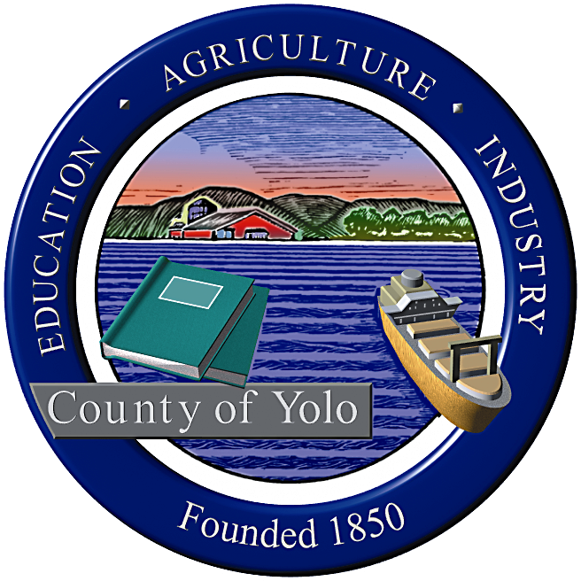
County of Yolo
Warren Westrup
DIRECTOR

PARKS AND RESOURCES DEPARTMENT

120 West Main Street, Suite C
Woodland, CA 95695
(530) 406-4880 FAX (530) 668-1801
www.yolocounty.org

NOTICE OF PUBLIC MEETING

The Yolo County Cache Creek Technical Advisory Committee (TAC) will be conducting a public meeting on Monday November 17, 2008 from 10:00 a.m. – 12:00 p.m. at: the County Department of Employment and Social Services Community Room (# 167), 25 N. Cottonwood Street, Woodland, CA 95695.

The meeting will include:

Public comments:
Members of the public may address the TAC on any subject relating to the TAC but not relative to items on the present agenda. The Committee reserves the right to impose a reasonable limit on time afforded to any individual speaker.

Staff updates:
A report by County staff on recent staff activities and meetings will be given relevant to the Technical Advisory Committee. No discussion by Committee members may occur except for clarifying questions. The Committee or an individual Committee member can request that an item be placed on a future agenda for discussion. Staff updates:

- Parks and Resources staff updates (10:00-10:10 am).
- Cache Creek Conservancy (CCC) staff updates (10:10-10:20 am).
- Yolo County Resource Conservation District (10:20-30 am)
- Yolo County Flood Control and Water Conservation District staff updates (10:30-10:40 am)
- TAC updates (10:40-10:50am)

The Technical Advisory Committee’s regular agenda:
- Release of 2008 Creek Walk Summary and Recommendations (10:50 am – 11:10 am)
- CCRMP Implementation priorities and recommendations based on 2008 Creek Walk (11:10-12:00 pm)

Written comments on any aspect of these items are invited and should be addressed to:

Kevin Schwartz, Resource Specialist
Yolo County Parks & Resources Department
120 W. Main Street, Suite C
Woodland CA 95695
(530) 406-4887
Kevin.Schwartz@yolocounty.org

NOTE: If requested, this agenda can be made available in appropriate alternative formats to persons with a disability, as required by Section 202 of the Americans with Disabilities Act of 1990 and the Federal Rules and Regulations adopted in implementation thereof. Persons seeking an alternative format should contact the Resource Specialist for further information. In addition, a person with a disability who requires a modification or accommodation, including auxiliary aids or services, in order to participate in a public meeting should telephone or otherwise contact the Resource Specialist as soon as possible and preferably 24 hours prior to the meeting. The Resource Specialist may be reached using the contact information above.

