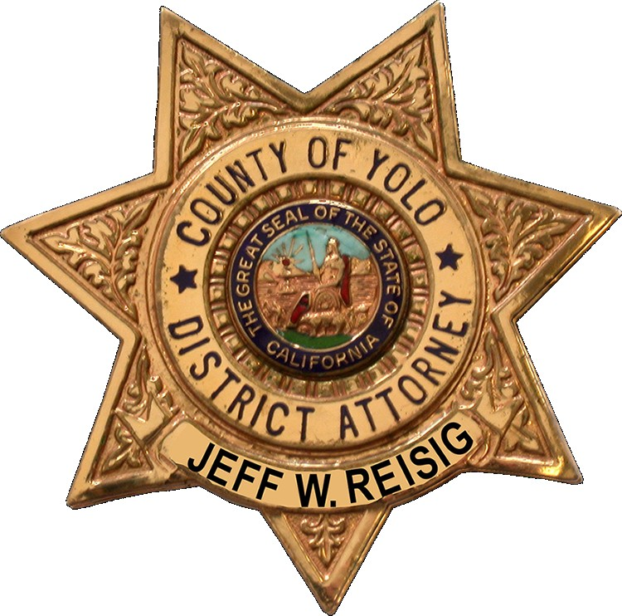
County of Yolo
Office of the District Attorney
Jeff W. Reisig, District Attorney

Meeting Request Form

Name of Person/Organization Requesting Meeting:

Available dates and times:

Contact name(s): Email:

Phone (office): Phone (mobile):

Attendees:

Name: Title/Organization:

Topics to be discussed:

Today’s date:

Please attach any pertinent information, and return to Wendy Wilcox by email: district.attorney@yolocounty.org or fax: (530) 666-8423.

Please note, while District Attorney Jeff Reisig makes every effort to meet with the citizens of Yolo County and other groups, due to numerous time constraints, this is not always possible. We need to receive this completed form before scheduling a meeting, but this form does not serve as a confirmation of your meeting. Someone from the Yolo County District Attorney’s staff will contact you directly.

Thank you for your request!
Scheduling

Meetings with District Attorney Jeff Reisig

All requests to meet with District Attorney Jeff Reisig must be made in writing. To ensure prompt receipt of your request please fax or email your requests to Wendy Wilcox.

Pertinent information for meeting requests should include:
- All attendees’ names, titles, and affiliations
- A detailed description of the subject matter you wish to discuss
- Contact information (i.e. phone, fax, address) for you and/or your group

