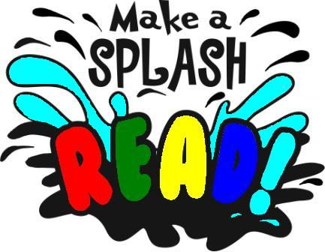

Make a Splash @ Your Library

2010 Summer Events for children ages 5-12 and their families

June 23 – 6:30 Randel McGee and Groark, ventriliquist

June 30 – 6:30 Stones & Songs, Old and New
Storyteller and musicians:
Jean Jackman/Ron Goldberg

July 7 – 6:30 Beach Party!

July 14 – 6:30 Uncle Jer’s Traveling Bee Show

July 21 – 6:30 Flippers, Fins & Feathers: Sing-Along Songs of the Watery Wild
Bonnie Lockhart, musician
===============================================
Listening, Writing, and Reciting: special sessions with
Davis Poet Laureate, Allegra Silberstein: June 24, July 8 & 22, 2-3 p.m.
=====================================

Preschool Programs

June-August 2010
Reading Incentive programs for ages up to 18 run
June 13-July 31.
Ask for details at the
Reference Desk.

Hug-a-Bye Baby for ages 2-12 months
Tuesdays at 10:15-10:35 a.m.

Mother Goose on the Loose for ages 1-3 years
Tuesdays & Thursdays at 11:00-11:30 a.m.

Bilingual Stories (Spanish) for ages birth to 5 years
Wednesdays at 10:30-11:00 a.m.

Stories for kids for ages 3-5 years
Thursdays at 10:15-10:45 a.m.

Sign language interpreter at our Tuesday programs.
All events are free. No registration required.

Sponsored by
Friends of the Davis Branch Library and First 5 of Yolo
============================
Stephens Davis Branch Library
2801 2nd Street
Davis, CA 95618

530-757-5593 x4
www.yolocountylibrary.org

