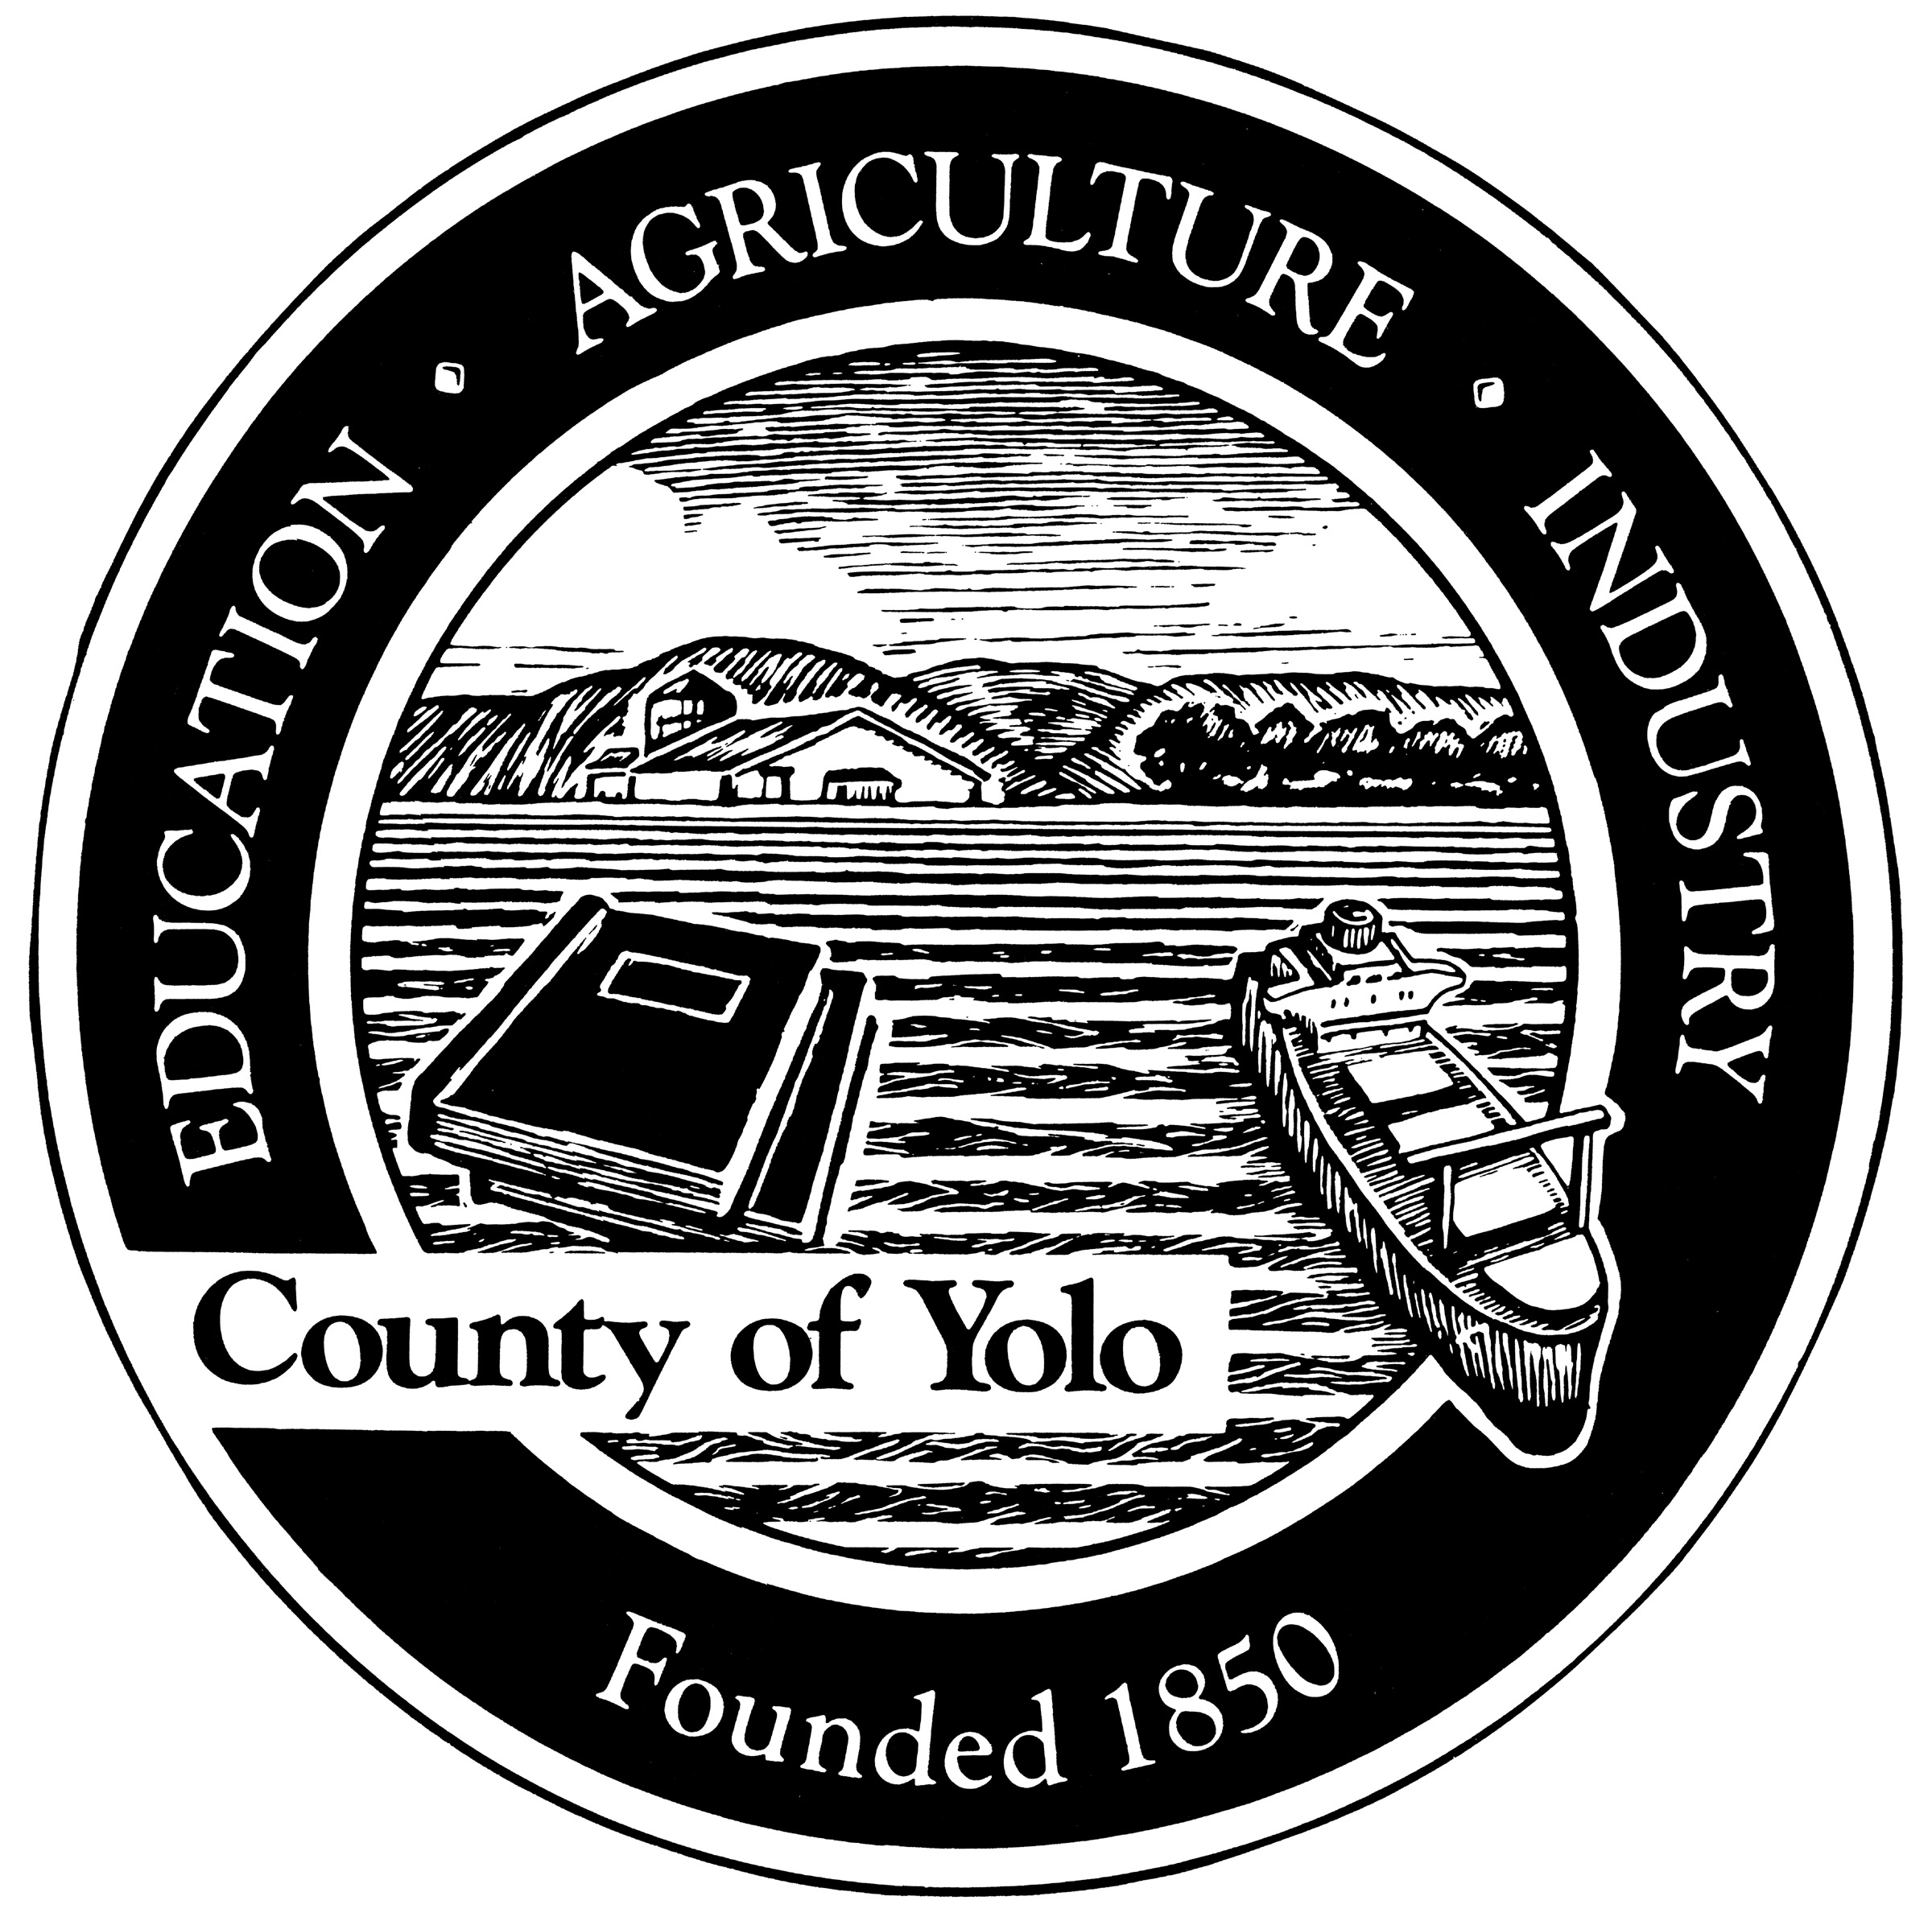
Yolo County Library
English Conversation Group
Volunteer Facilitator Training

Thank you for your interest in volunteering with the Yolo County Library!

English conversation groups are a fun way to give back to the community while meeting new and interesting people.

To volunteer, please follow these 5 steps:

- Contact the Yolo County Library branch where you would like to volunteer or complete the volunteer application and return it to your local branch. (Please keep in mind that not all branches have an English conversation program.)

- Once your application is received, you will be invited to come to the library to meet with the staff member who oversees the English conversation groups.

- The staff member will ask you to review this brief online training. Please be sure to copy the training certificate and provide it to the staff member.

- Attend an English Conversation Group meeting. This will be an opportunity to see a group in action and to meet a current English Conversation volunteer. Be sure to ask questions!

- Work with the library staff member to set a time for your group. You are ready to begin. Good luck and have fun!

The Purpose of this Training…

is to explain the role of volunteer conversation facilitators and to share ideas for engaging small groups of non-native English speakers in discussion.

Conversation Groups encourage language acquisition

Adults learning English need to practice listening and speaking skills in an environment where they feel comfortable making mistakes.

Communicating meaning is the primary goal. Communication will achieved by demonstration, use of pictures, gestures, drawings, mime, smiles, and great intuitive leaps!

The Volunteer Facilitator’s Role

Volunteers facilitate, foster, and encourage conversation in a social setting.

Ideal qualities for an English Conversation facilitator include:

- Patience
- A good sense of humor
- The facility for listening and drawing out conversation
- A tolerant ear that can decipher an assortment of sounds
- A reluctance to have conversations end with polite smiles and no comprehension
- Willingness to encourage miming or drawing as ways to impart meaning and supplement verbal communication
- Interested in and accepting of differences in culture
- Commitment to lead conversation groups for 1 hour per week for 6 months

What Volunteer Facilitators do Not do

- Facilitators do not teach in a traditional sense.
- They do not instruct participants or assume a role of authority.
- Facilitators do not teach lessons on structured speech.

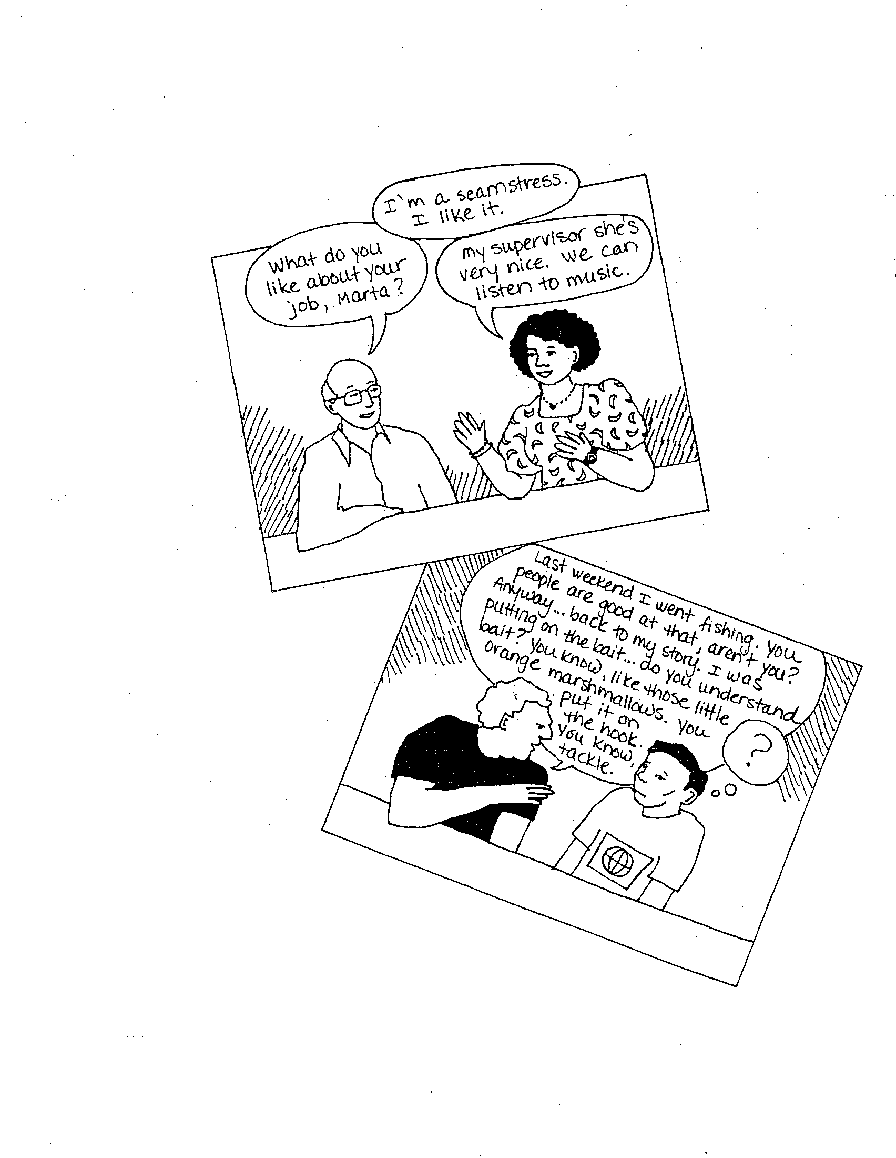

Preferred
Communication

The volunteer facilitator encourages discussion by asking questions, listening and ensuring everyone has an opportunity to speak. Conversation group participants should do most of the talking.

Image from the Talk Time Handbook.

Topic Selection: How to decide what to talk about

There are many ways to determine conversation topics.
- Ask conversation participants about topics of interest
- Negotiate future topics at the end of each session
- Bring topics to the group and allow the group to select their favorite
- Encourage group members to share discussion ideas and initiate conversations

Topic Selection: Topic Ideas

What are popular topics of discussion with friends, family and co-workers?

- Family
- Food
- Holidays (American and international)
- Local events (farmers market, parade, etc.)
- Using public transportation
- Shopping

Conversation Activities: Get people talking

When planning a session, include several different kinds of activities so that participants have a chance to ask questions, explain, discuss, and problem-solve.

Group Size

One way to vary activities and promote conversation practice is to change the group size.

It is usually easier for people to talk one-on-one rather than in front of a large group. Begin a conversation with a one-on-one speaking activity. After two participants share with each other, they will have more confidence to address the larger group.

Warm-up Activities

Warm-up activities happen at the beginning of the session. The goal of the warm-up is to make introductions and get people talking. Good warm-ups are short, easy to explain, involve everyone, and usually relate to the main topic of the session. Ask participants to introduce themselves and answer a question (What did you eat for breakfast today?), share a fact about themselves (hobbies), or draw a picture (favorite pet).
Framing

Framing provides participants with a structure for sharing information and allows them to practice common phrases. For example, when discussing favorite foods, a facilitator might use the frame “I like to eat…” Each participant would start sharing by saying, “I like to eat”.

Other frames might include:
Hello. My name is…
My favorite TV show is…

On the 4th of July Holiday…
I like to celebrate my birthday by…
When the weather is cold…
When I first came to the United States…

Role Plays

Role playing allows participants to practice regular activities or explore a topic with a different voice. Fun role plays may include grocery shopping, visiting the library, banking, or using public transportation. Physical objects such cans or boxes of food in a grocery shopping role play may help inspire participants.

Drawing

For beginning English learners, drawing may help to communicate objects or ideas for which the participant does not yet have vocabulary. For example, when discussing emotions, participants can draw faces to represent different emotions. Participants will learn new vocabulary and, hopefully, get a good laugh out of their pictures.

Reading Comprehension

A more advanced group of students may be interested in enhancing the conversation with materials such as newspaper articles or short stories.

Summarizing reading contents, asking questions, reviewing vocabulary, and using key phrases are all ways in which the written material can foster verbal communication.
Resources: Using Visuals and Objects

Nothing stimulates language better than seeing and holding the actual object while discussing it. Pictures, photographs, drawings, and objects can all be indispensible conversation tools.



Cookbooks, an atlas and books on animals can aid conversation.
Children’s books often have the best pictures.

The facilitator does not have to be the sole source of visuals. For example, a facilitator planning a discussion on family can encourage participants to bring pictures of their family to share with the group.

Conversation Support: Library Conversation Coordinators

Arthur F. Turner (West Sacramento) Branch
Cheryl Chapel cheryl.chapel@yolocounty.org or 916-375-6465

Esparto Regional Library
Malinda Baker malinda.baker@yolocounty.org or 530-787-3426

Stephens Davis Library
Deatra Cohen deatra.cohen@yolocounty.org or 530-757-5593

Winters Community Library

Toni Mendieta toni.mendieta@yolocounty.org or 530-795-4955

Conversation groups are supported in part by the Yolo Reads adult literacy program. Heather Bratt, librarian for literacy services, can be contacted at Yolo Reads at 530-666-8019 or at heather.bratt@yolocounty.org.

Communication

Communication is important to ensure the program functions smoothly and is an enjoyable experience for volunteers and participants.

Please be sure to:
- Contact your Library Conversation Coordinator if any problems arise.
- Call your Library Conversation Coordinator at least 24 hours in advance if you will miss a session. If there is usually more than one facilitator during the time in which you facilitate conversation, please notify that person.
- Complete information sheet after each session. The information sheets will be kept in a binder at the reference desk. Please be sure to complete a sheet after each session to document your volunteer hours and the number of participants.

Resources & Thanks

The Talk Time Handbook: Conversation Sessions for volunteer Facilitators and Limited English Speaking Participants is written by Marilyn Bentson and Elisabeth Mitchell and published by Tacoma Community House (1995).

Special thanks to the staff of the Solano County Library Adult Literacy Program for generously sharing advice and conversation training materials.

Congratulations!
You have completed the online English Conversation Facilitator training.

Please print this page, fill your name in the blank and complete the bottom of the form, and return to your Library Conversation Coordinator.

Certificate of Completion

___________________________
has completed the online training
for English Conversation Facilitator.

Volunteer Name: _________________________ Date: _______________
Phone number: _________________________
E-mail address: _________________________

Please provide any feedback or suggestions about the online training. Your input is appreciated! ________________________________________________________
___________________________________________________________________
___________________________________________________________________

