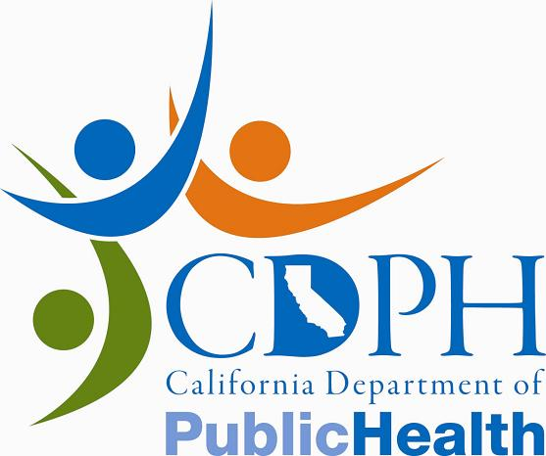News Release

CALIFORNIA DEPARTMENT OF PUBLIC HEALTH

FOR IMMEDIATE RELEASE
CONTACT: | Al Lundeen
 | Ralph Montano
 | (916) 440-7259
April 1, 2011
PH11-018

CDPH: Do Not Eat Certain Louie’s Brand Sprouts

SACRAMENTO – The California Department of Public Health (CDPH) Interim Director Dr. Howard Backer today warned people not to eat certain spouts distributed by Louie Foods International because the sprouts may be contaminated with Salmonella. The contamination was identified during routine testing. To date, no illnesses have been reported.

Louie Foods International is recalling all Louie’s brand sprouts with a “Use-By” date on or before 4/14/11. Products affected by the recall include:

- Louie’s Alfalfa Sprout Mix, 4 oz. cups (UPC 11324 04401)
- Louie’s Alfalfa Sprout Mix, 16 oz. bags (UPC 11324 16401)
- Louie’s Clover Sprouts, 4 oz. cups (UPC 11324 04406)
- Louie’s Clover Sprouts, 16 oz. bags (UPC 11324 04406)
- Louie’s Spicy Sprouts, 4 oz. cups (UPC 11325 04402)
- Louie’s Broccoli Sprouts, 4 oz. cups (UPC 11324 04407)

Symptoms of Salmonella infection include fever, abdominal cramps, and diarrhea which may be bloody. Most infected people recover within a week. Some may develop complications that require hospitalization. Infants, the elderly, and people with weakened immune systems are at highest risk for more severe illness. People who develop symptoms of Salmonella infection after consuming these sprouts should consult their health care provider.

The affected sprouts were sold to California distributors located in the Central Valley and along the Central Coast. Consumers are urged to destroy the above-listed products or to return them to the place of purchase for a full refund. Consumers may contact
Louie Foods International at (559) 264-2745 for additional information.

Consumers that observe the product being offered for sale are encouraged to report their findings to the CDPH toll-free complaint line at (800) 495-3232. Click here to view sample labels.

www.cdph.ca.gov



