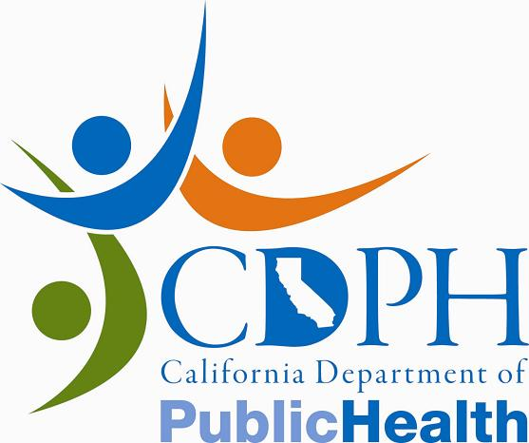News Release

CALIFORNIA DEPARTMENT OF PUBLIC HEALTH

FOR IMMEDIATE RELEASE
CONTACT: | Mike Sicilia
 | Ronald Owens
 | (916) 440-7259
October 21, 2011
PH11-047

CDPH Warns Of Possible Health Risk
from Consuming Certain Salad Products
Salmonella Found in Spinach from Taylor Farms Retail, Inc.
SACRAMENTO – Dr. Ron Chapman, director of the California Department of Public Health (CDPH), today warned people not to eat certain bagged spinach and salad products manufactured by Taylor Farms Retail Inc., Salinas, because they may be contaminated with Salmonella.

The recall was initiated after a package of fresh spinach tested positive for Salmonella in the state of Washington. CDPH is not aware of any illnesses linked to this positive test result.

Symptoms of Salmonella infection may include diarrhea, fever and abdominal cramps 12 to 72 hours after infection. The illness usually lasts 4 to 7 days, and most people recover without treatment. However, in some people, the diarrhea may be so severe that the patient needs to be hospitalized. The elderly, infants, and those with impaired immune systems are more likely to have a severe illness.

The affected spinach and salad products were distributed to Arizona, California, Colorado, Florida, Kentucky, Missouri, New Mexico, New York, North Carolina, Oregon, South Carolina, Texas, Virginia, Washington, and Puerto Rico.

For a list of Taylor Farms Retail, Inc. visit recalled products. Consumers may contact Taylor Farms Retail, Inc. at 1-877-323-7374 for further information. Consumers that may have purchased the affected salad product should discard them. If unsure whether the salad products purchased are affected by this recall, consumers should check with their place of purchase. People who develop symptoms of infection after consuming salad products should seek immediate medical attention.

Consumers that observe the product being offered for sale are encouraged to report the activity to the CDPH toll free complaint line at (800) 495-3232.

www.cdph.ca.gov



