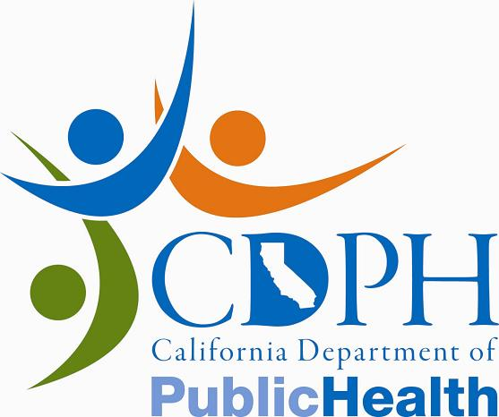News Release

CALIFORNIA DEPARTMENT OF PUBLIC HEALTH

FOR IMMEDIATE RELEASE
CONTACT: | Anita Gore
 | Heather Bourbeau
 | (916) 440-7259
February 23, 2012
PH10-010

Consumers: Do Not Eat Certain Rewari Candies Imported From India

SACRAMENTO – Dr. Ron Chapman, director of the California Department of Public Health (CDPH), today warned consumers not to eat four ‘Rewari’ candies imported from India, after tests conducted by CDPH found that all four exceed state standards for lead.
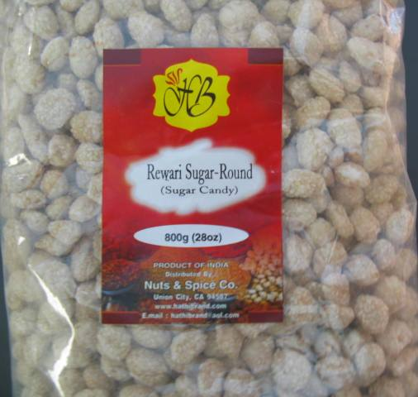
Those candies are HB Rewari Gur-Coin (Jaggery Candy), HB Rewari Sugar-Coin (Sugar Candy), HB Rewari Sugar-Flat (Sugar Candy) and HB Rewari Sugar-Round (Sugar Candy). Consumers in possession of these candies should discard them immediately.

CDPH testing showed that HB Rewari Gur-Coin (Jaggery Candy), HB Rewari Sugar-Coin (Sugar Candy), HB Rewari Sugar-Flat (Sugar Candy) and HB Rewari Sugar-Round (Sugar Candy) candies contained as much as 0.12, 0.11, 0.78, and 0.37 parts per million (ppm) of lead, respectively. California considers candies with lead levels in excess of 0.10 ppm to be contaminated.

HB Rewari Gur-Coin (Jaggery Candy), HB Rewari Sugar-Coin (Sugar Candy), HB Rewari Sugar-Flat (Sugar Candy) and HB Rewari Sugar-Round (Sugar candy) candies are distributed by Nuts & Spice Co., in Union City, CA. CDPH is working with the distributor to ensure that the contaminated candies are removed from the market place.

HB Rewari Gur-Coin (Jaggery Candy), HB Rewari Sugar-Coin (Sugar Candy), HB Rewari Sugar-Flat (Sugar Candy) and HB Rewari Sugar-Round (Sugar Candy) candies are sold in a clear plastic package with a net weight of 800 grams (28 oz.). In the center of the package is a red label. “HB” appears at the top of the label in a yellow background. The specific candy name appears in the center of the label.

All four candies are flat, light brown, oval-shaped and contain seeds. The candies are visible through the package.

Pregnant women and parents of children who may have consumed these candies should consult their physician or health care provider to determine if medical testing is needed.

Consumers who find any of the candies for sale are encouraged to call the CDPH Complaint Hotline at 1-800-495-3232.

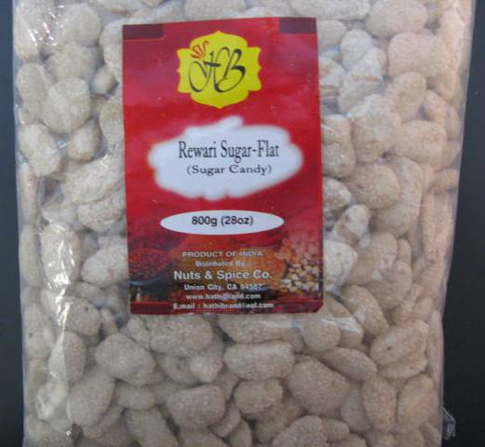
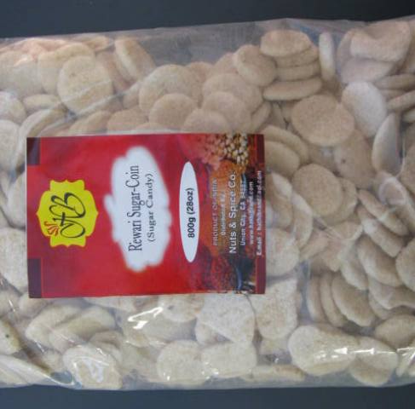
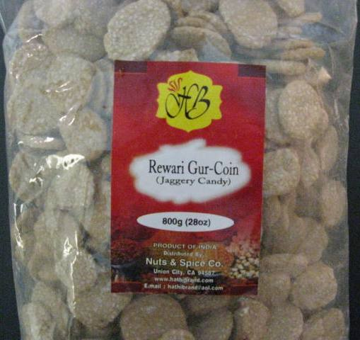
For more information about lead poisoning, contact your local childhood lead poisoning prevention program or public health department.
You can find additional information about these products and other food safety issues on the CDPH website.



