County of Yolo
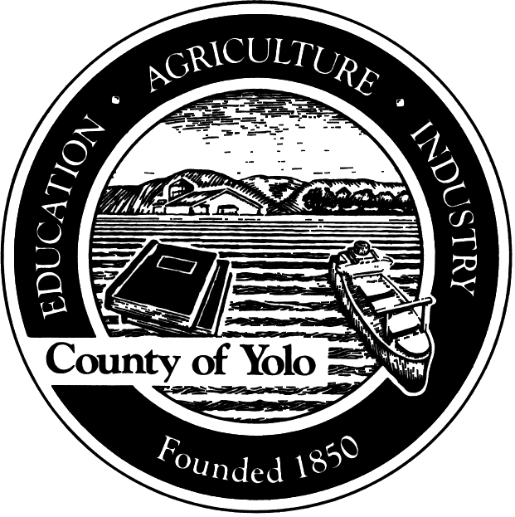

At Will Employee Appraisal

EMPLOYEE NAME:

EMPLOYEE JOB TITLE:

DEPARTMENT:

APPRAISAL PERIOD: FROM TO

MERIT INCREASE DUE: YES NO

The following criteria shall serve as the foundation for a discussion of the achievements of the At Will employee for the rating period noted. In addition to these guidelines, additional feedback and mentoring would be expected for an At Will employee and may be included in the appraisal narrative. Goals or objectives identified in this appraisal shall be for employee development only and do not infer a promise of continued employment.

SUMMARY OF DUTIES AND EXPECTATIONS DURING THIS RATING PERIOD
List and discuss with the employee those duties and responsibilities that were considered most significant or influential in completing the appraisal.

APPRAISAL CRITERIA AND NARRATIVE

JOB KNOWLEDGE: Identify the extent to which the employee displays an understanding of the aspects of his/her current assignment and demonstrates the ability to make sound, feasible decisions in a timely and independent manner.

ACCOMPLISHMENT OF OBJECTIVES: Consider the employee’s performance results on specific projects, objectives and/or goals assigned during this review period. Consider the amount of work accomplished and the effective utilization of time and efforts on key work-related issues and problems.

INITIATIVE AND CREATIVITY: How has the employee demonstrated initiative and follow through on assigned or assumed projects? Identify where the employee has shown the ability to handle routine, new and unusual work situations through prudent use of financial resources and collaborative use of human resources.

INTERPERSONAL RELATIONS: Consider the employee’s skill at establishing and maintaining effective working relationships with the public, co-workers, subordinates, and stakeholders based on advancing the vision and goals of the County.

EXCELLENCE IN LEADERSHIP: Identify the employee’s success in establishing accountability, promoting a strong work ethic, encouraging subordinates to accept new challenges, delegating responsibility, and inspiring others.

PROMOTING COUNTY VALUES: Consider the ways in which the employee advances the SPIRIT (Service, Performance, Integrity, Responsibility, Innovation, Teamwork) values, understands and adheres to the County’s administrative policies and procedures, and effectively represents the County to the community.

ADDITIONAL COMMENTS: Identify expectations for the future and any recommendations or commitments made to the employee for professional development and the achievement of mutually agreed upon goals.

Employee Signature Title Date

Supervisor Signature Title Date

Appointing Authority Signature Title Date

