Clarksburg General Plan Advisory Committee
Meeting Minutes, January 10, 2013

- 7:10 pm Call to order. In attendance: Acting Chair Bob Weber, Phyllis Dutra, Nancy Kirchhoff, Mike Heringer, Gary Merwin. Absent, Waits and Dimare. Also attending( list A attached)
- Pledge of allegiance
- Agenda revised to place Russell project action item before Bogle, approved.
- No minutes available from last meeting (date?)
- Action Item: Craig Russell request for change of use on his existing shop building for a wine tasting venue, Clarksburg Road. Questions from the committee included under what wine label (Russell will be creating his own, with plan to purchase local fruit, but produce off-site); if events will be held at location (limited on an irregular basis); projected opening of venue (optimistically Spring 2014); and parking design (gravel parking lot, paved area for handicapped). Noted by Merwin that large corporations want to move into Clarksburg, we need to support the local residents first. Motion Dutra, Second Heringer, approved: Recommended by the CGPAC that County approve the Russell Project.
- Discussion Item: Mia Walker from Capay Valley Vision Ag Task Force presented 10-item list of guidelines for their Ag District (attached “B”). Among the objectives is to simplify permitting processes/policies for ag areas, with less county oversight. Noted by Eric Parfrey that the updated zoning code in progress for the past 3 years can be viewed at Yolo county website—go to “Zoning Code Update”; October 10, 2013 will be first public hearing on Ag Zoning. M. Heringer expressed support of Rural Restaurants as “value added Ag”. Public comment: G. Berry questioned the cost of new zoning regulations to the taxpayer; Mr. Parfrey responded costs should be lower due to reduced planning staff. Ms. Walker requested committee written support to County for Capay plan; N. Kirchhoff suggested tabling until October to allow more thorough study of guidelines and info; agreed.
- “Action Item” : Bogle Wind Turbine Project. Although quorum was met with 5 of 7 committee members present, Kirchhoff/Weber/Heringer were recused; therefore no quorum for official recommendation to County. However, Warren Bogle addressed the group with a word of thanks for community support, both in the past and currently—the Bogle family makes several efforts to support Clarksburg as well. A description of the project was presented for public information by Bogle Vineyards facilities director Ryan Latrell, after which public sentiment was invited and listened to. A combined effort to accurately record public comment made by this secretary and Eric Parfrey follows.
- Kirchhoff moved, Dutra seconded, meeting adjourned 9:15 pm

WIND TURBINE
Project descriptions presented by Bogle Vineyards included:
- Wind turbine would provide 100% of Hamilton Road facility electric needs
- Problems with using solar energy as an alternative include ag dust making panels inefficient and disposal of panels
- US dept of Energy survey concluded little to no effect on property valutes
- Bird mortality per Biologist retained by Bogles is minimal
- Massachusets study showed insufficient evidence to support health issues caused by wind turbines, including noise
- NO large scale wind farm is a future possibility due to the lack of PGE large transmission lines in greater Clarksburg area
- Bogles have researched using smaller turbines but would need 100-160 to duplicate the amount of power produced by a single large turbine
- Installing a remote turbine elsewhere is not a possibility because it’s required to be contiguous with the facility

Response by CGPAC committee members

Gary Merwin: noted the need for energy; PGE currently sourcing energy for California from other state

Oral Testimony by Residents/Attendees

Matt Hunter, nearby neighbor

Strongly opposed to the project, believes it will be negative to the community and is not considerate of local residents. He talked for 10 minutes about specific issues inadequately addressed in the Mitigated Negative Declaration (MND), including:

- Noise: study needed (no acoustical consultant used by Bogles).
- Setbacks to nearest houses need to be increased, San Diego now uses 8 times turbine height, Quebec, Australia use 1 or 1.5 miles; 17 homes are in the “deadly debris zone”
- Visual analysis: photosimulations used wide angle lens to make the turbine appear small, visual impacts will be similar to tallest high rise in Sacramento
- Recently released LLL study that indicates that property values of nearby homes not affected by wind turbine is suspect since Seimens (major turbine manufacturer) is one of key funders, only small number of houses included in study that could actually see nearest turbines
- Biology: bird mortality, bio assessment in MND inadequate because biologist was there less than one day
- FEMA flood study needed
- Cropdusters need to be notified
- Need to require wind speed report, Hunter believes mean wind speed in the area is 6.6 mph, turbine needs 8 mph to operate. CEMEX employees told him that turbine is losing money, is not turned on most of the time because of low wind speeds
- Large concern for birds bats and animals—was EIR done?

Ryan Lutrell (Bogle manager) responded briefly

Bogle did a wind speed study, analyzed data from 1987-2012 from two nearest stations, Sac Exec Airport and Dixon.

Tom Uslan, nearby neighbor

Strongly opposed to the project, believes many false assumptions have been made. He respectfully requested the committee to support common sense. He talked for 5 minutes about specific issues inadequately addressed in the Mitigated Negative Declaration (MND), including:

- Area is included in the Delta Primary Zone of the Delta Protection Act
- He is creating bird sanctuary on his lot less than ½ mile from turbine
- Swainson’s hawks in the mitigation easement and proposed turbine property
- He has studied and banded tri-colored blackbirds; strongly believes turbine will have a negative impact on them
- The MND contains only a “drive-by” biological assessment
- The MND biologist did not see tri-colored blackbirds, but they are there, he has located them, most recently last Saturday
- He has also seen yellow-headed blackbirds, American white pelican, and white tailed kite in the area. Which are California designated species of special concern
- The proposed turbine will nullify the Bogle’s Swainson’s hawk easement
- Clarksburg will begin to look like Rio Vista with the turbines
- He requests that the County prepare noise study and an analysis of infrasound impacts of the turbine in humans; County has ignored previous requests for more information
- Requesting full Evironmental Impact Report

Deline Hunter, nearby neighbor

The MND photosimulation photos are wrong and de-emphasize how big the turbine would appear
She showed large blown-up photos that she had prepared to show the real visual impacts

(Further comments were timed to 3 minute maximum)
Christopher Lee, attorney and farmer in Walnut Grove

He is a cherry farmer in Walnut Grove, has known Bogles 40+ years
He remembers when the 2,000-foot TV relay towers were first proposed and built near Walnut Grove, now no-one objects to them—“bucolic” delta still exists
This project should not be an issue when larger threats to the Delta are looming (tunnel project)

Steve Heringer, local farmer

He has mixed emotions about the project, wonders if more study would be helpful

Glen Berry, local resident, retired military
Spoke negatively about /to the opponents of the project and positively to support Bogles

Mark Wilson, local vintner

He hears different people with different perspectives coming to different conclusions
He remembers when the BDCP hearing occurred in Clarksburg after little attendance up north, and the room was packed; Clarksburg has endured and shown great cohesiveness and activism in the past 5 years of threats to intentionally flood the area
100 acres of agricultural industrial zoning in Clarksburg, the Clarksburg Ag District is still unfinished
Changed Delta Protection Commission policies
Turbine is one more high value improvement added to the district
Added value will protect us and sustain Ag, we need to double size of vineyard acreage

Steve Haupt, nearby resident

Lives on Alameda Ave. (10 years)
Complains about shot gun, pellet guns used by neighbors
The area IS very wlndy
See Swainson’s hawks after alfalfa cutting during the day
Refuted Canadian studies of turbines
Has 7 windows and 1 door facing the project and has no objection to the project

Skip Seebeck, local resident

Grew up with Bogles, can vouch for the integrity of the family and the Bogle’s honesty

Pat Brewer, local resident on Hamilton Road

Lived on Hamilton for seven years
She’s concerned about light flicker, noise from turbine
She is suspect of any studies coming from the manufacturer
She is opposed to the project

Tom Merwin, local resident

Speaking from the 30 year-old age group, a life-long local who farms with his father
Project will create jobs; Going green creates a great model for reinventing Ag and sustatining ag businesses

Andy Wallace

Engineer in W. Sac, has a winery in Old Sugar Mill
Bogle is largest employer here
Wallace-Kuhl had to lay off employees (200) because of downturn, jobs are important
From a business perspective he supports the project

Paul Taormina, Cub scout leader

Supports the project—good model for renewable energy source, good example to youth

CGPAC Committee

Comments included: (Dutra) what matters most is that Ag businesses remain successful; (Merwin) understands energy costs and supports the project; (Heringer) sensitive to the visual impact, but noted other aspects of farming (sulfur spray) may be unpleasant but necessary and supports the project; (Webber) supports; (Kirchhoff) suggested working with designers/FAA to minimize red blinking lights or other visual distractions, supports the project.

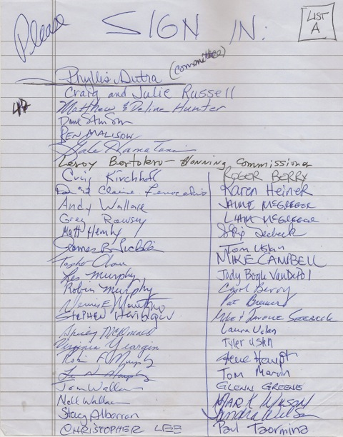
Attachment B 