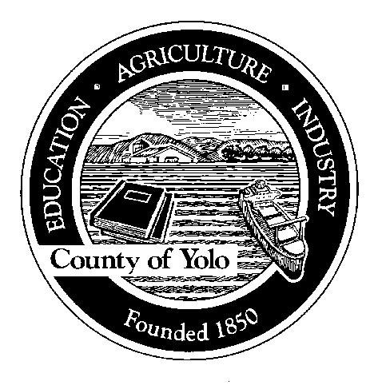

County of Yolo

70 COTTONWOOD STREET WOODLAND, CALIFORNIA 95695-2557 (530) 666-8140

FAX (530) 662-6094

John Young
AGRICULTURAL COMMISSIONER
SEALER OF WEIGHTS AND MEASURES

ORGANIC PESTICIDE USE REPORT SEARCH
Please note that a fee of $118/hour applies to public information requests.
An estimate will be provided and the amount is due at the time of request.

REQUIRED INFORMATION

Name of Applicant: _______________________________________________________________

Phone Number: __________________________________________________________________

Email Address: __________________________________________________________________

Property Owner: _________________________________________________________________

Total Acres: _____________________________________________________________________

Section, Township and Range: _______________________________________________________

Assessor Parcel Number: __________________________________________________________

Grower History: Please list any grower who has farmed this property for the past 3 years. List the farm name and the field Identification numbers. (For example, John Doe Farming, Field B1).

____________________________________________________________________________________________________________________________________________________________________________________________________________________________________________________________________________________________________________________________________________________________________________________________________________________________________________________________________________________________________________________________________________________________
Include a map of the field or fields. Please include roads, field borders and structures.

Signature of Applicant:_________________________________________________________________

