**COUNTY OF YOLO**

**DEPARTMENT OF FINANCIAL SERVICES**

**REVENUES DIVISION**

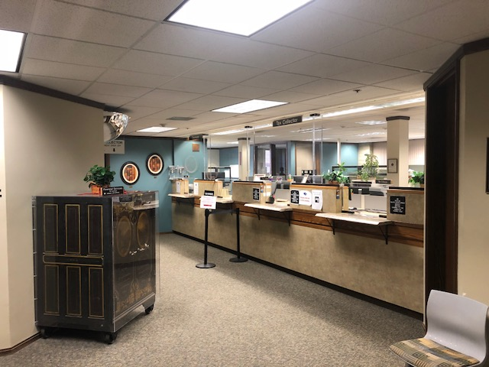

**CANNABIS TAX REPORTING GUIDE**

***This guide is intended to give a broad overview of Cannabis Tax requirements. The legal requirements for Cannabis Taxation and compliance requirements are established in Ordinance # 1496 and should be consulted to ensure compliance.***

***Welcome to Yolo County Cannabis Tax***

The County of Yolo Department of Financial Services understands the importance supporting business success. We are mindful that reviewing, understanding, and reporting all required documents for the cannabis taxation can be overwhelming. The Revenues Division within the Department of Financial Services will guide you through cannabis taxation process. Our goal is to provide information that is easily accessible, which will not only assist you in understanding your tax obligations but help you avoid simple filing mistakes. This guide provides the information that we believe is important to you in managing your tax obligations. We have organized this guide to address the general needs of all cannabis tax payers. Please feel free to reach out to us at any time for further clarification, or with any questions or concerns.

***Who needs to Complete and Pay Cannabis Tax Returns?***

Measure K went into effect in July 2018 for the taxation of all commercial cannabis activities in the County of Yolo unincorporated areas. If you own a cannabis business located in the unincorporated area, or if you conduct cannabis-related transactions in the unincorporated area, then you are required to file a tax return. For additional clarification, please locate a copy of the cannabis ordnance located on the Revenues website.

***What is included with Cannabis Tax Return Filing and Payment?***

Cannabis companies will need to include a completed Quarterly Cannabis Tax Return and full payment at the time of filing. The county cannot accept a tax filing without payment in full. Penalties and interest will accrue until full payment is received. The Cannabis Tax Return form should be filled in completely and signed by the legal officer of the company.

***How to Report and Pay Cannabis Tax Returns?***

Please visit our website for electronic or use the attached cannabis tax reporting form completing the necessary fields in the form. The information below can be used for a general reference of the required information. Please always refer back to the cannabis tax ordinance 1496 for your legal guide.

***Cannabis Tax Calculations -*** *Cannabis taxes are calculated on gross receipts based on the fiscal year quarterly periods below:*

*1st Quarter – July 1st through September 30th*

*2nd Quarter – October 1st through December 31st*

*3rd Quarter – January 1st through March 31st*

*4th Quarter – April 1st through June 30th*

***Cannabis Tax from & Payment Submission -*** *Depending on the payment method, they can be made in person or by mail. We suggest that you review the return in details and cross check all details for completeness and accuracy. Please contact the Revenues division should you have any questions or concerns so that you have ample time to process the completed return.*

We are working on additional online reporting and payment methods. Currently we are only accepting payments in person at our revenues division counter or by mail.

***When to Report and Pay Cannabis Taxes?***

We understand that you may not have all information available on the last day of the taxation reporting period (described below). The reporting deadlines are listed below for each reporting period.

1st Quarter – October 31st

2nd Quarter – January 31st

3rd Quarter – April 30th

4th Quarter – July 31st

We require that you visit our website at [www.yolocounty.org/cannabistax](http://www.yolocounty.org/cannabistax) to request an appointment should you be making a cash payment. Appointments limited based on availability. Please contact us 2 days in advance should you need any escort assistance or other accommodations.

***Where to Report and Pay Cannabis Taxes?***

All cannabis taxes are coordinated through the Yolo County Department of Finance Services Revenue Division. Payments can be made in person or by mail to the following address:

Revenues Office

625 Court Street

Woodland, CA 95695

Days of Operation - Monday through Friday

Hours of Operation - 8:00 AM to 4:00 PM

***Why Report and Pay Cannabis Taxes?***

Reporting and paying taxes is an integral part of commercial business activities and contributes to the community that it operates in. All cannabis taxes are subject to significant penalties and interest resulting from non-compliance by failure to report. The Revenues Division has the right to audit records to verify that reported amounts are accurate and complete.

***Please see the below additional useful information.***

Our website is located at [www.yolocounty.org/cannabistax](http://www.yolocounty.org/cannabistax)

Please submit General Questions to [taxinfo@yolocounty.org](mailto:taxinfo@yolocounty.org) for normal course of business. Should you not receive a response in 48 hours, please contact the below:

Edward Burnham

Accounting Manager, Treasury & Revenue

530-666-8212

[edward.burnham@yolocounty.org](mailto:edward.burnham@yolocounty.org)

Linda Styczynski

Accountant III

[Linda.Styczynski@yolocounty.org](mailto:Linda.Styczynski@yolocounty.org)