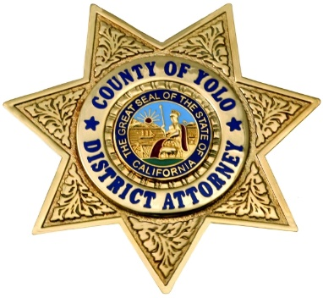

County of Yolo

Office of the District Attorney

Jeff W. Reisig, District Attorney

301 Second Street - Woodland, California 95695 - 530.666.8180 - Fax 530.666.8185

**FOR IMMEDIATE RELEASE**

**Date:** March 14, 2019 **Contact:** YCDA Investigator Paul Hillegass

Paul.Hillegass@yolocounty.org

Bilingual Spanish Representative Available

@ (530) 666-8356

**YOLO COUNTY DISTRICT ATTORNEY’S OFFICE CITES FIVE FOR TOBACCO SALES TO MINORS**

(Woodland, CA) – March 14, 2019- Investigators from the District Attorney’s Office conducted 27 undercover decoy operations in Davis, CA over the weekend and cited five individuals for the illegal sale of tobacco products to minors.

In an effort to combat the issue of tobacco sales to minors, the Yolo County District Attorney works in cooperation with the Yolo County Health Department to provide tobacco enforcement to the areas of Woodland, Davis, Winters, and the unincorporated areas of Yolo County. These efforts are funded entirely by licensing fees collected from businesses which sell tobacco. As part of this program, District Attorney staff have received specialized training about issues of compliance so that they can determine whether businesses with licenses who sell tobacco products are lawfully operating.

Rather than only trying to "catch" a business violating the law by selling tobacco products to underage customers, the District Attorney and Health Department offer a balanced approach focused on compliance. Health Department and DA staff first work to educate businesses about compliance issues, visiting the businesses and even offering a report card of compliance issues where they may need correction or improvement. During these outreach visits the businesses are informed about the goals of compliance and that underage tobacco purchase operations will be conducted as part of the overall illegal tobacco sales cessation effort.

The DA’s office provides consistent enforcement of tobacco control laws by entering into businesses which sell tobacco with an undercover DA investigator and an undercover minor decoy who attempts to purchase tobacco. If the clerk sells to the minor the DA investigator gives the clerk a citation and the business is referred to the Yolo County Health Department for administrative action.

Most of those cited during the underage tobacco purchase operations will be able to choose alternative sentencing options including diversion or participation in Neighborhood Court where Restorative Justice is utilized. The businesses where the clerks were employed face administrative sanctions and fines.

District Attorney Reisig stated, "We have a long-standing partnership with the Health Department to try to enhance the health of our community. These efforts are an important opportunity to educate our youth about healthy choices, but also serve as opportunity to help the business community understand their role and responsibility in the health of our youth."

The Yolo County District Attorney's Office, in collaboration with the Yolo County Department of Health Services and the Yolo County Anti-Tobacco Youth Coalition, form the Tobacco Retail Monitoring Program. The goal of this program is to decrease the illegal sale rate of tobacco to minors in Yolo County.

For more information, please contact Investigator Paul Hillegass via email at [Paul.Hillegass@yolocounty.org](mailto:Paul.Hillegass@yolocounty.org).

###