**About:**

When you join a Zoom meeting hosted by another user, you are considered an attendee. There are a number of ways to join the meeting including:

1. Click on a link provided (you will have to then download and install Zoom when you click the link if you do not already have it on your computer or device)
2. Join directly through the Zoom App
3. Join through a web browser

Instructions follow. Please provide at least 20 minutes to set up your computer/device before the start of a zoom meeting to ensure you are set up correctly.

**Joining a Meeting (information from Zoom)**

**Zoom provides a video too:** https://support.zoom.us/hc/en-us/articles/201362193-Joining-a-meeting

Before joining a Zoom meeting on a computer or mobile device, you can download the Zoom app from [our Download Center](https://zoom.us/download). Otherwise, you will be prompted to download and install Zoom when you click a join link.

You can also [join a test meeting](https://zoom.us/test) to familiarize yourself with Zoom.

## Prerequisites

* Each meeting has a unique 9, 10, or 11-digit number called a [meeting ID](https://support.zoom.us/hc/en-us/articles/201362373-What-is-a-Meeting-ID-) that will be required to join a Zoom meeting
* If you are joining via telephone, you will need the [teleconferencing number](http://zoom.us/zoomconference) provided in the invite.

**To Join a Meeting through the Zoom App**

1. Open the Zoom desktop client.
2. Join a meeting using one of these methods:
   * Click**Join a Meeting** if you want to join without signing in.  
     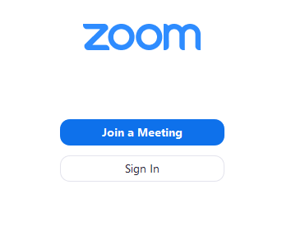
   * Sign in to Zoom then click **Join.**  
     
3. Enter the [meeting ID](https://support.zoom.us/hc/en-us/articles/201362373-What-is-a-Meeting-ID-) number and your display name.
   * If you're signed in, change your name if you don't want your [default name](https://support.zoom.us/hc/en-us/articles/201363203) to appear.
   * If you're not signed in, enter a display name.  
     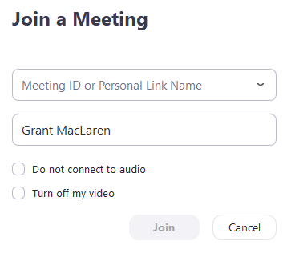
4. Select if you would like to connect audio and/or video and click **Join**.

**To Join a Meeting through a Web Browser**

### Google Chrome

1. Open Chrome.
2. Go to [join.zoom.us](https://join.zoom.us).
3. Enter your [meeting ID](https://support.zoom.us/hc/en-us/articles/201362373-What-is-a-Meeting-ID-) provided by the host/organizer.  
   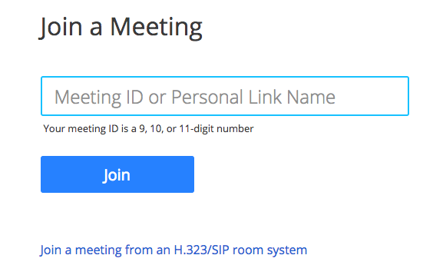
4. Click **Join**.
   * If this is your first time joining from Google Chrome, you will be asked to open the Zoom client to join the meeting.
   * You can check **Always open these types of links in the associated app** to skip this step in the future.
   * Click **Open Zoom Meetings** (PC) or **Open zoom.us**(Mac).  
     

### Safari

1. Open Safari.
2. Go to [join.zoom.us](https://join.zoom.us).
3. Enter your [meeting ID](https://support.zoom.us/hc/en-us/articles/201362373-What-is-a-Meeting-ID-) provided by the host/organizer.  
   
4. Click **Join**.
5. When asked if you want to open zoom.us, click **Allow**.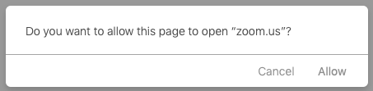

### Microsoft Edge or Internet Explorer

1. Open Edge or Internet Explorer.
2. Go to [join.zoom.us](https://join.zoom.us).
3. Enter your [meeting ID](https://support.zoom.us/hc/en-us/articles/201362373-What-is-a-Meeting-ID-) provided by the host/organizer.  
   
4. Click **Join**.

### Mozilla Firefox

1. Open Firefox.
2. Go to [join.zoom.us](https://join.zoom.us).
3. Enter your [meeting ID](https://support.zoom.us/hc/en-us/articles/201362373-What-is-a-Meeting-ID-) provided by the host/organizer.  
   
4. Click **Join**.
   * If this is your first time joining from Firefox, you may be asked to open Zoom or the Zoom installer package.
   * To skip this step in the future, check **Remember my choice for zoommtg links**.
   * Click **Open Link.**  
     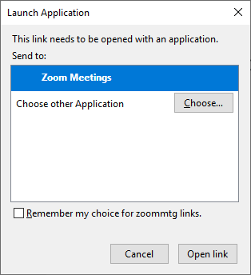

**Hooray, now you are in Zoom**

**If you want to check your audio, check out the how to video on this link:** https://support.zoom.us/hc/en-us/articles/201362283-Testing-computer-or-device-audio

**The Zoom Menu Bar:**

The Zoom menu bar appears at the bottom of the Zoom window once the meeting begins. If you don’t see the menu bar, move your mouse slightly and the bar will appear. (The bar disappears after a few seconds when in full-screen mode.)

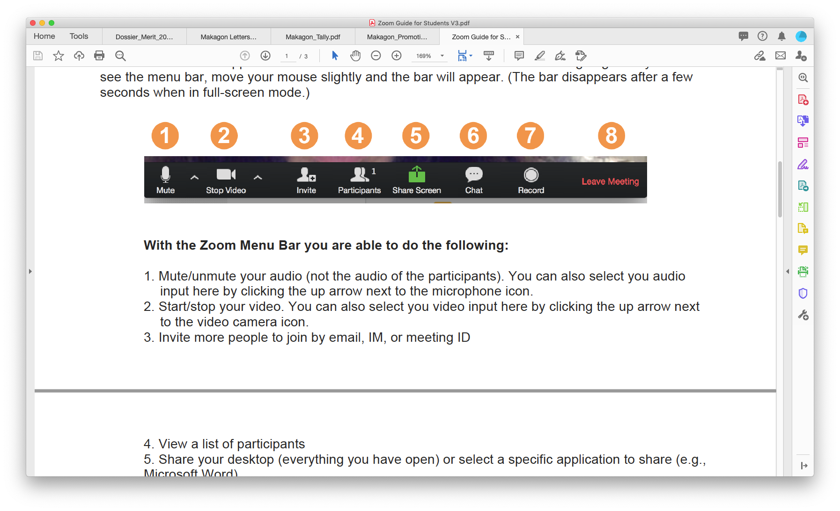

With the Zoom Menu Bar you are able to do the following:

1. Mute/unmute your audio (not the audio of the participants). You can also select you audio

input here by clicking the up arrow next to the microphone icon. **Please stay muted for CSA Meetings and use Chat (described below) for questions.**

2. Start/stop your video. You can also select you video input here by clicking the up arrow next

to the video camera icon. **Having your video on makes it feel more like an in person meeting**.

3. Invite more people to join by email, IM, or meeting ID. (if you have been granted permission)

4. View a list of participants (this is where you will find the “Raise Hand” function too)

5. Share your desktop (everything you have open) or select a specific application to share (e.g.,

Microsoft Word) (if you have been granted permission)

6. Send a message to one person (using private chat) or to all participants (Everyone). **Please use this function for your questions.**

7. Record the meeting (if you have been granted permission)

8. Leave or end the video meeting

**How to Raise Hand on Windows PC and Mac**

If you happen to be attending a Zoom Meeting from your Windows PC or Macbook, follow this guide to learn how to provide nonverbal feedback to the host by raising your hand.

**Step 1:** Launch Zoom and join a meeting as a participant (not a host).

**Step 2:** Click the ‘Participants’ button from the meeting controls at the bottom of the screen. This brings up several options to choose from to provide nonverbal feedback.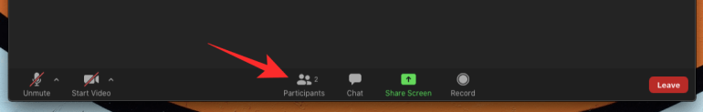

**Step 3:** Select the ‘Raise Hand’ option inside the Participants panel from the right-hand side of the screen.

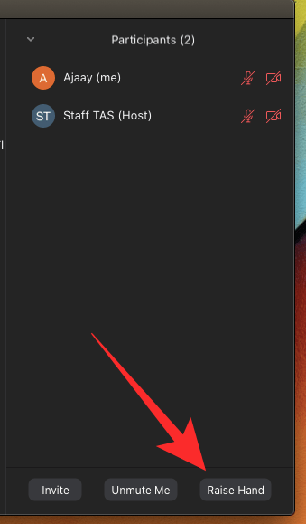

In some versions of Zoom it looks like a **blue hand in the bottom left corner of the participants window**.

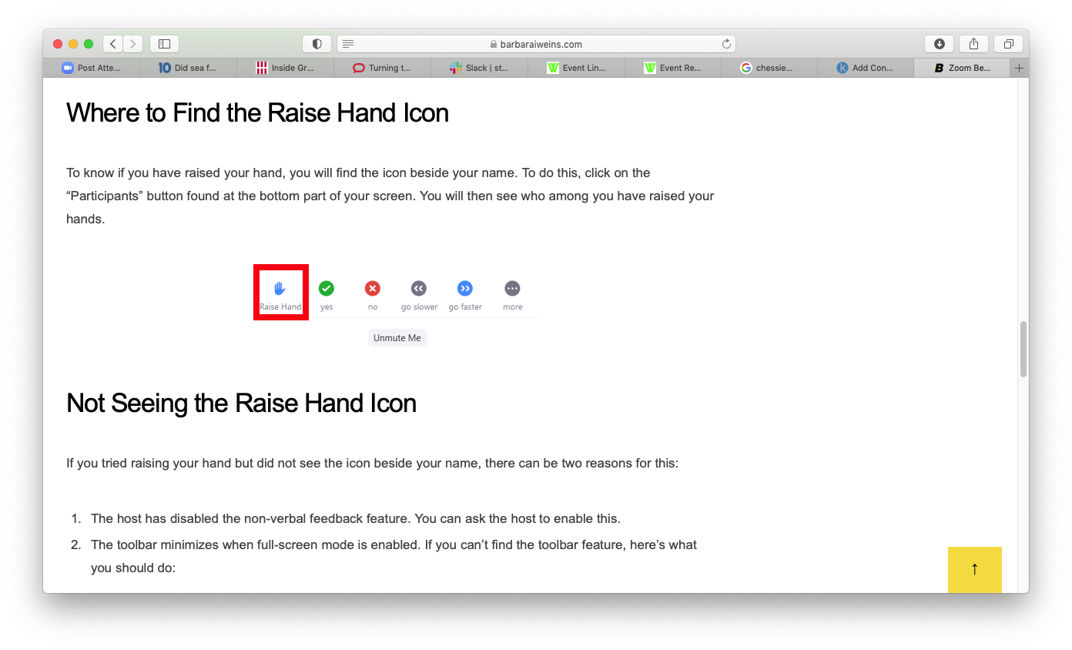

When you are finished asking your question, you can “Lower Hand” the same way it was raised (i.e. where it says Raise Hand, will now say Lower Hand).