County of Yolo
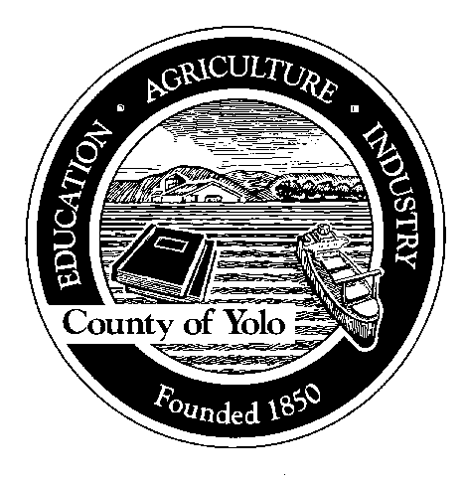

70 COTTONWOOD STREET WOODLAND, CALIFORNIA 95695-2557 (530) 666-8140
FAX (530) 662-6094

Humberto Izquierdo
AGRICULTURAL COMMISSIONER SEALER OF WEIGHTS AND MEASURES

Attention All Landscape Professionals
Please read this notice if, as part of your business, you apply any pesticides (this is any weed killers, including “Roundup”, insecticides, fungicides, rodent bait, etc.). If you are using any pesticides, you are required under Section 11704 of the California Food and Agriculture Code to have a Maintenance Gardener Pest Control Business License. This license is issued by the California Department of Pesticide Regulation (DPR).

To qualify for a Maintenance Gardener Pest Control Business License, you must first obtain a Qualified Applicator’s Certificate (also issued by DPR). This certificate is issued after the applicant passes a test covering laws and regulations, and the landscape maintenance pest control category. Also, each licensed pest control business who works in a given county is required to register with the County Agricultural Commissioner before performing pest control work.

Remember, it is a violation of the law to apply pesticides or perform any type of pest control for hire as a gardener, landscape maintenance business, or interiorscape business without a Maintenance Gardener Pest Control Business License.

If you have employees who apply pesticides, you must comply with all of the pesticide worker safety requirements found in the California Code of Regulations, Section 6700.

Any person who violates these laws and regulations is subject to a civil penalty of up to $5000 per violation.

For further information and assistance, contact the Yolo County Agriculture Commissioner at:

Yolo County Agriculture Department 70 Cottonwood Street
Woodland, California 95695
(530) 666-8140

