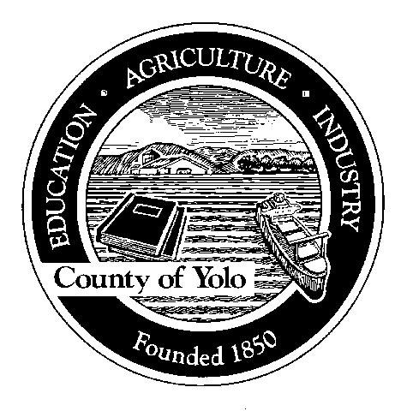

County of Yolo

70 COTTONWOOD STREET WOODLAND, CALIFORNIA 95695-2557 (530) 666-8140

FAX (530) 662-6094

Humberto Izquierdo
AGRICULTURAL COMMISSIONER
SEALER OF WEIGHTS AND MEASURES

I, _________________________, of ____________________________
(Print name of farm operator) (Print name of Permitee/Farm/Business)

designate my employee / PCA, ________________________________ (circle one) (Print authorized representative’s name)

as my authorized representative, as defined in Section 6000 of the California Code of Regulations, to obtain my restricted materials permit.

I further certify that I am the operator of the property to be treated, as defined in Section 6000 of the California Code of Regulations.

__________________________________________________________
FARM OPERATOR (signature) Date

__________________________________________________________
AUTHORIZED REPRESENTATIVE (signature) Date

Authorized representative phone number(s):

Office ________________________
Mobile ________________________
E-mail ________________________

