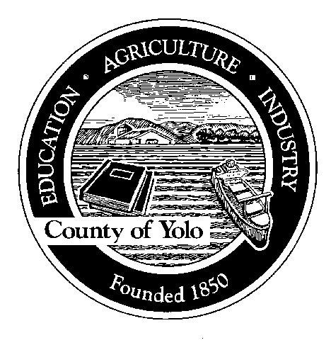County of Yolo

70 COTTONWOOD STREET WOODLAND, CALIFORNIA 95695-2557 (530) 666-8140

FAX (530) 662-6094

Humberto Izquierdo
AGRICULTURAL COMMISSIONER
SEALER OF WEIGHTS AND MEASURES
CERTIFIED WEED FREE FORAGE PROGRAM
APPLICATION FOR CROP CERTIFICATION
Compliance Agreement #:
Name: |  |  | DBA:
Mailing Address: |  |  | Telephone:
City: | Zip: |  | FAX Number:
Field 1 location:
Site number: |  |  | Proposed harvest date:
Crop: |  | Acreage: |  |  | Estimated number of bales:
Crop cutting number
Field 2 location:
Site number: |  |  | Proposed harvest date:
Crop: |  | Acreage: |  |  | Estimated number of bales:
Crop cutting number
Field 3 location:
Site number: |  |  | Proposed harvest date:
Crop: |  | Acreage: |  |  | Estimated number of bales:
Crop cutting number
Field 4 location:
Site number: |  |  | Proposed harvest date:
Crop: |  | Acreage: |  |  | Estimated number of bales:
Crop cutting number
THIS APPLICATION SHALL BE SUBMITTED NO LATER THAN 14 DAYS PRIOR TO HARVEST AND BE ACCOMPANIED BY A DETAILED MAP OF ALL FIELD LOCATIONS TO BE CERTIFIED.
Signature
Printed Name |  |  |  | Date:

