***Avatar Quick Start Guide***

**Quick Reference Links**

* **Sign-in**
* **Self-Service Password Resets**
* **General Information**
* **Views**
* **Additional Options**
* **My Forms**
* **Searching for a form**
* **Client Widget**
* **Searching for a Client**
* **Close Open Clients**
* **Chart View**
* **Exporting Reports**

Return to Quick Reference Link

# **Sign-in**

In your internet browser Yolo County Avatar can be accessed using the link: <https://yolo.netsmartcloud.com/radplus/index.jsp>. Yolo County Avatar can only be accessed through the county network and is separate and distinct from other county Avatar systems.

Avatar will display a sign-in dialogue box (Refer to Figure 1). Using the access information provided by the Avatar Administrator, enter the information provided to you in the appropriate place and click on “Sign In”

**Heads Up!**

**The System Code and Username will always need to be in uppercase. Please be careful no additional spaces are added when entering this information.**

**Figure 1. Sign-in dialogue box**

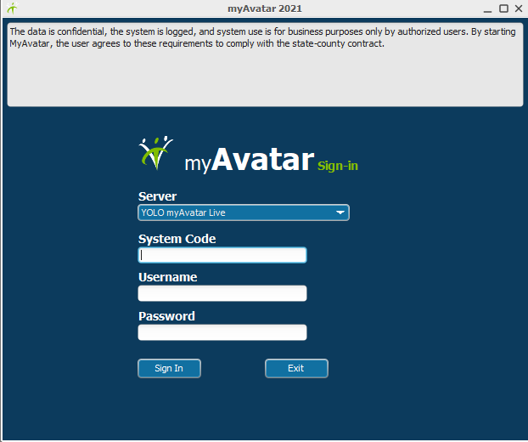

A dialogue box called “myAvatar 2021- System Generated Password” will open (Refer to Figure 2), requesting a new password. Click on OK and another dialogue box will appear called “myAvatar 2021 - New password entry” (Figure 3).

Return to Quick Reference Link

Passwords should meet the following requirements:

* must be between 8-10 characters,
* contain 1 letter,
* contain 1 number,
* contain 1 special character.

**Heads Up!**

**Passwords expire every 90 days and can only be reused after 730 days (2 years).**

**Figure 2. New Password Request**

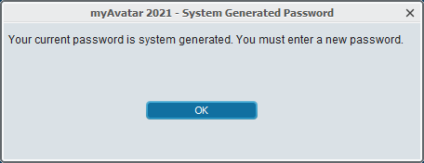

**Figure 3. New Password Entry**

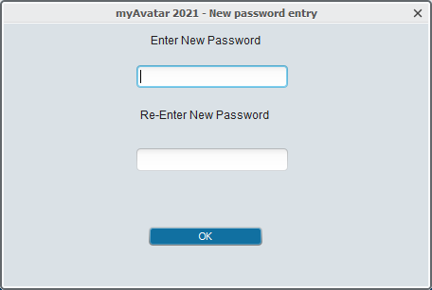

Return to Quick Reference Link

# **Self-Service Password Resets**

There are multiple ways in which a user may reset their password: Contacting the System Administrator, Contacting the Helpdesk at (530) 406-5000, or setting up a User Authentication Question for Self-Service Password Reset.

The recommendation is to create a User Authentication Question for Self-Service Password Reset as this will remove the necessity to wait on another entity to provide access. This form is to create a security question to prompt users if they log in to Avatar with an incorrect password.

Open the form ‘User Failed Authentication Question’ using the “Search Forms” field location in Forms widget on the home screen (Refer to Figure 4). Complete the form with the requested information (Refer to Heads Up!) and click on “Test Email”. Click on “Submit” if a test email was received successfully.

**Figure 4. User Failed Authentication Question**

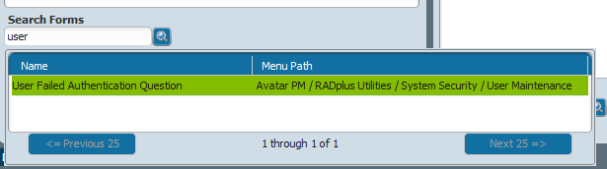

When an incorrect password is used, a dialogue box called “myAvatar 2017 – User Authentication” will open (Refer to Figure 5). The user may choose to not reset the password and attempt to access Avatar by selecting “No”. To reset the password, “Yes” should be selected.

The question that was setup in the “User Failed Authentication Question” form will be required. If the question is answered correctly, the existing password is invalidated, and an email with a temporary system-generated password is emailed. When the user logs in with the temporary password, they will be allowed to enter a new password of your choosing.

**Figure 5. User Authentication**

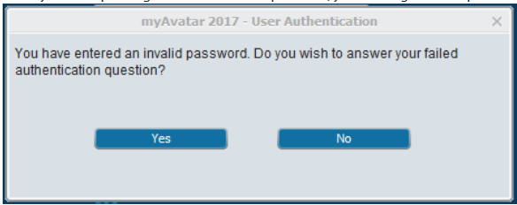

Return to Quick Reference Link

**Heads Up!**

**In the System Code field, precede the system code you use (e.g., MH, BHS, TCC) with LIVE. For example: LIVEMH, LIVEBHS, LIVETCC etc. (Refer to Figure 5)**

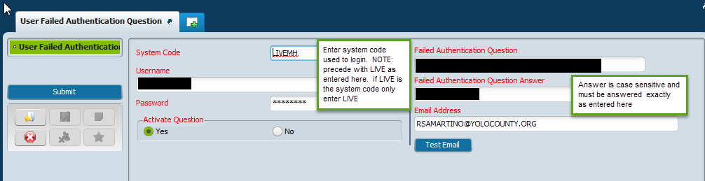

# **General Information**

Below is a brief description of some of the features seen in Avatar:

* **REQUIRED FIELDS** will be in red. If information is missing, and it is a required field, you will not be able to submit the information.
* **RADIO BUTTONS** will only allow you to select one entry. To erase your entry hit F5.
* **DATE FIELD**: you can press T for today or Y for yesterday
* **GRAYED OUT SECTIONS** cannot be changed
* **TIME FIELD**: you can press the current button to get the current time
* **LIGHT BULBS** contain helpful hints that will help you better understand the question or the type of

information that is required.

* **DROP DOWN MENUS** will only allow you to choose one item
* **SEARCH BAR** or Smart Search; will allow you to enter alpha numeric or Text when searching for a client or staff member.
* **PROCESS SEARCH**: once you enter information in a search bar, press this button to process your Search
* **TEXT EDITOR**: Double click on this icon to open the text editor which will allow you to check for spelling
* **TEXT BOX**: this field allows you to enter up to eight (8) pages of information. You may also copy from Microsoft office Word and paste on to this Text box.
* **MESSAGE CENTER**: Displays messages issued by Administrator.

Return to Quick Reference Link

# **Views**

Each user will have access to a minimum of one view based upon the requested user role. Views can be toggled back and forth by clicking on the views available. The “Home” view can be found at the top left corner and will take the user back to their primary view (Refer to Figure 6).

**Figure 6. Views**

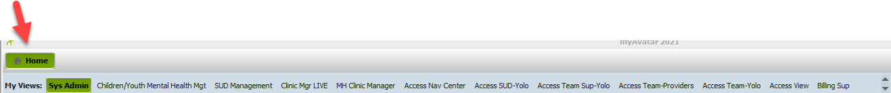

# **Additional Options**

Other quick options for users include preferences, lock (locking avatar when stepping away), sign out (signing out of Avatar), switch (switching to a different system code) and help (Refer to Figure 7).

Additional setup options are available in “Preferences” (Refer to Figure 8), located in the top right-hand corner. Each user will have access to a minimum of one view based upon the requested user role. Available options include: Spell checking, Printer default selections, themes, Adding/Deleting Calendars, Chart Displays, General (i.e., my forms duplication control and setting up to be able to sign using mouse or touch for signatures).

**Figure 7. Additional Options**



**Figure 8. Preference Options**

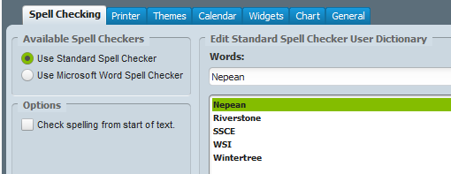

Return to Quick Reference Link

# **My Forms**

Forms can be accessed from the Home View using the Forms & Data Widget. There may already be available forms assigned based upon the user role. To manage the “My Forms” click on “Edit” located in the right-hand corner of the Forms & Data Widget (Refer to Figure 9). In the entry box, type in the name of the form to be added (Refer to Figure 10 -2), double click on the form to be added (Refer to Figure 10-3) and select “Add Form” (Refer to Figure 10 -4). Once all forms have been added click on “Save”.

**Heads Up!**

**To add a folder structure, right-click and select “Add Folder”, then drag and drop forms into the folder structure as needed.**

**Figure 10. Forms & Data**

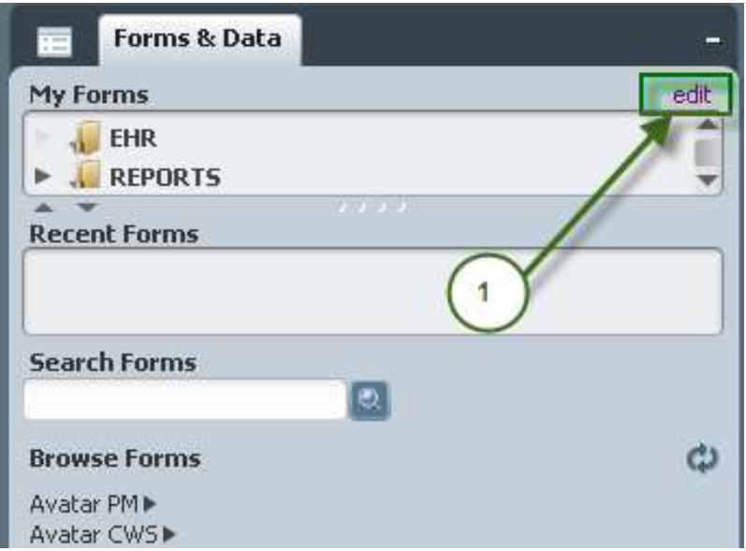

**Figure 10. Forms & Data**



Return to Quick Reference Link

**Figure 10. Forms & Data**



# **Searching for a form**

Under the “Search Forms” field (Refer to Figure 11), type in the name of the form or a key phrase. For key phrase’s, the system uses a smart search and will return all forms available to your user role with the phrase entered.

**Figure 11. Searching for a form under Search Forms**

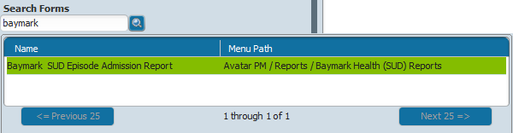

Select the form you wish to open by double-clicking on the form name. Alternatively, forms can be navigated to under “Browse Forms” (Refer to Figure 12). The user will need to follow the menu paths to navigate to the where the form is located.

**Figure 12. Searching for a form under Browse Forms**



Return to Quick Reference Link

# **Client Widget**

The Client/Staff Widget provides the ability to display a list of current clients and staff (Refer to Figure 13). The **CLIENT WIDGET** will display a list of all clients assigned to the Practitioner’s Caseload in the “My Clients” section of the Widget. This assignment is done through the admitting or attending practitioner field on the Admission screen.

**RECENT CLIENTS**: is a list of clients that have been accessed during the active session. This list will be blank upon next login.

**Figure 13. Client/Staff Widget**



# **Searching for a Client**

Under the “Search Clients” field (Refer to Figure 13), type in the name of the client or the Medical Record Number (MR#). The system uses a smart search and will return all clients with the entered name, including any alias names. Double-click on the client name to select the client.

An advanced search can be completed by selecting “advanced” (Refer to Figure 14). Enter the Last Name, First Name (First letter can be entered), and Sex at minimum and click on Search. A list of all clients that meet the parameters entered will be displayed.

Note: The smart search can search a client using the client name, client alias name, MR#, social security number and date of birth.

Return to Quick Reference Link

**Figure 13. Client/Staff Widget**

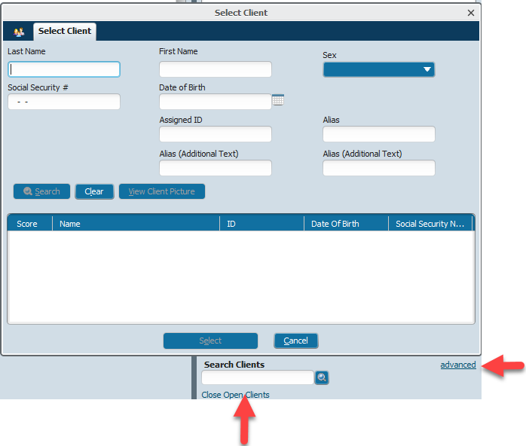

# **Close Open Clients**

Each time a client chart is opened (opened by double clicking on the client name in “My Clients”/ “Recent Clients” or “Search Clients”) a tab will open at the top of the screen (Refer to Figure 14). To close all charts at one time selected “Close Open Clients” (Refer to Figure 13).

**Figure 14. Open Client Charts**



**Heads Up!**

**When client names appear, the number contained in brackets is the medical record number associated with the client. E.G. TESTCLIENT,YOLO (000011136).**

Return to Quick Reference Link

# **Chart View**

The CHART is an interactive screen the displays a client’s medical record. **OVERVIEW** - displays the Chart main view (Refer to Figure 15). There will be some default form links setup based on user roles located on the left side of the overview – click the form link to open the form in the chart. To add additional form link, select the  icon located next to overview (Refer to Figure 15). This will open the customizing forms feature. Select the  icon to add links for forms wanted (Refer to Figure 16). Select “Save” upon completion.

**Figure 15. Overview of Client Chart**

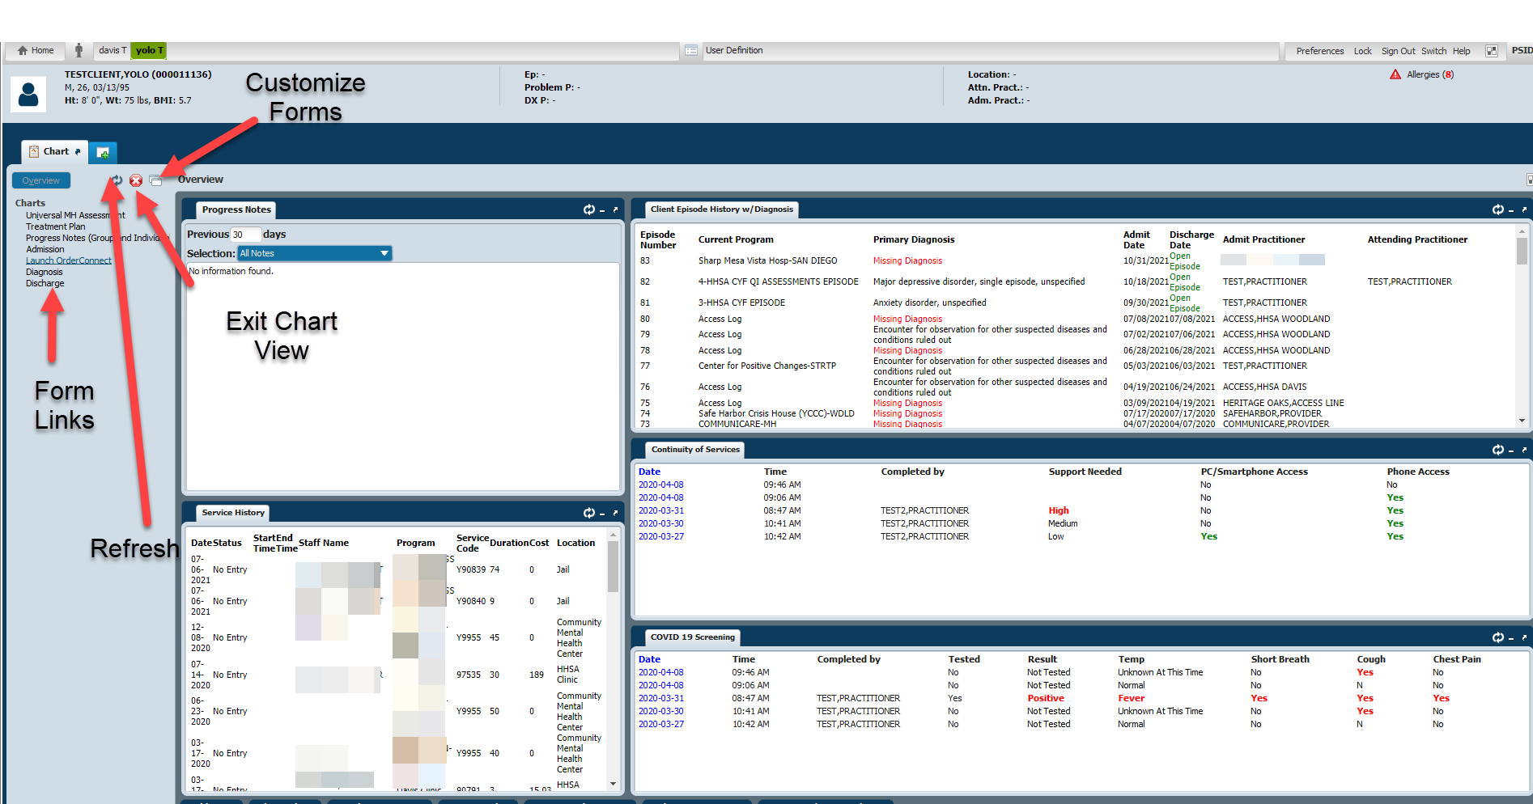

**Figure 16. Customizing the Chart View**

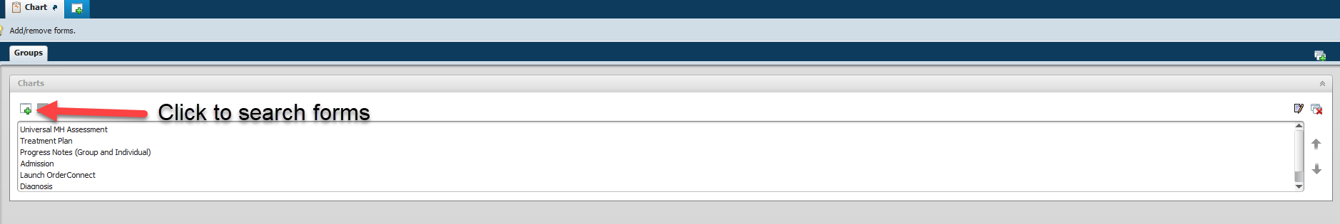

To open a new form while in the Chart view select the search icon (Refer to Figure 16) and the various ways that a form can be searched in the Home view will be available.

Return to Quick Reference Link

**Figure 16. Opening a new form in Chart view**



# **Exporting Reports**

To export data from reports into your chosen format, select the  icon, found in the upper left-hand corner of the report.

A dialogue box will open asking for the format to export to (Refer to Figure 17). Select the format required. For Excel exports, it is recommended that Microsoft Excel 97-2000-Data only (XLS) is selected if data needs to be mined or extracted.

Return to Quick Reference Link

**Figure 17. Dialogue box with format options**

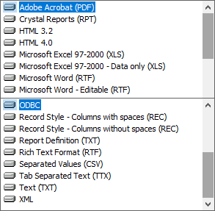

Next select the Destination (Refer to Figure 18). Generally, the most common destination options are “Application” and “Disk File”. To open the report, select “Application”. To save the report, select “Disk File”

**Figure 18. Dialogue box with destination options**

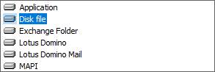

Next, select “Custom” on the Excel Format Options pop up then click the “Options >>>” button.

Next, change the dropdown under “Column width based on objects in the:” to “Report Header,” place a check mark in “Maintain column alignment,” and click the “OK” button.

