***Medication Management***

The purpose of this desk reference is to provide guidance in how to complete the Medication Management Yolo form.

**Menu Path**

Avatar CWS > Other Chart Entry or you can enter “Medication Management Yolo” under Search Forms

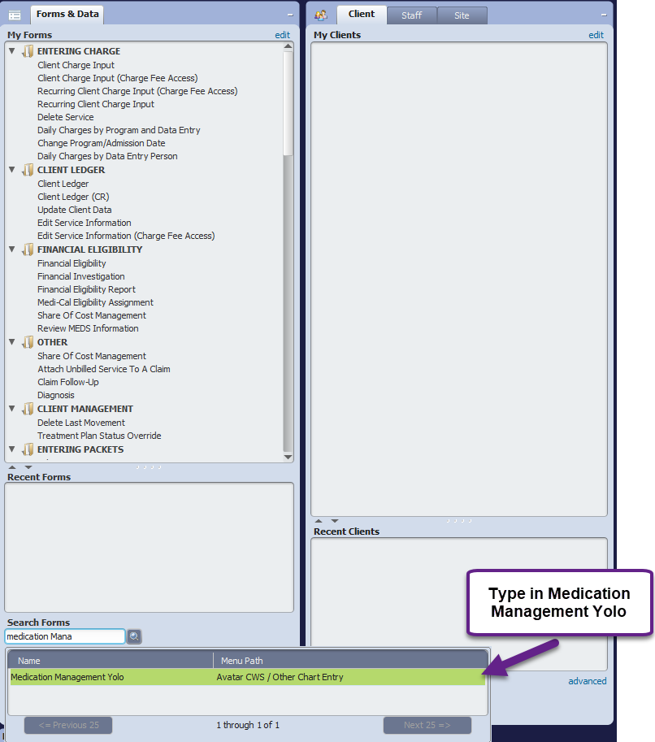

**Details**

* The Medication Management Yolo form is a Yolo designed form that tracks medications prescribed to clients per state requirements.
* This form is driven by the “Date of Service”. A new entry should be completed for each date of service provided.
* It is recommended that vitals be checked and recorded in your own EHR prior to Medication appointments for state reporting needs.
* All fields highlighted “Red” are required; the form cannot be submitted until completed.

## Steps

* Open the Medication Management Yolo form
* Select the client

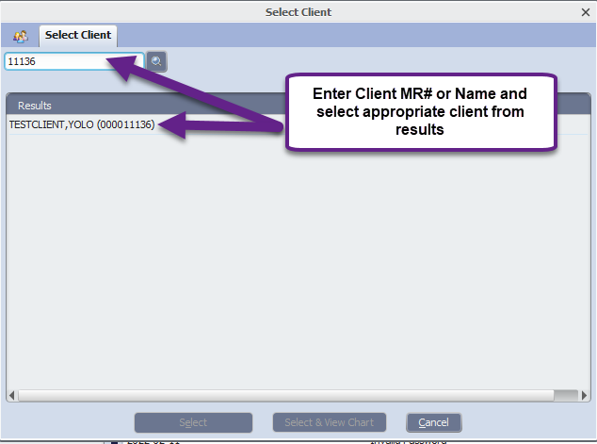

* Select the episode

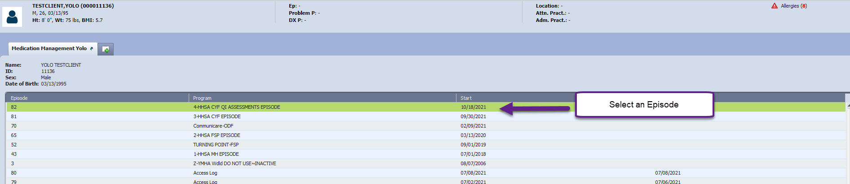

* Select from the options, Add, Edit, Delete or Cancel. To Edit or Delete a line item, click on the line item and then select the appropriate selection.

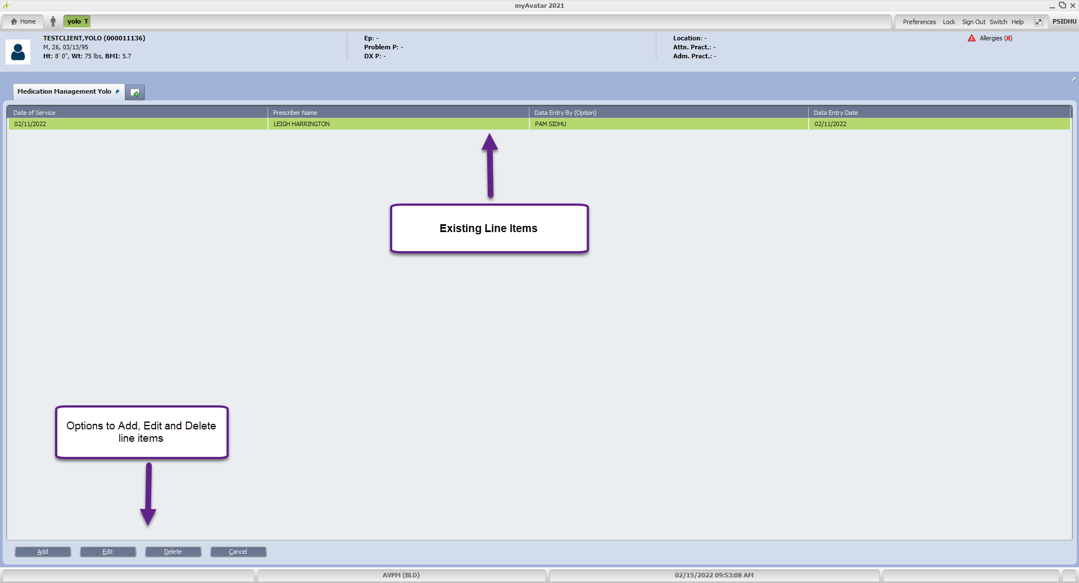

* In the “Date of Service” field, enter the Date of Service for when medication was prescribed.

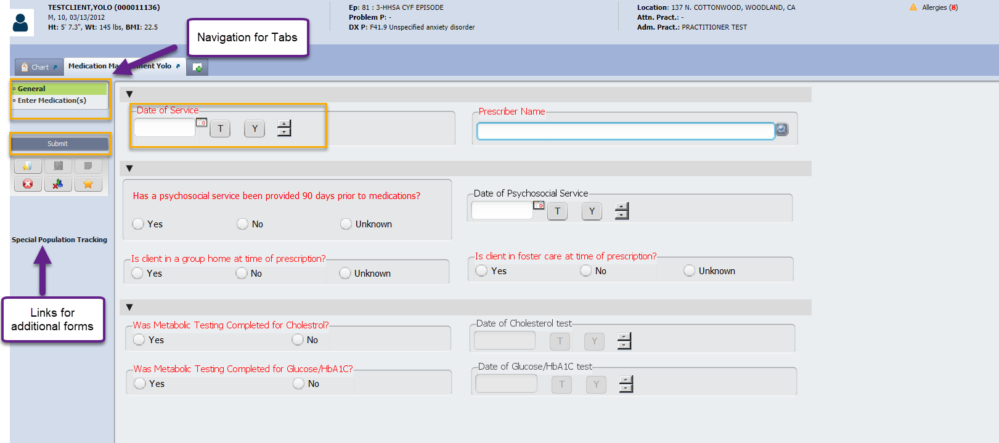

* In the “Prescriber Name” field, enter the name of the Prescriber (Last Name, First Name). This field is linked to Practitioner Enrollment. If a prescriber is not enrolled within Yolo’s Avatar system, select the name of this individual entering the form.

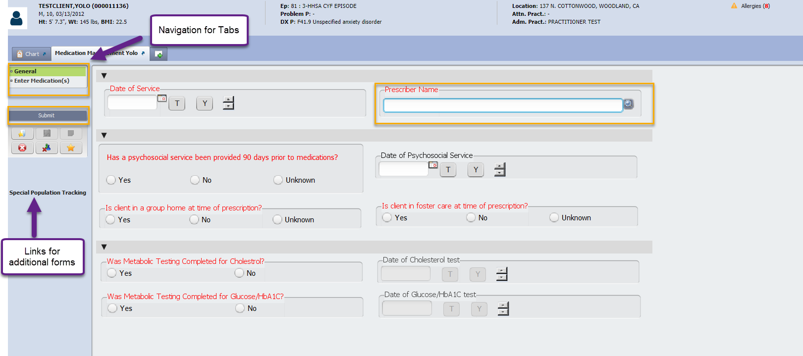

* In the “Has a psychosocial service been provided 90 days prior to medications?”, select Yes, No or Unknown. If “Yes” is selected, then the “Date of Psychosocial Service” field becomes a required field.
* In the “Date of Psychosocial Service” field, enter the date of when the client received their last Psychosocial service.

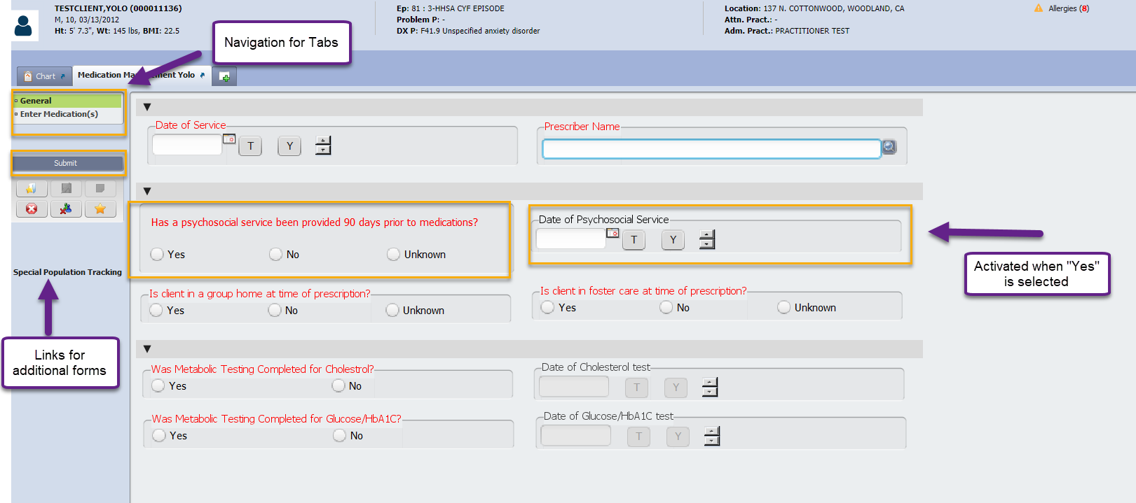

* In the “Is client in a group home at time of prescription” field, select Yes, No or Unknown.
* In the “Is client in foster care at time of prescription” field, select Yes, No or Unknown.

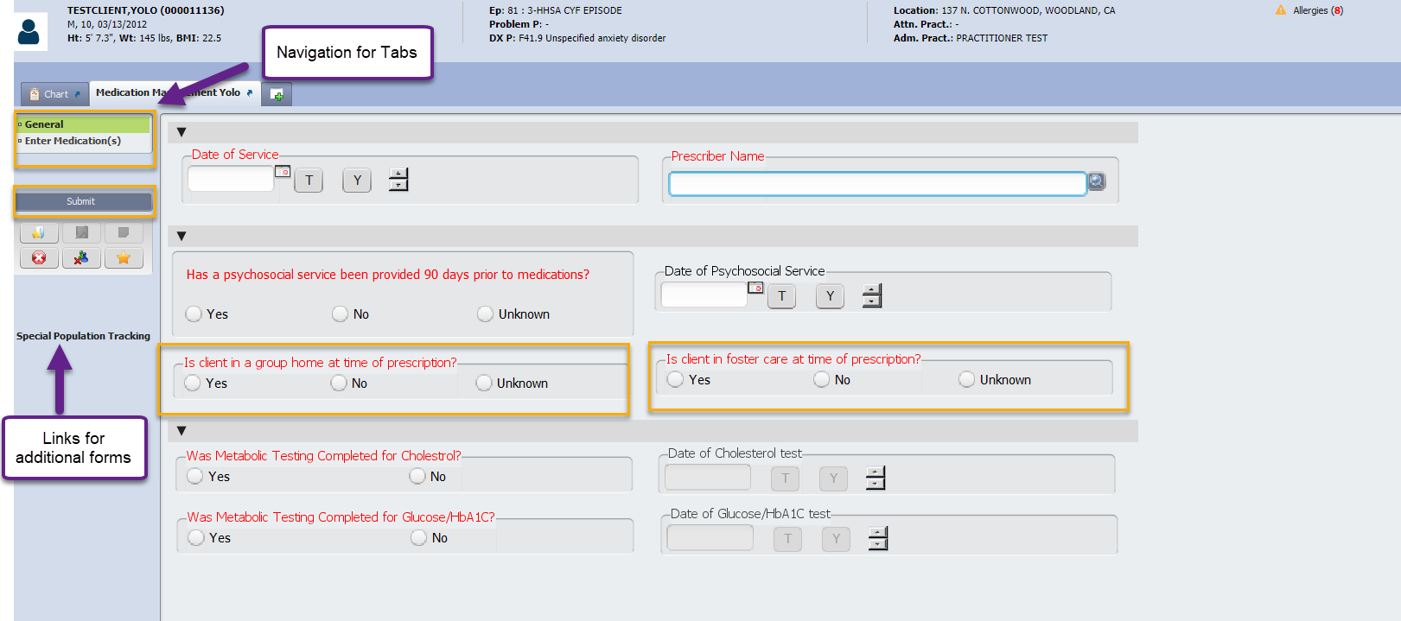

* In the “Was Metabolic Testing Completed for Cholesterol?” field, select Yes or No. Selecting “Yes” will enable “Date of Cholesterol test” field.

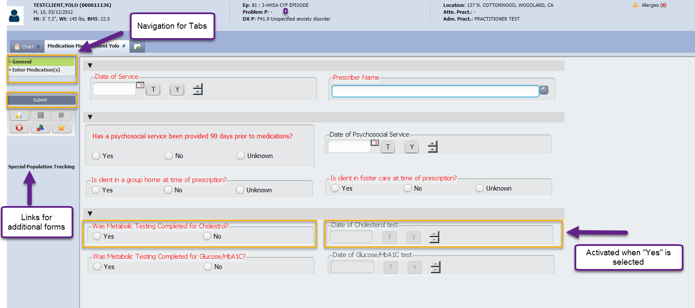

* In the “Was Metabolic Testing Completed for Glucose/HbA1C?” field, select Yes or No. Selecting “Yes” will enable “Date of Glucose/HbA1C” field.

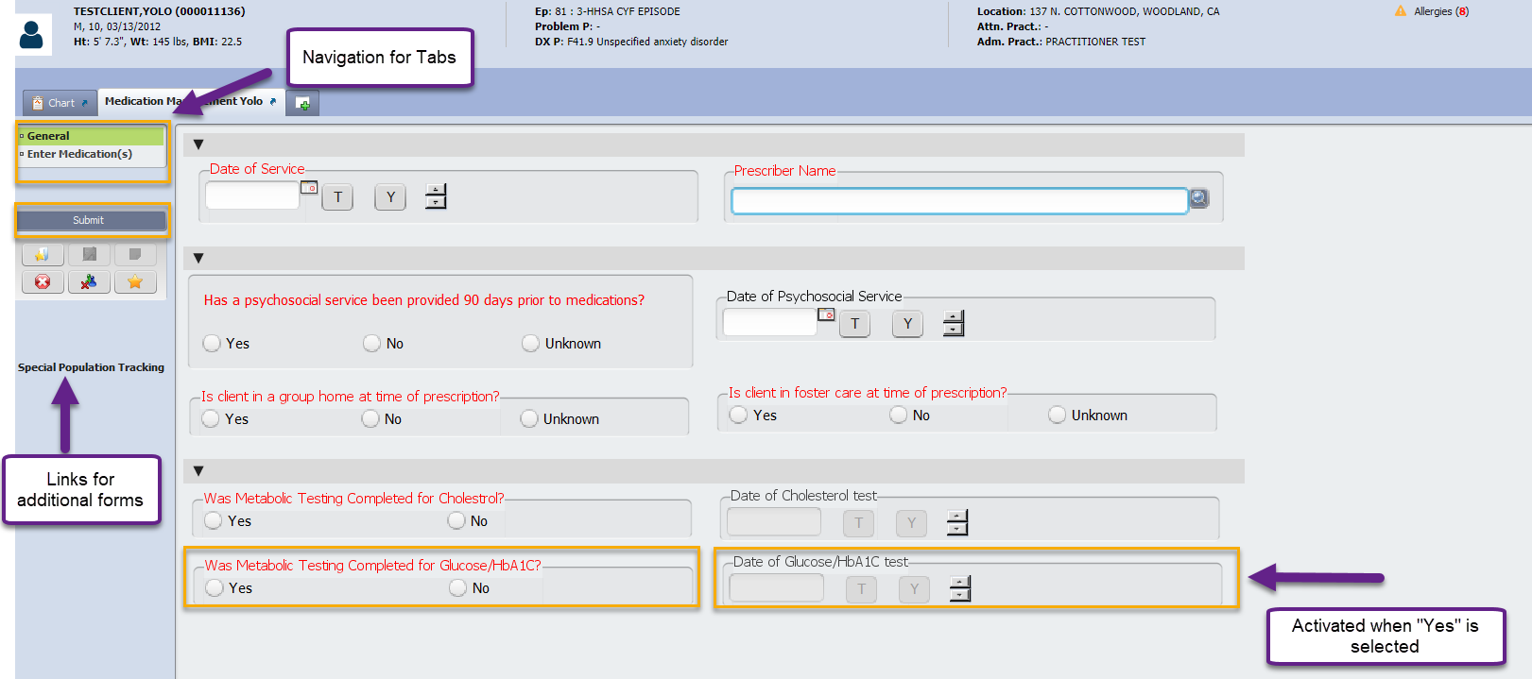

* Select the “Enter Medications” tab, from the Navigation menu.
* Select “Add New Item”, “Edit Selected Item” or “Delete Selected Item”. To Edit or Delete, the line item will need to be selected first.

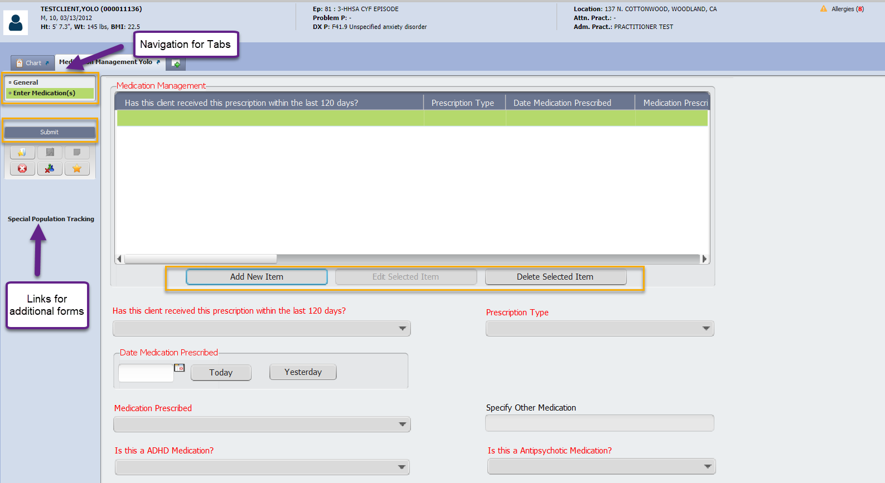

* In the “Has this client received this prescription within the last 120 days?” field, select Yes or No. “Prescription Type” field auto populates with “New” or “Continuing” based on the selection.

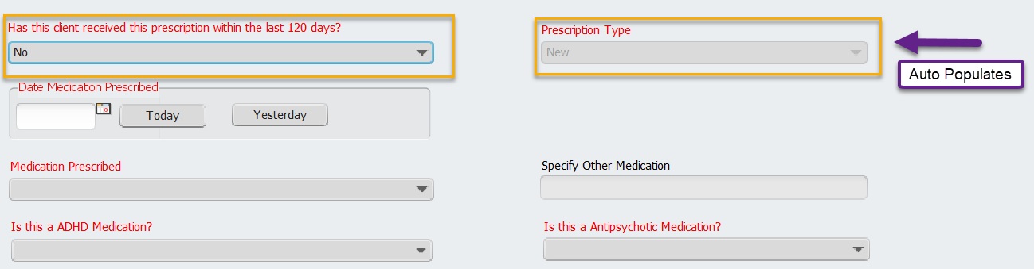

* In the “Date Medication Prescribed” field, enter the date the medication was prescribed.

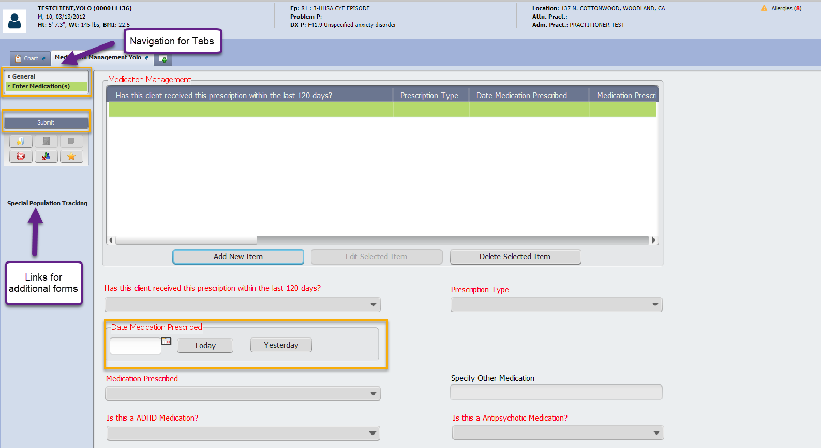

* In the “Medication Prescribed” field, select the medication. 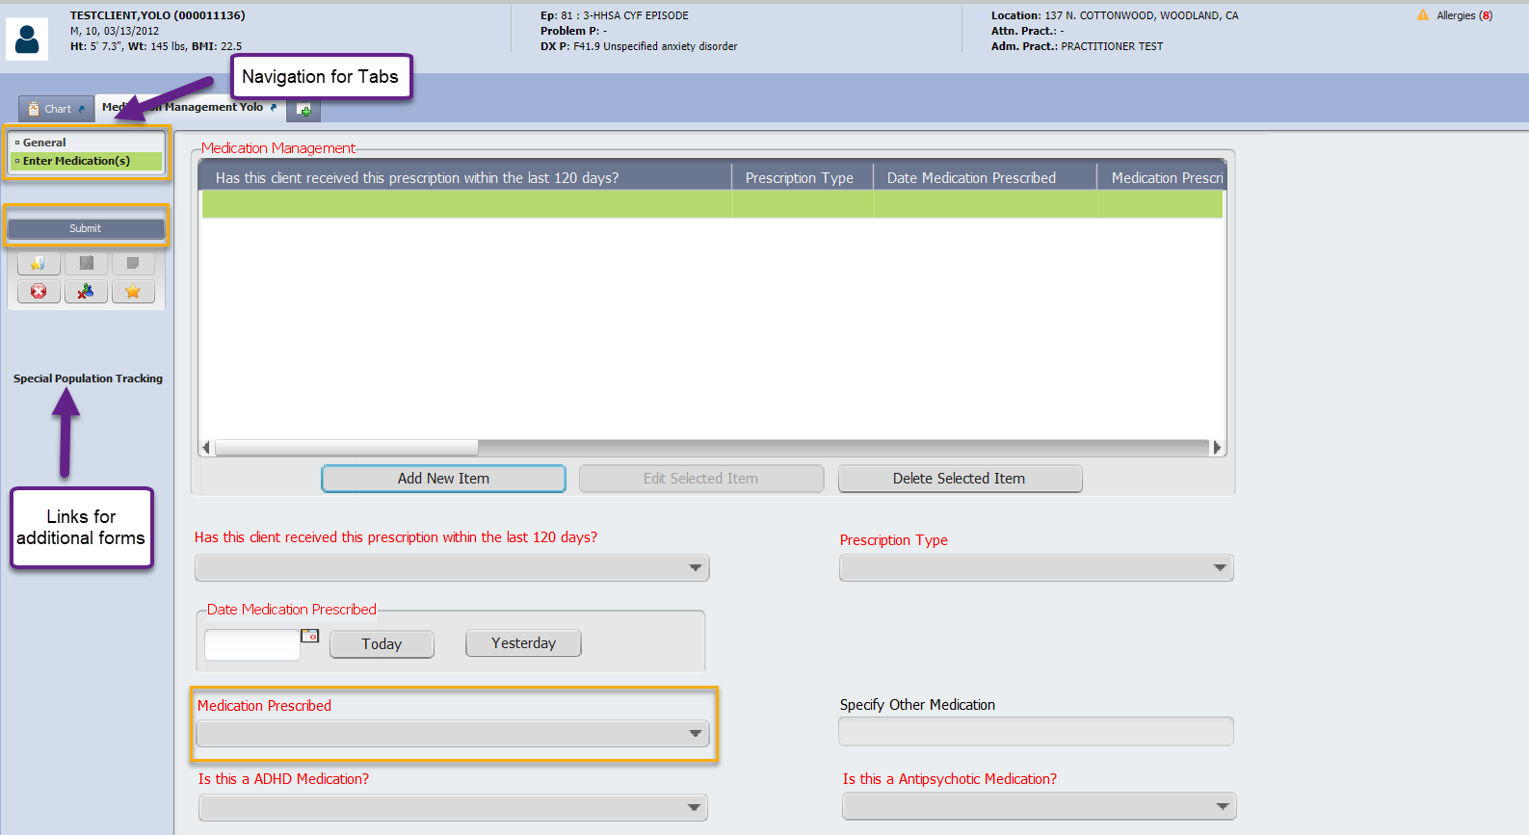
* If the medication is not listed, then select “Other”, this will activate the field “Specify Other Medication”. Enter the name of the medication in the “Specify Other Medication” field.

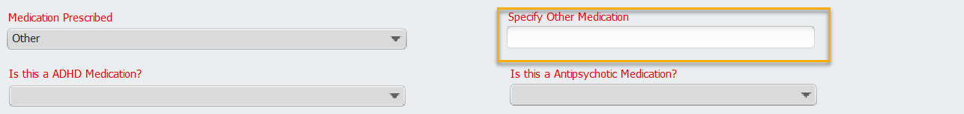

* In the “Is this a ADHD Medication” field, select “Yes” or “No”

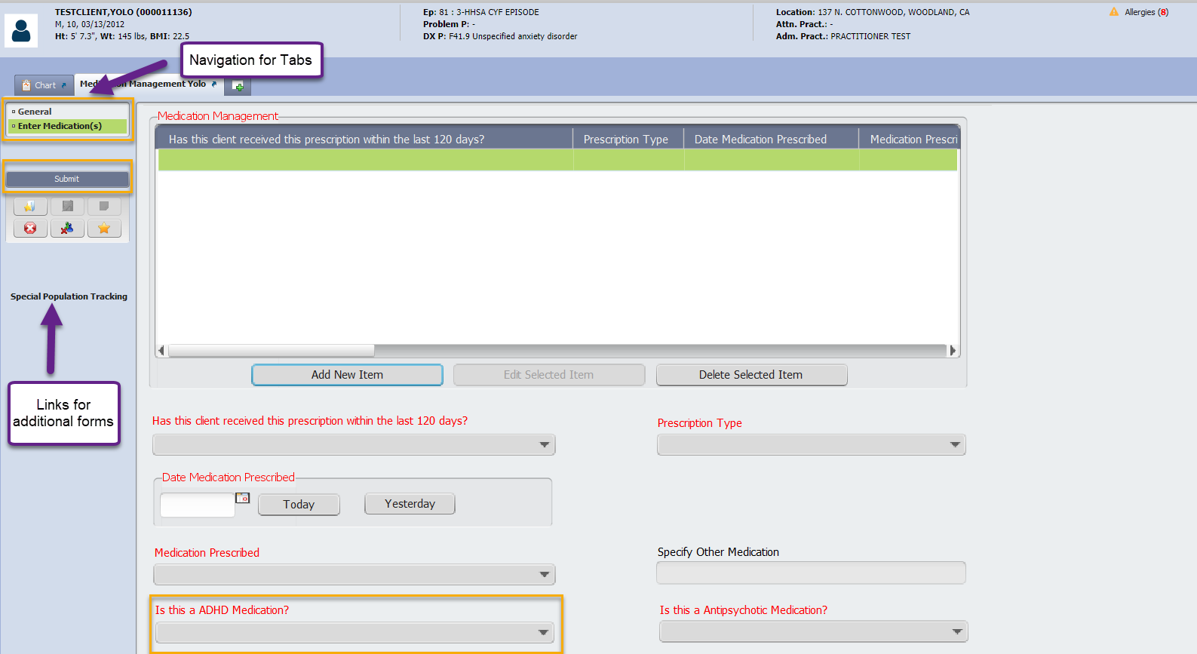

* In the “Is this a Antipsychotic Mediation?” field, select “Yes” or “No”

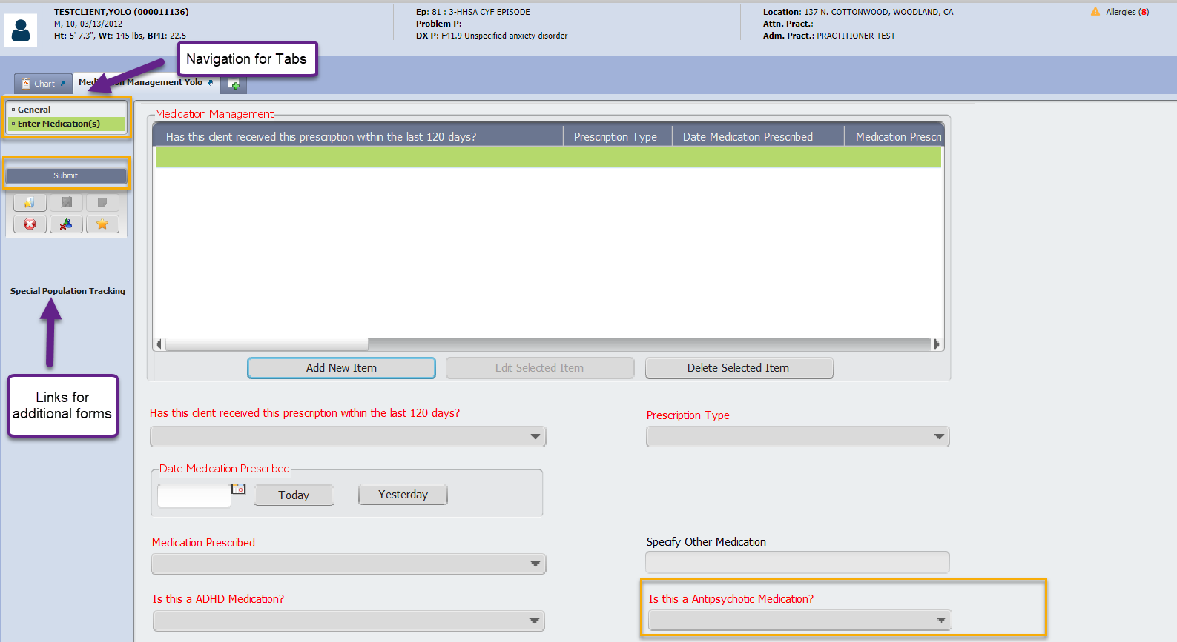

* In the “Medication Dose” field, enter the dosage

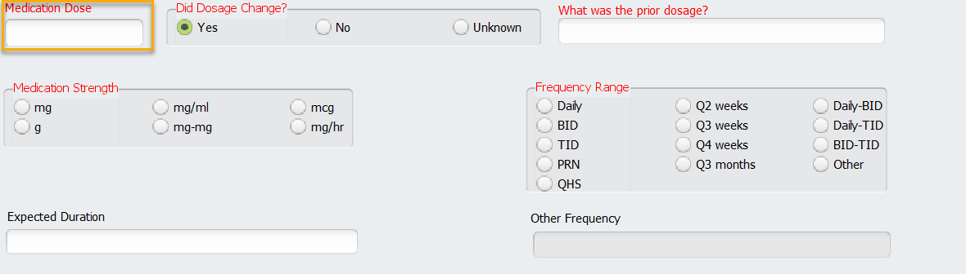

* In the “Did Dosage Change?” field, select Yes, No or Unknown. If Yes is selected, the “What was the prior dosage?” field will become required. In the “What was the prior dosage?”, enter dosage and strength information.

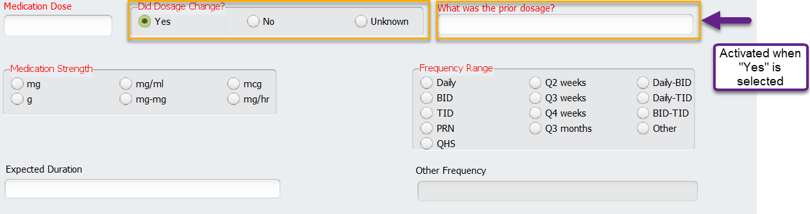

* In the “Medication Strength” field, select the strength of the medication prescribed

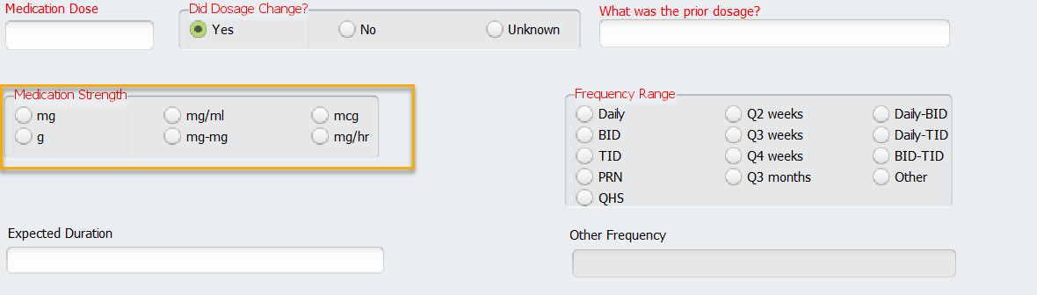

* In the “Frequency Range” field, select the frequency of how often medication should be taken. If “Other” is selected, the “Other Frequency” field will become required.

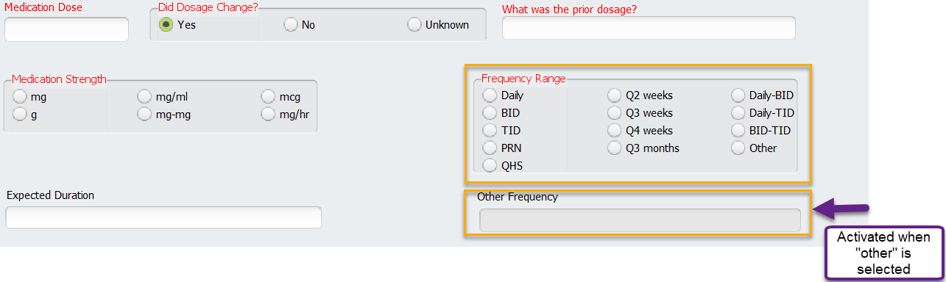

* In the “Expected Duration” field, enter how long you expect the medication will be required by the client.

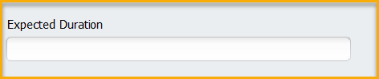

* In the “Name of Prescriber (if different from current prescriber)” field, enter the name of the prescriber if is different from the entry in the “Prescriber Name” field, found in the General tab. Name’s should be entered in the format Last Name, First Name. If a name is listed in this field, the fields “Prescriber Organization Name” and “Prescriber Contact Number” field will become required.

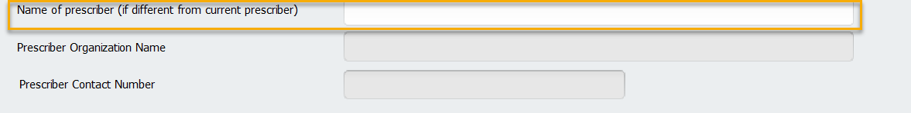

* In the “Prescriber Organization Name” field, enter the company name for where the prescriber is employed.

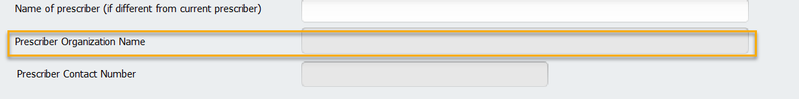

* In the “Prescriber Contact Number” field, enter the prescribers contact phone number.

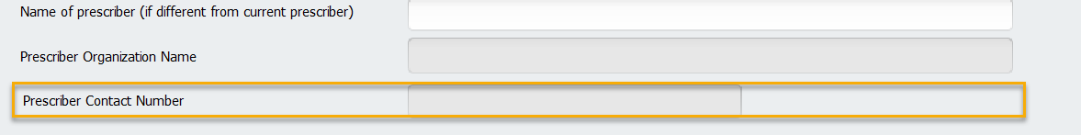

* Upon completion of the form, click on Submit.

