# AGENCY PROFILE

The El Macero County Service Area #1 (CSA) was established on February 16, 1969 to provide extended services to the El Macero unincorporated community. The CSA was formed as a replacement to the El Macero Sewer Maintenance District that provided wastewater services and the El Macero Unit #1 Maintenance District that provided water services. The nature of services offered has evolved over time. At formation, the CSA was authorized to provide water, wastewater, and storm drainage services that it had assumed from the former maintenance districts. In 1971, the Board of Supervisors (BOS) authorized street sweeping and street lighting services. In 1994, the BOS approved the addition of street improvements/maintenance and street right of way landscaping work.

El Macero CSA is located just southeast of the City of Davis, and immediately abuts the City’s boundaries. The CSA is bounded to the north by the back property lines of residential properties lying north of North El Macero Drive, Sandy Circle, and Caddy Court, along the City of Davis city limits. To the east the CSA abuts the back property lines of residential properties lying east of Caddy Court East El Macero Drive, and Eagle View Court, and to the south the CSA is bounded by the back property lines of residential and County-owned properties lying south of Eagle View Court and South El Macero Drive. To the west, the CSA’s bounds are the centerline of Mace Boulevard and the City of Davis city limits. The CSA’s sphere of influence (SOI) is coterminous with its boundaries.

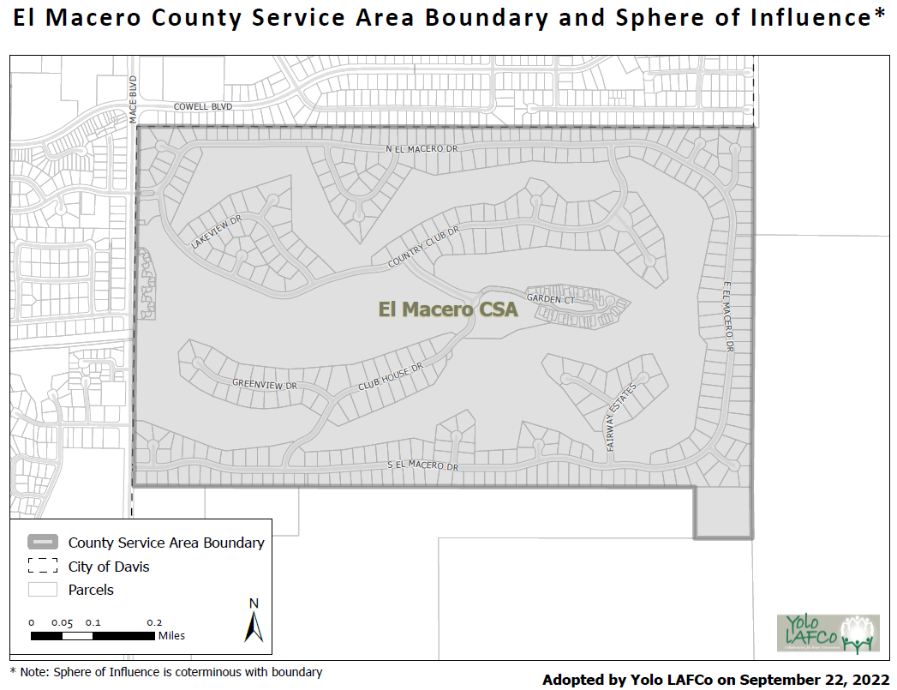

The CSA includes 410 parcels zoned for single family homes, 53 parcels zoned for multi-family residences along with their associated common areas, the El Macero Country Club and three County-owned parcels. In 2015, the County approved a 16-unit townhome development on previous El Macero Country Club corporation yard area that do not receive services through the CSA even though the land is included in the CSA boundary. In 2020, LAFCo approved an extension of water and sewer services to 27384 Eagle View Court (APN 033-011-024) due to health and safety reasons. On September 22, 2022 LAFCo approved a CSA SOI amendment and annexation of this parcel into the CSA.

El Macero CSA is governed by the BOS and is treated as a special district under the LAFCo Law. The BOS is advised as to the maintenance and operation of the CSA by a five-member advisory committee comprised of local El Macero residents who are appointed to the committee by the BOS. The advisory committee meets on a regular basis to discuss the ongoing issues pertinent to the El Macero CSA. As directed by California Government Code Section 25212.4, the advisory committee’s role is to provide advice to the BOS regarding the services and facilities of the CSA, but it is not within the authority of the advisory committee to make decisions, manage, or direct the delivery of services and facilities.

The CSA is currently staffed and managed by the County’s Department of Community Services. The CSA is billed for the staff time of the CSA administrative support team, the County finance staff, and County legal counsel, when such services are utilized.

# MUNICIPAL SERVICE REVIEW

## Potentially Significant MSR Determinations

The MSR determinations checked below are potentially significant, as indicated by answers to the key policy questions in the checklist and corresponding discussion on the following pages. If most or all of the determinations are not significant, as indicated by “no” answers, the Commission may find that a MSR update is not warranted.

|  |  |  |  |
| --- | --- | --- | --- |
|  | Growth and Population |  | Shared Services |
|  | Disadvantaged Unincorporated Communities |  | Accountability, Structure, and Efficiencies |
|  | Capacity, Adequacy & Infrastructure to Provide Services |  | Broadband Access |
|  | Financial Ability |  | Status of Previous MSR Recommendations |

## LAFCo Municipal Service Review:

On the basis of this initial evaluation, the required determinations are not significant, and staff recommends that an MSR is NOT NECESSARY. The subject agency will be reviewed again in five years per Government Code Section 56425(g).

The subject agency has potentially significant determinations and staff recommends that a comprehensive MSR IS NECESSARY and has been conducted via this checklist.

|  |  |  |  |
| --- | --- | --- | --- |
| 1. Growth and Population Growth and population projections for the affected area. | **Significant Issue** | **Potentially Significant** | **No Issue** |
| 1. *Will development and/or population projections over the next 5-10 years impact the subject agency’s service needs and demands?* |  |  |  |
| 1. *Do changes in demand suggest a change in the agency’s services?* |  |  |  |

**Discussion:**

None.

**Growth and Population MSR Determination:**

The El Macero CSA is considered built out and significant population change that would impact the agency’s service needs and demands is not anticipated.

**Recommendation(s):**

None.

|  |  |  |  |
| --- | --- | --- | --- |
| 2. Disadvantaged Unincorporated Communities The location and characteristics of any disadvantaged unincorporated communities within or contiguous to the sphere of influence. | | | |
|  | **Significant Issue** | **Potentially Significant** | **No Issue** |
| 1. *If the subject agency provides services related to sewers, municipal and industrial water, or structural fire protection, are there any “inhabited unincorporated communities” (per adopted Commission policy) within or adjacent to the subject agency’s sphere of influence that are considered “disadvantaged” (80% or less of the statewide median household income) that do not already have access to public water, sewer, and structural fire protection?* |  |  |  |
| 1. *If “yes” to a), it is feasible for the agency to be reorganized such that it can extend service to the disadvantaged unincorporated community? If “no” to a), this question is marked “no” because it is either not needed or not applicable.* |  |  |  |

**Discussion:**

None.

**Disadvantaged Unincorporated Communities MSR Determination:**

There are no disadvantaged unincorporated communities within or contiguous to the El Macero CSA[1].

**Recommendation(s):**

None.

|  |  |  |  |
| --- | --- | --- | --- |
| 3. Capacity and Adequacy of Public Facilities and Services Present and planned capacity of public facilities, adequacy of public services, and infrastructure needs or deficiencies including needs or deficiencies related to sewers, municipal and industrial water, and structural fire protection in any disadvantaged, unincorporated communities within or contiguous to the sphere of influence. | | | |
|  | **Significant Issue** | **Potentially Significant** | **No Issue** |
| 1. *Are there any deficiencies in the* ***infrastructure, equipment, and capacity of agency facilities*** *to meet existing service needs for which the agency does not have a plan in place to resolve (including deficiencies created by new state regulations)?* |  |  |  |
| 1. *Are there any issues regarding the agency’s capacity and ability to meet the service demand of reasonably foreseeable future needs?* |  |  |  |
| 1. *Are there any service needs or deficiencies for disadvantaged unincorporated communities related to sewers, municipal and industrial water, and structural fire protection within or contiguous to the agency’s sphere of influence?* |  |  |  |
| 1. *Is the agency needing to consider climate adaptation in its assessment of infrastructure/service needs?* |  |  |  |

**Discussion:**

El Macero CSA was formed in 1969 as a replacement to the El Macero Sewer Maintenance District and the El Macero Unit #1 Maintenance District that provided water services. Storm drainage services provided by the City of Davis was included in the CSA formation. In 1971, the BOS authorized street sweeping and street lighting services. In 1994, the BOS approved the addition of street improvements/maintenance and landscaping work. The following services (and corresponding funds) are provided by the CSA. The CSA advisory committee has subcommittees that focus on issues related to service areas.

|  |  |
| --- | --- |
| **Existing CSA Services Authorized/Provided** | **Service Provider** |
| Municipal Water | City of Davis |
| Sewer/Wastewater | City of Davis |
| Streets: paving, maintenance, sweeping, and landscaping/lighting | Yolo County |
| Drainage (outflow from the EMCSA) | City of Davis |

Water

El Macero CSA provides water to its residents through a contract with the City of Davis for operations and maintenance of the CSA-owned system. The County, on behalf of El Macero CSA (formerly the El Macero Unit No. 1 Maintenance District), initially entered into an agreement with the City for maintenance and operations of the CSA’s water system in November 1966. A new agreement was signed in 1977. According to the agreement the City is responsible for furnishing all power, labor, equipment, materials, and supplies necessary to operate and maintain the water distribution and supply facilities in the CSA. In return, the CSA pays compensation to the City in the form of water rates that are consistent with those paid by city residents. El Macero CSA retains ownership of the water distribution system. However, the City is responsible for replacement of the existing system should there be wear or a failure. CSA residents have in the past paid for significant infrastructure needs to serve the area (i.e., construction of a new well).

Since the 2016 MSR, the Woodland-Davis Clean Water Agency completed its regional surface water supply project to bring surface water from the Sacramento River to the area to eliminate reliance on well water. Through the CSA’s interties with the City, the surface water is also provided to El Macero. Since project completion and the CSA-owned well (EM3) was no longer being used by the City, well use was leased to the El Macero Country Club for golf course irrigation.

Sewer/Wastewater

El Macero CSA provides wastewater to its residents through a contract with the City of Davis for operations and maintenance of the CSA-owned collection system. The County, on behalf of El Macero CSA (formerly the El Macero Sewer Maintenance District), entered into an agreement with the City for maintenance and operations of the CSA’s wastewater system in November 1966. According to the agreement, the City is responsible for furnishing all power, labor, equipment, materials, and supplies necessary to operate and maintain the wastewater collection facilities in the CSA. In return, the CSA pays compensation to the City of the aggregate of service charges for all water service connections. The CSA retains ownership of the collection system within its boundaries, while the City is responsible for replacement of the existing system in the event of failure. As part of the agreement with the City, the CSA assisted with the financing of the City’s wastewater treatment plant.

The City provides operation and maintenance of the CSA’s wastewater collection system. Effluent is then transported to the City’s Water Pollution Control Plant for treatment and disposal. The CSA’s collection system was originally constructed in the 1960s during the development of the community. There are no concerns regarding capacity of the wastewater system at this time. There are no flow meters to track the amount of effluent flow produced within the CSA. However, given the low number of sewer system overflows, it can be determined that there is sufficient wastewater capacity to serve existing demand in the El Macero CSA.

Street Paving, Maintenance, Sweeping, and Landscaping/Lighting

The CSA finances road maintenance and improvements and other services related to the streets, including street sweeping, entrance lighting, and median landscaping. Large improvement projects are put out to bid for completion. Median landscaping services are provided by a private contractor. Street sweeping services are provided by a private contractor. Entrance lights are solar and are maintained by the landscape vendor.

The El Macero CSA has paid for a higher condition level of its streets as compared to other County residential roads. However, a recent Prop 218 election to increase road fees failed. Therefore, the $180 assessment from 1994 will continue to be charged. The revenue collected will continue to fund the street sweeping and landscaping, but services are being reduced to stay within available funding. The street fund will no longer be able to accumulate the necessary funds to maintain the streets and landscaping at the same higher level as before. Although street paving, maintenance, sweeping and landscape/lighting is not an essential municipal service, the El Macero CSA Advisory Committee needs to calibrate community expectations and recommend how the limited $180 annual street fee funding should be prioritized going forward. Services either need to be reduced to stay within available funding and/or potentially separate out the street fee into more specific components and attempt another Prop 218 increase.

Drainage Outflow

There is a drainage channel that runs along the boundary of the CSA, into which drainage flows from the surrounding City and County areas, as well as from within the CSA. The City of Davis maintains the El Macero Drainage Channel and pump station by agreement with the County and the Yolo County Flood Control and Water Conservation District (YCFCWCD). Fees for the EMCSA’s contribution were historically paid out of the street fund as an outflow of street drainage. However, as years went by lands changed ownership, and split parcels which caused disruptions in the percentage each jurisdiction was responsible for. Per a 2009 letter, YCFCWCD was not collecting all the assessments required to pay its share and opted to terminate the drainage agreement, which ended in 2010. Because the agreement was terminated, the City of Davis stopped billing the EMCSA.

In 2018, the City of Davis approached the County to charge EMCSA drainage fees again, and the County indicated a willingness to pay for the drainage it contributes. The City of Davis began a drainage study to determine the contribution percentage, but the study was put on hold due to COVID and the drought. The City is currently restarting the drainage study process, so drainage fees will likely be reinstated. But currently, no drainage fees have been paid by the EMCSA since 2010.

**Capacity and Adequacy of Public Facilities and Services MSR Determination**

There are no significant capacity and adequacy issues identified for the EMCSA. The CSA advisory committee has subcommittees that focus on issues related to each of the services provided. The City of Davis provides water services, and the Woodland-Davis Clean Water Agency completed its regional surface water supply project in 2016 to bring surface water from the Sacramento River to the area to eliminate reliance on well water, although with the current extreme drought conditions increased groundwater pumping may have reduced perceived water quality. The City provides operation and maintenance of the CSA’s wastewater collection system. Effluent is then transported to the City’s Water Pollution Control Plant for treatment and disposal. There are no concerns regarding capacity of the wastewater system at this time. The El Macero CSA has paid for a higher condition level of its streets as compared to other County residential roads; however, a recent Prop 218 election to increase road fees failed so higher road maintenance is being reduced in line with available funding. Drainage charges for the outfall provided by the City of Davis have been on hold pending a new City drainage study to determine EMCSA’s contribution.

**Recommendation(s):**

* Although street paving, maintenance, sweeping and landscape/lighting is not an essential municipal service, the El Macero CSA Advisory Committee needs to calibrate community expectations and recommend how the limited $180 annual street fee funding should be prioritized going forward. Services either need to be reduced to stay within available funding and/or potentially separate out the street fee into more specific components and attempt another Prop 218 increase.

|  |  |  |  |
| --- | --- | --- | --- |
| 4. Financial Ability Financial ability of agencies to provide services. | | | |
|  | **Significant Issue** | **Potentially Significant** | **No Issue** |
| 1. *Is the subject agency in a stable financial position, i.e. does the 5-year trend analysis indicate any issues?* |  |  |  |
| 1. *Is there an issue with the organization’s revenue sources being reliable? For example, is a large percentage of revenue coming from grants or one-time/short-term sources?* |  |  |  |
| 1. *Is the organization’s revenue sufficient to fund an adequate level of service, necessary infrastructure maintenance, replacement and/or any needed expansion? Is the fee inconsistent with the schedules of similar local agencies* |  |  |  |
| 1. *Does the subject agency have a capital improvement plan (CIP)? Has the agency identified and quantified what the possible significant risks and costs of infrastructure or equipment failure? Does the agency have a reserve policy to fund it?* |  |  |  |
| 1. *Does the agency have any debt, and if so, is the organization’s debt at an unmanageable level? Does the agency need a clear debt management policy, if applicable?* |  |  |  |
| 1. *Is the agency insured or in a risk management pool to manage potential liabilities?* |  |  |  |
| 1. *Can the subject agency improve its use of generally accepted accounting principles including: summaries of all fund balances, summaries of revenues and expenditures, general status of reserves, and any un-funded obligations (i.e. pension/retiree benefits)? Does the agency have accounting and/or financial policies that guide the agency in how financial transactions are recorded and presented?* |  |  |  |
| 1. *Does the agency board need to receive regular financial reports (quarterly or mid-year at a minimum) that provide a clear and complete picture of the agency’s assets and liabilities, fully disclosing both positive and negative financial information to the public and financial institutions?* |  |  |  |

**Financial Background**

The El Macero CSA revenue currently consists of property taxes (AB 8), service charges and assessments that are enrolled on the property tax bills, interest, and a small amount from intergovernmental subventions.

Prior to the passage of Proposition 13 in 1979, the CSA services were funded primarily from property taxes. At that, time local governments, special districts and CSAs were able to set their own property tax rates to fund their operations. However, Proposition 13 limited government agencies’ tax raising abilities by capping the tax rate on real estate to 1% of the property’s full cash value. The proposition decreased property taxes by assessing values at their 1976 value and restricted annual increases of assessed value to an inflation factor, not to exceed 2% per year. This limited the amount of property taxes that could be raised by the CSA, thus as the growth of expenditures exceeded the growth of property taxes the CSA had to start charging service fees. The property tax revenue has in affect over the years reduced the amount required from service charges. Service charges now account for over 96% of revenue in fiscal year 2022. Future service charge increases are subject to the provisions of Proposition 218 which require proper notification to affected citizens and voter approval.

Interest income is earned on all funds deposited with the County Treasury which operates like a mutual fund. The County, CSAs, and most special districts and schools are all participants in the County Treasury. Each quarter, the County Treasurer allocates investment earnings (interest income and gains and losses on investments) based on a fund’s average daily balance during the quarter. Prior to 2016 the quarterly allocation of investment earnings included “unrealized” gains/losses and “accrued” interest, which were amounts not actually received by the Treasury. This allocation was based on adjusting cash and investments to fair market value (FMV). After 2016, the quarterly investment earnings allocation only includes the actual gains/losses realized and interest received by the County Treasury. The FMV adjustment, which is required by Government Accounting Standards Board Statement No. 31, “*Accounting and Financial Reporting for Certain Investments and for External Investment Pools*”. This statement requires that cash and investments in the County Treasury, and at the fund level, be adjusted to FMV for financial statement reporting purposes. Since this FMV adjustment includes unrealized gains/losses and accrued interest, the Department of Financial Services has advised pool participants to not include this balance as available funds for budgetary purposes. The FMV of investments is recalculated at the end of each fiscal year. These adjustments are reordered in a separate cash account and investment earnings revenue account for analysis purposes. Intergovernmental revenues are reimbursements from the State for the homeowners’ property tax exemption.

Prior to 2017, El Macero CSA accounting transactions were recorded in a single fund. Since, the County’s Department of Financial Services has created four funds to segregate revenues and expenditures by activity: Administration, Streets, Water, and Sewer. This change in accounting provides more transparency and to simplifies the reporting to the residents of El Macero.

**Discussion[2]:**

The 2022/23 property-related fees, assessments and/or special taxes for the El Macero CSA[3] is as shown the table below:

|  |  |  |  |
| --- | --- | --- | --- |
| **El Macero CSA Services** | **Service Provider** | **Annual Charge Per Parcel** | **No. of Parcels Charged** |
| Water:   * Single Family (base fee) * Condominium (base fee) * Vacant (base fee) * El Macero Country Club (base fee) * Passthrough (actual use) | City of Davis | $47.02  $47.02  $47.02  $47.02  Varies | 403  37  7  1  Varies |
| Sewer/Wastewater:   * Single Family * Condominium * El Macero Country Club | City of Davis | $568.06  $408.04  $7,550.22 | 403  37  1 |
| Street (maintenance, drainage, sweeping, and landscaping):   * Residential * El Macero Country Club | Yolo County | $180.00  $3,600.00 | 447  1 |
| Drainage (outflow from the EMCSA) | City of Davis | NA | NA |

Increases in service charges are subject to voter approval as described above. The following is a listing of Prop 218 proceedings, over the past 5 years, and the results:

* 7/28/2015 – Water rates (passed)
* 7/09/2019 – Water and sewer rates (passed)
* 1/12/2021 – Streets rates (failed)

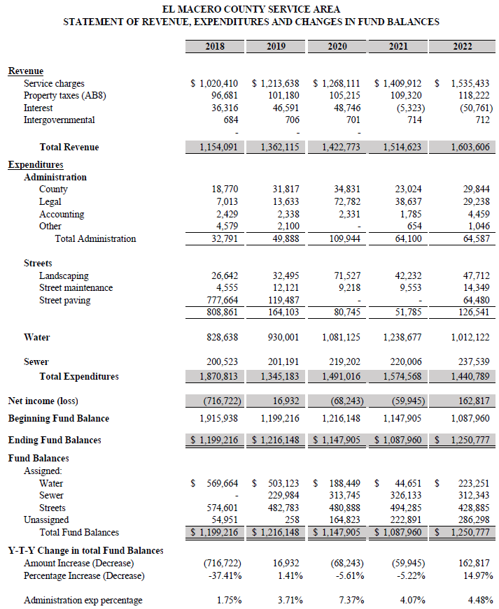

The El Macero CSA is financially sound. The total fund balance remained relatively flat from 2018 to 2022, increasing by $51,561. Revenues have generally kept pace with on-going operational expenditures. The cost of residential water provided by the City of Davis has increased an average of 12% each fiscal year from 2018 to 2021, but then went down by 18% in 2022. The residents are billed one year in arears when the actual expenditure amount and usage data becomes available from the City of Davis. Over 2018-2022, 66% of total expenditures are water related, 16% streets (maintenance, landscaping, and sweeping), 14% wastewater, and 4% administration.

As a dependent district of the County, all accounting records are processed and maintained by the County’s Department of Financial Services (DFS). All transactions are subject to the policies and procedures of the County, which comply with the Government Accounting Standards Board, the accounting standards setting body for governments. In addition, the accounting and financial reporting of the CSA is also in compliance with the California State Controller’s Office. However, due to delayed billings by the City of Davis and other service providers, expenditures reported on the County’s accounting system through 2019 may not reflect the actual cost of service for any particular year. For example, as allowed by general accepted accounting principles, estimates of expenses owed at year end were recorded instead of the actual cost due to delayed billings by service providers. The accruals were reversed at the beginning of the following fiscal year, as required by accounting practice, so that only the amounts actually billed and paid by the CSA would be recorded in the ledgers. The County and City of Davis have worked together to resolve this lag in invoicing.

County staff provides financial reports to the advisory committee at least quarterly. As part of this process, detailed general ledger reports are generated showing all transactions posted to each account, which are then reviewed by County staff. All discrepancies are referred to DFS staff for investigation and if necessary is corrected.

Yolo County has been sued by Richard Lauckhart (or the El Macero Owners for Fair Taxes created by him), and he continues to allege there is $4 million of property taxes (AB 8 funds) missing and there are “295 invoices” (which include all transactions, they are not all invoices) charged to the CSA account that should not be. LAFCo staff has reviewed all information provided by Richard Lauckhart. Underlying these allegations is a misunderstanding about the CSA’s use of property tax revenue, which is used each year to pay for CSA costs that are not otherwise paid for by other assessments and fees. Therefore, a portion of or all these funds are spent each year and have not built up into some reserve that was misappropriated by the County. Based on LAFCo’s review of the CSA’s finances, all revenues paid by residents for the CSA were solely used for CSA purposes and all unexpended fund(s) at year-end remained in the CSA fund(s) to be available for future years. Regarding CSA invoices, LAFCo staff reviewed over 50% of all invoices and backup (far more than typical auditor review for quality control) as well as 100% of the City of Davis invoices, and confirmed that all were appropriate. There are ample internal controls and segregation of duties in approving El Macero CSA transactions. The cost of legal services to the El Macero CSA responding to these allegations continues to be significant due to citizen Public Records Act requests and costs defending lawsuits but are expected to decrease in the current fiscal year.

Per Agreement No. 77-90 for water and Agreement 75-97 for sewer, the City of Davis operates and maintains the water and wastewater systems within the CSA, including replacing any portion of the system which wears out or fails. Therefore, no additional CSA reserve is needed to protect against unexpected water and sewer system costs. However, the CSA needs to carry an ongoing cash balance to cover the water and sewer costs paid to the City while the costs are collected from property owners through the property tax bills, which can result in a delay of several months before the CSA is reimbursed. The CSA does not have any debt.

**Financial Ability MSR Determination:**

The CSA is financially sound. The 5-year trend indicates revenues and expenditures are in balance and the fund balance is increasing slightly. There are concerns from a few residents about the propriety of the accounting of the CSA funds. However, LAFCo’s five-year review of transactions confirmed that all revenues deposited to the CSA were solely used for CSA purposes and that all unexpended fund(s) at year-end remained in the CSA fund(s) to be available for future years. Prior to 2017, El Macero CSA accounting transactions were recorded in a single fund. Currently, four funds are used to segregate revenues and expenditures by activity: Administration, Streets, Water, and Sewer. This change in accounting provides more transparency and to simplify the reporting to the residents of El Macero.

Revenues have generally kept pace with on-going operational expenditures. The rate/fee is sufficient to fund an adequate level of service. The water and sewer rates include an amount for system maintenance and replacement as needed. Excluding water usage fees, ongoing expenditures have remained relatively flat. The cost of residential water provided by the City of Davis has increased 2018 – 2021, but then went down in 2022 (keeping in mind water is currently paid one year in arrears). Over 2018-2022, 66% of total expenditures are water related, 16% streets (maintenance, landscaping, and sweeping), 14% wastewater, and 4% administration. The cost of legal services is significant due to citizen Public Records Act requests and costs defending a lawsuit but are expected to decrease in the current fiscal year.

**Recommendation(s):**

None.

|  |  |  |  |
| --- | --- | --- | --- |
| 5. Shared Services and Facilities Status of, and opportunities for, shared facilities. | | | |
|  | **Significant Issue** | **Potentially Significant** | **No Issue** |
| 1. *Are there any opportunities for the organization to share services or facilities with neighboring, overlapping, or other organizations that are not currently being utilized?* |  |  |  |

**Discussion:**

None.

**Shared Services MSR Determination:**

The El Macero CSA already obtains shared water and sewer services provided by the City of Davis. Street improvements/maintenance and landscaping services is contracted out on a per project basis by the Yolo County Department of Community Services and uses pooled purchasing wherever possible.

**Recommendation(s):**

None.

|  |  |  |  |  |  |  |
| --- | --- | --- | --- | --- | --- | --- |
| 6. Accountability, Structure, and Efficiencies Accountability for community service needs, including governmental structure and operational efficiencies. | | | | | | |
|  | **Significant Issue** | **Potentially Significant** | | **No Issue** | |
| 1. *Are there any recommended changes to the organization’s governmental structure or operations that will increase accountability and efficiency (i.e. overlapping boundaries that confuse the public, service inefficiencies, and/or higher costs/rates)?* |  | |  | |  | | |
| 1. *Does the agency need to secure independent audits of financial reports that meet California State Controller requirements? Are the same auditors used for more than six years? Are audit results not reviewed in an open meeting?* |  | |  | |  | | |
| 1. *Are there any issues with filling board vacancies and maintaining board members? Is there a lack of board member training regarding the organization’s program requirements and financial management?* |  | |  | |  | | |
| 1. *Are there any issues with staff capacity and/or turnover? Is there a lack of staff member training regarding the organization’s program requirements and financial management?* |  | |  | |  | | |
| 1. *Does the organization need to improve its public transparency via a website (see* [*https://www.yololafco.org/yolo-local-government-website-transparency-scorecards*](https://www.yololafco.org/yolo-local-government-website-transparency-scorecards)*)?* |  | |  | |  | | |

**Discussion[4]:**

Changes to the El Macero CSA’s operations to have the City provide direct billing to residents for water and sewer services would improve accountability and efficiency. Water fees are especially complicated because water is charged based on usage, where sewer is a flat fee calculated annually. And the water pass-through is always one year in arrears. Within a fiscal year, City of Davis is collecting water usage amounts and then in July each year, the EMCSA is sent one amount due for the entire community. The EMCSA pays the water charges to the City in advance of collecting the amounts from the residents, for example in fiscal year 2018-19 the CSA collected the water charges for 2017-18 but paid the City for usage for fiscal year 2018-19, thus creating a structural deficit each year. The CSA Manager calculates the annual water charge for each property, and then generates the annual direct charge for the next year’s property tax roll.

The current method of paying for water service has several issues and inefficiencies:

* When a property is sold, the new resident is responsible for paying for the water usage of the previous resident(s) through the remainder of the fiscal year, which may not be fair depending on the difference in usage.
* This delayed method of collecting fees annually from residents on the property tax bill does not lend itself to water conservation efforts, because fees are not necessarily noticed (with monthly fluctuations) as directly by the homeowner. Residents can access the City’s Aquahawk data to see their usage, but this requires diligence on the resident’s part.
* The El Macero CSA pays the water charges to the City in advance of collecting the amounts from the residents, creating a structural deficit each year. Cash reserves from the operations fund is used to float during these timing differences to alleviate the need to borrow funds.
* The CSA Manager estimates it requires 4-5 hours of time per year to consolidate monthly billings, verify accuracy, and prepare the tax roll, with this administrative cost being passed on to the residents.

LAFCo therefore recommends the City bill El Macero CSA residents directly for water and sewer fees. The sewer charges should reflect the 2015 amendment to Agreement No. 75-97 settling the billing dispute.

The CSA has a five-member advisory committee to advise the BOS regarding CSA services and facilities. Per Government Code Section 25212.4 the BOS may appoint one or more advisory committees to give advice to the BOS regarding a county service area’s services and facilities and may provide for the appointment, qualifications, terms, procedures, meetings, and ethical conduct of the members of an advisory committee. Therefore, it’s within the purview of the BOS to decide if and how it provides for these items. There have been resident complaints about the advisory committee and term limits. In February 2021 the BOS Clerk amended the appointment process to ensure justification to exceed advisory committee two-term limit be publicly available online prior to the appointment. Term tracker shows one seat currently vacant[5]., however Kristin Kelleher Wong was appointed to fill this seat on September 27, 2022.

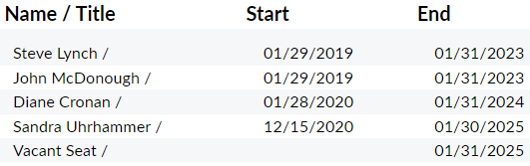

There have been four CSA managers in the past five years and the program has moved from the Department of Community Services to the County Administrator’s Office and back again. Despite these changes, CSA operations have improved with the evolutions of program operations and current staff are well-trained and very knowledgeable.

The El Macero CSA is included in the annual audit of the County’s Annual Comprehensive Financial Report (ACFR). The CSA is reported as a blended component unit and accounted for as a special revenue fund. According to the State Controller’s Office, the County’s audited ACFR meets general audit requirements and the ACFR satisfies the requirements of Government Code 25214(c) and 26909[6]. In June 2021, the El Macero Owners for Fair Taxes filed a complaint in Yolo County Superior Court alleging Yolo County is required to audit the EM CSA separately, rather than as a blended component of the County’s audit (the Court denied the petition). The EMCSA received an 94% website transparency score in 2021[7].

**Accountability, Structure, and Efficiencies MSR Determination**

The CSA is covered by County governance and policies and is included in the County’s annual audit. Although CSA operations have had four managers in the past five years and under two departments, CSA operations have improved with the evolutions of program operations and current staff are well-trained and very knowledgeable. There have been complaints from a few residents regarding the advisory committee and term limits, however it’s within the purview of the BOS to decide if and how it provides for appointment, qualifications, terms, procedures, meetings, and ethical conduct of the members.

Changes to the EMCAS’s operations to provide for direct City billing for water and sewer services would improve accountability and efficiency. The El Macero CSA pays the water charges to the City in advance of collecting the amounts from the residents, creating a structural deficit each year. Cash reserves from the operations fund is used to float during these timing differences to alleviate the need to borrow funds. This practice is inefficient and leaves the EMCSA somewhat at risk financially. In addition, new homeowners end up paying for the water usage of previous residents, which is inequitable. And paying water charges annually on a property tax bill undermines water conservation efforts. For all these reasons, LAFCo again recommends the City bill El Macero CSA residents directly for water and sewer fees, rather than through the CSA.

**Accountability, Structure and Efficiencies MSR Recommendation(s)**

* Amend the current CSA contracts to provide for direct billing for water and sewer services by the City of Davis to El Macero residents. The sewer charges must reflect the 2015 amendment to Agreement No. 75-97 settling the billing dispute.

|  |  |  |  |
| --- | --- | --- | --- |
| 7a. Broadband Access Any other matter related to effective or efficient service delivery, as required by commission policy.  Per Yolo LAFCo Project Policy 6.2 “*it is the intent of Yolo LAFCo to comprehensively review broadband access in MSRs of local agencies that either serve communities and/or provide emergency services where broadband connection is critical (i.e. cities, CSDs, CSAs, FPDs and RDs).”* | | | |
|  | **Significant Issue** | **Potentially Significant** | **No Issue** |
| 1. *Is there a lack of high-performance broadband (25/3 Mbps) available in the community?* |  |  |  |
| 1. *Is there a lack of low-income subscription rates and/or digital literacy programs available?* |  |  |  |

**Discussion[8]:**

Below is the 25/3 Mbps served status for the El Macero CSA. The green color indicates areas served by at least 25/3 Mbps download/upload speeds.

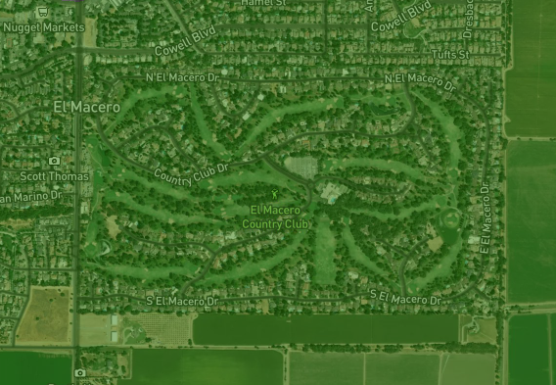

**Broadband Access MSR Determination:**

The CPUC map indicates cable modem DOCSIS technology is available from Comcast at speeds up to 1,000/35 Mbps (download/upload speeds). Broadband adoption at 25/3 Mbps is reported to be greater than 80% (the highest category).

**Recommendation(s):**

None.

|  |  |  |  |
| --- | --- | --- | --- |
| 7b. Status of Previous MSR Recommendations Any other matter related to effective or efficient service delivery, as required by commission policy. | | | |
|  | **Significant Issue** | **Potentially Significant** | **No Issue** |
| 1. *Are there any recommendations from the agency’s previous MSR that have not been implemented?* |  |  |  |

**Discussion:**

The 2016 MSR had several recommendations and most of them have been implemented.

| **2016 MSR Recommendations** | **2022 Status** |
| --- | --- |
| 1. The County, in consultation with the CSA advisory committee, should develop options for future maintenance and improvements to roads, including a feasibility and cost/benefit analysis of potentially privatizing the El Macero road system for maintenance by the HOA. The analysis should review the potential for any unintended consequences to this change in service structure, in particular with respect to homeowner costs, public safety enforcement and solid waste collection. | Privatizing roads was considered by the CSA Advisory Committee and it recommended that HOA street maintenance would be more difficult and create negative consequences. Therefore, this recommendation was not pursued and LAFCo accepts this outcome. |
| 2. LAFCo recommends that County staff compile a long-term capital improvement plan for the CSA with a focus on anticipated street needs over the next few decades to ensure that the assessment being charged is sufficient to finance projected costs. | CSA staff prepared a scope of work for this CIP in 2018 per LAFCo’s recommendation. However, as noted under Capacity and Adequacy of Public Facilities Section the Prop 218 to support these efforts failed such that the CSA will not be able to fund it. See new recommendations in Capacity and Adequacy of Public Facilities Section. |
| 3. The reserve level of El Macero CSA should be reviewed to determine if it is appropriate to the needs of the CSA and the service structure after a capital improvement plan is developed to determine all capital needs of the CSA. | See status for #2. Considering the Prop 218 for street improvements failed and water/sewer system maintenance is handled by the City of Davis and included in the fee structure, a reserve study is not currently needed. |
| 4. In order to enhance transparency, it is recommended that the County develop a worksheet or bill that can be distributed to the residents at the same time as the property tax bill to clearly demonstrate how the charges are determined. | Done. The intent of this recommendation was addressed by property tax bills showing separate charges. |
| 5. The County, in consultation with the CSA Advisory Committee, should consider amending the County-City contract to provide for direct billing for services by the City of Davis to El Macero residents to further enhance efficiency and transparency and save the CSA in administration fees to the County for billing. This recommendation assumes the existing sewer rate that has already been agreed upon by the City and the County would be retained for the duration of the existing term of agreement and future rates would continue to be negotiated between the CSA and the City of Davis, as necessary. | This recommendation has not been implemented. LAFCo has reiterated this recommendation again in this MSR. |

**Status of Previous MSR Recommendations Determination:**

Of the five recommendations from the 2016 MSR, four are no longer needed or are inapplicable. The one outstanding recommendation regarding the City of Davis directly billing residents for water and sewer fees has been restated in this MSR.

**Status of Previous Recommendations MSR Recommendation**

See Capacity and Adequacy of Public Facilities and Accountability, Structure and Efficiencies MSR Recommendations.

# SPHERE OF INFLUENCE STUDY

On the basis of the Municipal Service Review:

Staff has reviewed the agency’s Sphere of Influence and recommends that a SOI Update is not necessary in accordance with Government Code Section 56425(g). Therefore, NO CHANGE to the agency’s SOI is recommended and SOI determinations HAVE NOT been made.

Staff has reviewed the agency’s Sphere of Influence and recommends that a SOI Update IS NECESSARY in accordance with Government Code Section 56425(g). Therefore, A CHANGE to the agency’s SOI is recommended and SOI determinations HAVE been made and are included in this MSR/SOI study.

1. CALAFCO Statewide DUCs Refined GIS Layer, RSG, Inc. December 10, 2021
2. Yolo County Financial Data INFOR reports
3. County of Yolo Resolution No. 22-61 regarding charges on the 2022-23 tax roll for CSAs
4. County Service Areas Government Code Sections 25210 – 25217.4
5. County of Yolo Agenda Quick Term Tracker module 10/27/2022
6. Per email dated July 6, 2021 from Sandeep Singh, Manager, Local Government Policy Section Office of State Controller, Local Government Programs and Services Division
7. https://www.yololafco.org/yolo-local-government-website-transparency-scorecards
8. California Interactive Broadband Map, December 31, 2019 data