# AGENCY PROFILE

North Davis Meadows County Service Area (CSA) #10 was established on May 12, 1987 to provide water, sewer, stormwater, landscaping, and street lighting services. The original CSA boundary included Unit I of the subdivision with 56 single family residential (SFR) lots. In 1995 LAFCo annexed Unit II with 39 additional SFR lots and a two-acre California Department of Fish and Wildlife habitat parcel which runs along the western boundary of the Unit II. In addition to Unit II, three additional parcels were annexed at the landowner request because they might benefit from CSA services in the future (but have yet to connect): The Newton, Nicholas Farms (Korte), and Dugger parcels. The Davis Municipal Golf Course surrounds the North Davis Meadows I subdivision, and the golf course is adjacent to the North Davis Meadows II subdivision, however, the golf course is not within the CSA’s boundaries.

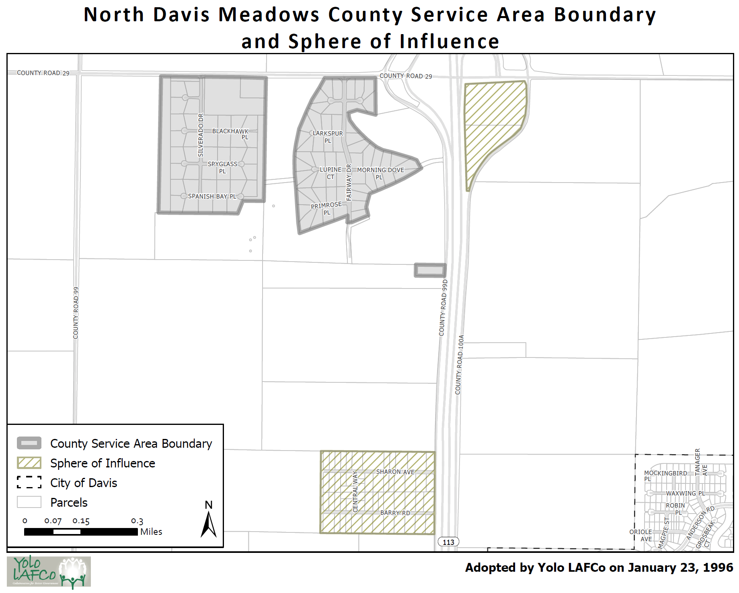

North Davis Meadows CSA is governed by the County Board of Supervisors (BOS) and is treated as a special district under the LAFCo Law. The Board of Supervisors is advised as to the maintenance and operation of the CSA by a five-member advisory committee. This advisory committee meets three times a year to discuss the ongoing issues pertinent to the CSA. As directed by California Government Code Section 25212.4, the advisory committee’s role is to provide advice to the Board regarding the services and facilities of the CSA, but it is not within the authority of the advisory committee to make decisions, manage, or direct the delivery of services and facilities.

The North Davis Meadows CSA is currently staffed and managed by the County’s Department of Community Services. The CSA is billed for the staff time of the CSA administrative support team, the County finance staff, and County legal counsel, when such services are utilized.

# MUNICIPAL SERVICE REVIEW

## Potentially Significant MSR Determinations

The MSR determinations checked below are potentially significant, as indicated by answers to the key policy questions in the checklist and corresponding discussion on the following pages. If most or all of the determinations are not significant, as indicated by “no” answers, the Commission may find that a MSR update is not warranted.

|  |  |  |  |
| --- | --- | --- | --- |
|  | Growth and Population |  | Shared Services |
|  | Disadvantaged Unincorporated Communities |  | Accountability, Structure, and Efficiencies |
|  | Capacity, Adequacy & Infrastructure to Provide Services |  | Broadband Access |
|  | Financial Ability |  | Status of Previous MSR Recommendations |

## LAFCo Municipal Service Review:

On the basis of this initial evaluation, the required determinations are not significant, and staff recommends that an MSR is NOT NECESSARY. The subject agency will be reviewed again in five years per Government Code Section 56425(g).

The subject agency has potentially significant determinations and staff recommends that a comprehensive MSR IS NECESSARY and has been conducted via this checklist.

|  |  |  |  |
| --- | --- | --- | --- |
| 1. Growth and Population Growth and population projections for the affected area. | **Significant Issue** | **Potentially Significant** | **No Issue** |
| 1. *Will development and/or population projections over the next 5-10 years impact the subject agency’s service needs and demands?* |  |  |  |
| 1. *Do changes in demand suggest a change in the agency’s services?* |  |  |  |

**Discussion:**

None.

**Growth and Population MSR Determination:**

The North Davis Meadows CSA has little opportunity for new development or growth. Only one of the north Davis Meadows lots has yet to be built on. There are no changes in service demand that would suggest a change in the agency’s services.

**Recommendation(s):**

None.

|  |  |  |  |
| --- | --- | --- | --- |
| 2. Disadvantaged Unincorporated Communities The location and characteristics of any disadvantaged unincorporated communities within or contiguous to the sphere of influence. | | | |
|  | **Significant Issue** | **Potentially Significant** | **No Issue** |
| 1. *If the subject agency provides services related to sewers, municipal and industrial water, or structural fire protection, are there any “inhabited unincorporated communities” (per adopted Commission policy) within or adjacent to the subject agency’s sphere of influence that are considered “disadvantaged” (80% or less of the statewide median household income) that do not already have access to public water, sewer, and structural fire protection?* |  |  |  |
| 1. *If “yes” to a), it is feasible for the agency to be reorganized such that it can extend service to the disadvantaged unincorporated community? If “no” to a), this question is marked “no” because it is either not needed or not applicable.* |  |  |  |

**Discussion:**

None.

**Disadvantaged Unincorporated Communities MSR Determination:**

There are no disadvantaged unincorporated communities within or contiguous to the North Davis Meadows CSA[1].

**Recommendation(s):**

None.

|  |  |  |  |
| --- | --- | --- | --- |
| 3. Capacity and Adequacy of Public Facilities and Services Present and planned capacity of public facilities, adequacy of public services, and infrastructure needs or deficiencies including needs or deficiencies related to sewers, municipal and industrial water, and structural fire protection in any disadvantaged, unincorporated communities within or contiguous to the sphere of influence. | | | |
|  | **Significant Issue** | **Potentially Significant** | **No Issue** |
| 1. *Are there any deficiencies in the* ***infrastructure, equipment, and capacity of agency facilities*** *to meet existing service needs for which the agency does not have a plan in place to resolve (including deficiencies created by new state regulations)?* |  |  |  |
| 1. *Are there any issues regarding the agency’s capacity and ability to meet the service demand of reasonably foreseeable future needs?* |  |  |  |
| 1. *Are there any service needs or deficiencies for disadvantaged unincorporated communities related to sewers, municipal and industrial water, and structural fire protection within or contiguous to the agency’s sphere of influence?* |  |  |  |
| 1. *Is the agency needing to consider climate adaptation in its assessment of infrastructure/service needs?* |  |  |  |

**Discussion:**

North Davis Meadows County Service Area (CSA) provides water, sewer, stormwater, landscaping, and street lighting services as noted below.

|  |  |
| --- | --- |
| **Existing CSA Services Authorized/Provided** | **Service Provider** |
| Municipal Water | City of Davis |
| Sewer/Wastewater | CSA/City of Davis |
| Stormwater/Drainage | YCFCWCD |
| Landscaping | CSA |
| Street Lighting | PG&E |

Water

The North Davis Meadows CSA provides water service to the North Davis Meadows I and the North Davis Meadows II subdivisions through a March 22, 1988 agreement with the City of Davis. The City of Davis maintains the CSA's water distribution and well system, including fire hydrants. The Korte, Newton, and Moore parcels are connected to private well systems. The CSA wells and water system are maintained and operated by the City of Davis in a manner similar to and in accordance with standards of wells in the City of Davis. North Davis Meadows’ SFR water connections are not currently metered.

The North Davis Meadows water supply exceeds the MCL for hexavalent chromium. A stricter primary drinking water standard was enacted for hexavalent chromium in 2014, and since that time, the system has been in violation of the standard as the wells consistently test higher than the MCL. In order to resolve water quality issues, Yolo County has been pursuing a connection with the City of Davis water system.

The project will connect the North Davis Meadows community water system to the City of Davis’ water distribution system. The proposed improvements will include construction of a six-inch diameter pipeline in John Jones Road/County Road 99D to connect CSA homes to the existing city water distribution system. The connection is to be sized to meet only the North Davis Meadows community needs with no capacity available for other properties. This pipeline would connect homes to the existing 14-inch diameter pipe in John Jones Road near the entrance road to the City’s west tank area.

Litigation from three landowners has delayed the connection for years. Yolo County won lawsuit and appeal and is moving forward. The CSA Manager applied for and was awarded $7.6 million of State Revolving Fund grant funding and is working with state to finish financial agreement. A loan will still be required to complete the project because the 2018 construction estimate was $8.25 million considering inflation and increased construction costs. The construction plans are completed and waiting to go out for bid. The estimated construction timeline is July – December 2023. Connections with be metered and have an added backflow device. The City will bill residences directly for water service.

Sewer

The City of Davis agreed to accept wastewater flows from the North Davis Meadows CSA on May 19, 1998.[2] Within the CSA, only the North Davis Meadows I and the North Davis Meadows II subdivisions receive wastewater service from the CSA wastewater collection system. Of the homes in the two subdivisions, 82 are connected to the sewage collection system and also have individual grinder pumps; the remaining homes have individual septic systems. The agreement with the City sets the maximum number of connections at 95. The CSA also allowed the Teichert properties to connect to the sewer main for sewer collection services. Teichert paid a connection fee and pays annual charge to the CSA based on the amount of flow (LAFCo authorized extended services in 2006 to the Teichert property, which is within the CSA’s SOI but not its current boundaries) .

The CSA is responsible for the operation and maintenance of the infrastructure on each residential lot in the CSA that receives wastewater service. Each lot that receives service contains a wastewater grinder pump and wastewater service line. The grinder pump system minimizes the likelihood of obstructions in the existing line. The line extends to the main wastewater line on which the parcel fronts or accesses. Maintenance of the grinder pumps is provided by private companies by contract. The CSA has instituted a grinder replacement program to replace up to 17 grinders annually as needed.

The wastewater system consists of collection and transmission facilities that collect effluent and transmit the effluent to a point of collection with an existing transmission main of the City of Davis. A four-inch low pressure sewer pipeline generally extends from the CSA properties south along County Road 99D to an existing City of Davis sewer manhole located just north of the intersection of County Road 31 with County Road 99D. The effluent enters the existing sewer system of the City and is conveyed to treatment and disposal facilities of the City. There are no concerns regarding capacity and adequacy of the wastewater system currently.

Stormwater

The North Davis Meadows CSA is in a flood prone area. The CSA manages drainage through the use of natural gravity flow, drainage ditches, swales (shallow ditches), the golf course, and holding ponds. The CSA provides for the spraying, excavating, and clearing of perimeter ditches in both subdivisions and partners with the City of Davis Golf Course to provide ditch maintenance in the North Davis Meadows I area. The CSA maintains a cement culvert along County Road 29. The CSA is also responsible for drainage extending outside the CSA through a 1986 drainage facilities agreement between the former Barlo Farms parcel and the Davis Golf Course Estates (North Davis Meadows CSA). The agreement splits maintenance costs 50% each between the CSA and the Barlo property. The Barlo property is located at the southwest corner of County Road 29 and 101-A. Surface water from the CSA and the Davis Municipal Golf Course drains through the County-maintained roadside ditches along County Road 29, then through the "Barlo" ditches, along the westerly boundary of the Barlo property to approximately the midpoint of and east through the Barlo property to County Road 10I A. The CSA contracts with the Yolo County Flood Protection and Water Conservation District (YCFCWCD) to maintain the Barlo drainage ditches.

Landscaping

The CSA provides for the maintenance of open space and median strips throughout and around the North Davis Meadows subdivisions through landscaping activities, which include mowing, trimming, spraying, etc. These areas include median strips along the main roads Silverado Drive and Fairway Drive, the golf course, space between home lots and the golf course, along roads, around the drainage pond, and in the habitat buffer west of North Davis Meadows II. The CSA provides the service via contract with private landscaping services. The CSA will need to consider options to redesign its common landscape areas and street medians to be drought resistant and the current assessments will not cover the new City water rates.

Street Lighting

The CSA contracts with Pacific Gas and Electric (PG&E) to supply electricity for its public lighting system, as well as to install, maintain, and service the light poles in the community. The light poles utilize LED lighting technology. The CSA does not own or operate any equipment, although it is financially responsible for all one-time and ongoing costs associated with the street lighting network. The CSA functions as a pass-through agency, collecting funds from the North Davis Meadows residents to pay the PG&E bills for the public street lighting service. The PG&E street lighting is LED technology and the electricity is provided by Valley Clean Energy, which utilized more sustainable energy sources.

**Capacity and Adequacy MSR Determination:**

The North Davis Meadows water supply exceeds the MCL for hexavalent chromium enacted in 2014, and since that time, the system has been in violation of the standard as the wells consistently test higher than the MCL. To resolve water quality issues, Yolo County has been pursuing a connection with the City of Davis water system, which has been delayed due to landowner litigation but is moving forward and expected to be completed by the end of 2023. However, the City of Davis is currently indicating individual service agreements with each landowner will be required, which will be time consuming to get signed, notarized, recorded for each parcel. For the wastewater system, the CSA maintains grinder pumps on individual parcel connections, but the effluent is treated by the City of Davis and there are no concerns about capacity and adequacy. The CSA contracts with the Yolo County Flood Protection and Water Conservation District (YCFCWCD) to maintain the CSA’s stormwater runoff through the Barlo drainage ditches. The CSA provides the service via contract with private landscaping services. The CSA will need to consider options to redesign its common landscape areas and street medians to be drought resistant and the current assessments will not cover the new City water rates. The PG&E street lighting is LED technology and the electricity is provided by Valley Clean Energy, which utilized more sustainable energy sources.

**Recommendation(s):**

* The North Davis Meadows CSA will need to consider options to redesign its common landscape areas and street medians to be drought resistant because the current assessments will not cover the new City water rates.

|  |  |  |  |
| --- | --- | --- | --- |
| 4. Financial Ability Financial ability of agencies to provide services. | | | |
|  | **Significant Issue** | **Potentially Significant** | **No Issue** |
| 1. *Is the subject agency in a stable financial position, i.e. does the 5-year trend analysis indicate any issues?* |  |  |  |
| 1. *Is there an issue with the organization’s revenue sources being reliable? For example, is a large percentage of revenue coming from grants or one-time/short-term sources?* |  |  |  |
| 1. *Is the organization’s revenue sufficient to fund an adequate level of service, necessary infrastructure maintenance, replacement and/or any needed expansion? Is the fee inconsistent with the schedules of similar local agencies* |  |  |  |
| 1. *Does the subject agency have a capital improvement plan (CIP)? Has the agency identified and quantified what the possible significant risks and costs of infrastructure or equipment failure? Does the agency have a reserve policy to fund it?* |  |  |  |
| 1. *Does the agency have any debt, and if so, is the organization’s debt at an unmanageable level? Does the agency need a clear debt management policy, if applicable?* |  |  |  |
| 1. *Is the agency insured or in a risk management pool to manage potential liabilities?* |  |  |  |
| 1. *Does the agency board need to receive regular financial reports (quarterly or mid-year at a minimum) that provide a clear and complete picture of the agency’s assets and liabilities, fully disclosing both positive and negative financial information to the public and financial institutions?* |  |  |  |

**Discussion[3]:**

The 2022/23 property-related fees, assessments and/or special taxes for the North Davis Meadows CSA[4] is as shown the table below:

|  |  |  |
| --- | --- | --- |
| **North Davis Meadows CSA** | **Annual Charge Per Parcel** | **No. of Parcels Charged** |
| Water | $2,070.64 | 95 |
| Water Project Loan Repayment | $4,157.00 | 94 |
| Water Project Loan Repayment (vacant parcel) | $3,339.00 | 1 |
| Sewer | $2,043.96 | 82 |
| Stormwater | $158.18 | 95 |
| Landscaping | $486.30 | 95 |
| Street Lighting | $130.38 | 95 |

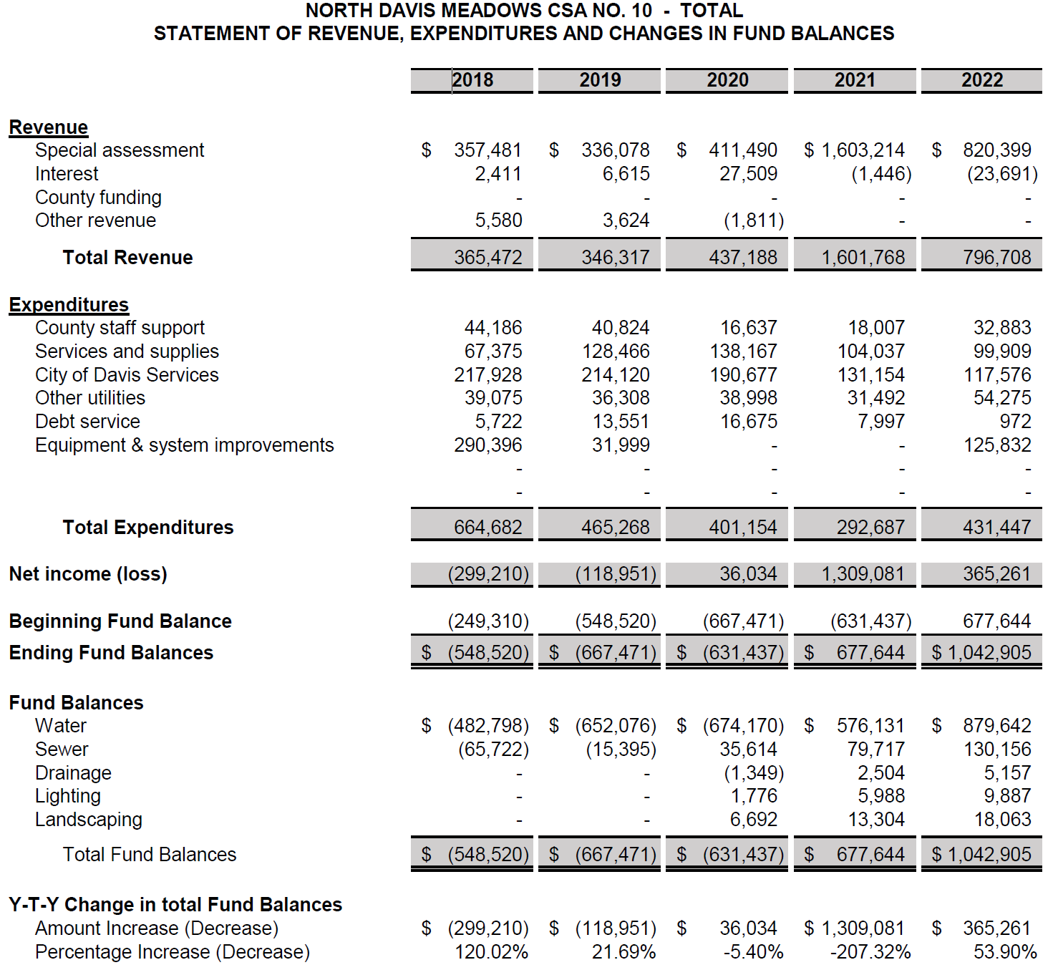

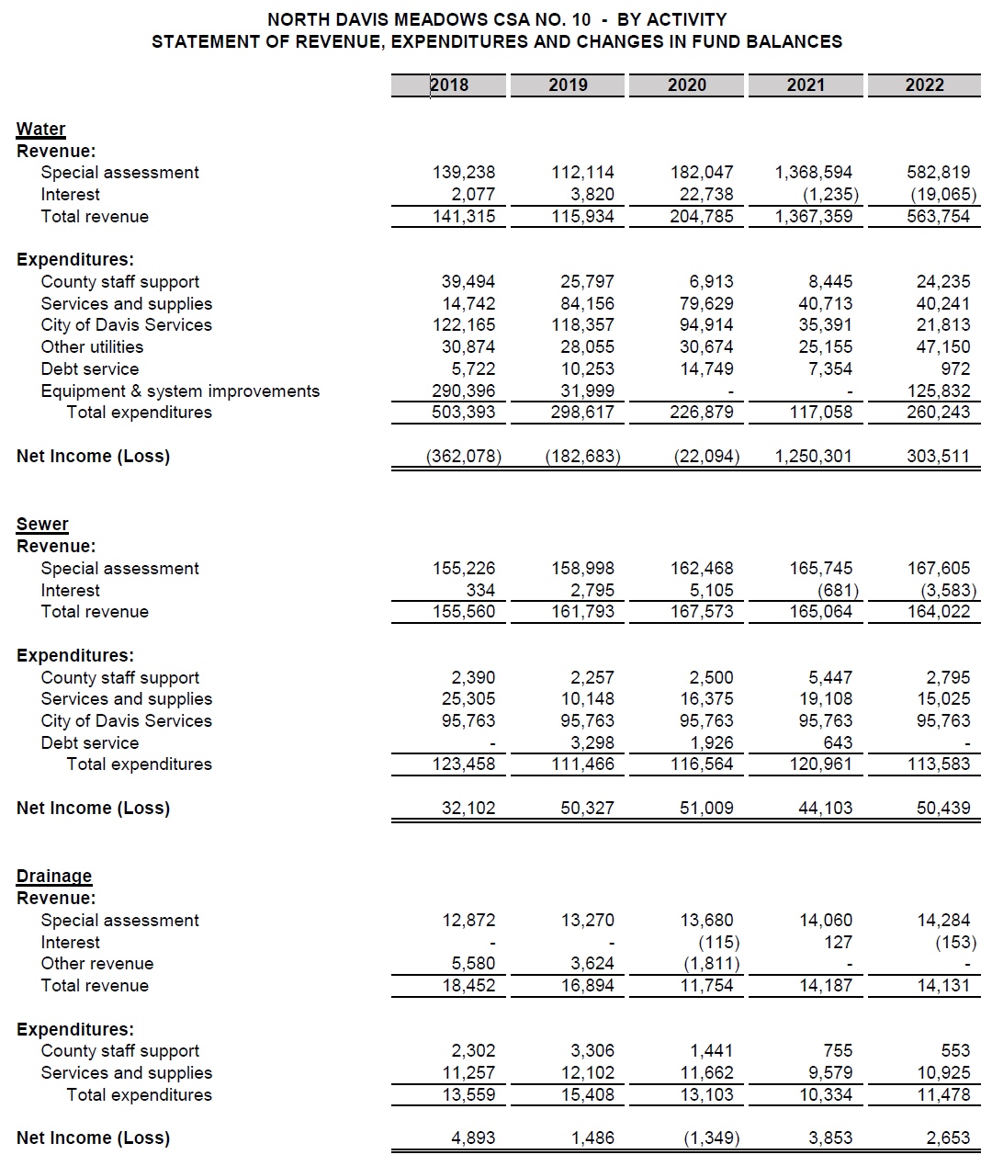

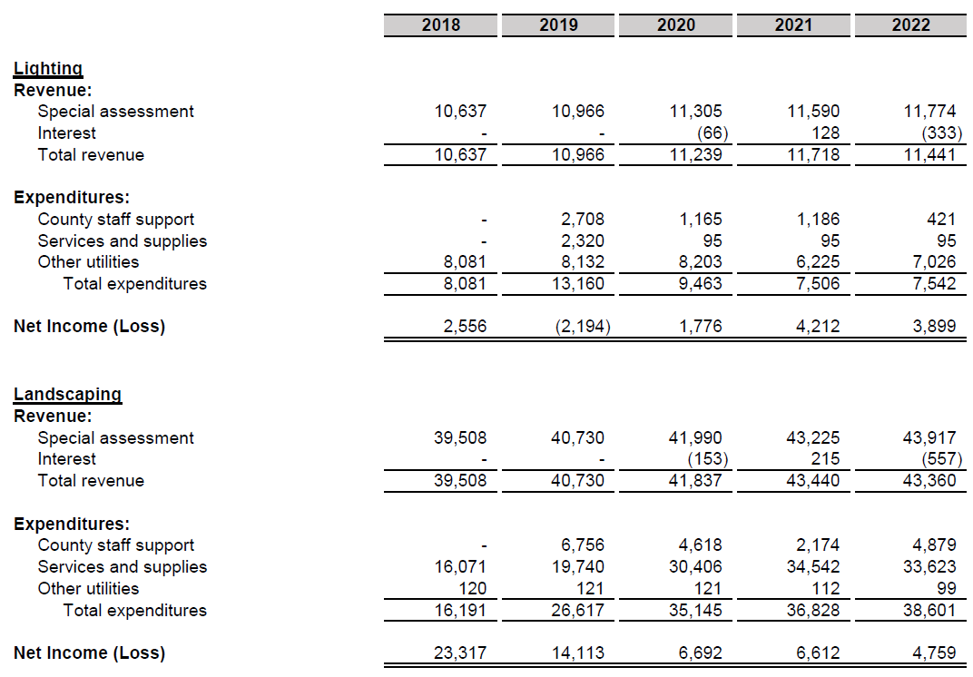

Water rates were increased significantly in 2021 to pay for project costs to connect to the City of Davis and there was a bump in 2021 to repay a 2017 County loan to front these costs. The CSA Manager applied for and was awarded $7.6 million of State Revolving Fund grant funding to help fund the water connection project and is working with the State to finish the financial agreement. A loan will still be required to complete the project because the 2018 construction estimate was $8.25 million considering inflation and increased construction costs. The City will bill residences directly for water service. The sewer, drainage, lighting, and landscaping accounts all appear stable.

**Financial Ability MSR Determination:**

The North Davis Meadows CSA is in a stable financial position and the 5-year trend does not indicate any issues. Revenues are sufficient to fund an adequate level of service and necessary infrastructure. Although the CSA was awarded a $7.6 million load from the State Revolving Fund, a loan will be necessary to bridge the gap to construct the water project connecting to the City of Davis. The amount of the loan needed has not been determined yet because the project has not yet gone out for bid, but the loan amount is expected to be manageable. With the City of Davis maintaining the water (once connected) and sewer system, a substantial CIP is not needed.

**Recommendation(s):**

None.

|  |  |  |  |
| --- | --- | --- | --- |
| 5. Shared Services and Facilities Status of, and opportunities for, shared facilities. | | | |
|  | **Significant Issue** | **Potentially Significant** | **No Issue** |
| 1. *Are there any opportunities for the organization to share services or facilities with neighboring, overlapping, or other organizations that are not currently being utilized?* |  |  |  |

**Discussion:**

None.

**Shared Services MSR Determination:**

The CSA is already sharing services as feasible. The City of Davis will be providing water service once the water project is completed) and treating the community’s wastewater. YCFCWCD is maintaining the drainage system. For landscaping, the CSA either performs some of the work in-house from other County Departments, contracts with private landscaping services, or contracts with the City of Davis for work around the golf course. Pacific Gas and Electric (PG&E) provides electricity for its public lighting system, as well as to install, maintain, and service the light poles in the community. There are no known additional opportunities to share services.

**Recommendation(s):**

None.

|  |  |  |  |  |  |  |
| --- | --- | --- | --- | --- | --- | --- |
| 6. Accountability, Structure, and Efficiencies Accountability for community service needs, including governmental structure and operational efficiencies. | | | | | | |
|  | **Significant Issue** | **Potentially Significant** | | **No Issue** | |
| 1. *Are there any recommended changes to the organization’s governmental structure or operations that will increase accountability and efficiency (i.e. overlapping boundaries that confuse the public, service inefficiencies, and/or higher costs/rates)?* |  | |  | |  | | |
| 1. *Are there any issues with filling board vacancies and maintaining board members? Is there a lack of board member training regarding the organization’s program requirements and financial management?* |  | |  | |  | | |
| 1. *Are there any issues with staff capacity and/or turnover? Is there a lack of staff member training regarding the organization’s program requirements and financial management?* |  | |  | |  | | |
| 1. *Does the agency need to secure independent audits of financial reports that meet California State Controller requirements? Are the same auditors used for more than six years? Are audit results not reviewed in an open meeting?* |  | |  | |  | | |
| 1. *Does the organization need to improve its public transparency via a website (see* [*https://www.yololafco.org/yolo-local-government-website-transparency-scorecards*](https://www.yololafco.org/yolo-local-government-website-transparency-scorecards)*)?* |  | |  | |  | | |

**Discussion[5]:**

The CSA has a five-member advisory committee to advise the BOS regarding CSA services and facilities. All seats are currently filled[6].

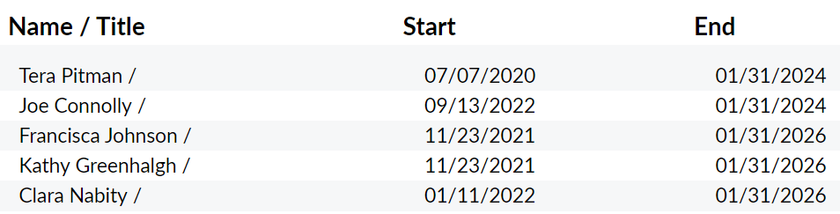

**Accountability, Structure, and Efficiencies MSR Determination:**

There are no recommended changes to the organization’s governmental structure or operations that will increase accountability and efficiency. Board and staff capacity, and audits are not an issue as these are handled by Yolo County. Advisory committee seats are currently all filled. The CSA is staffed and managed by the County’s Department of Community Services. The CSA is billed for the staff time of the CSA administrative support team, County finance staff, and County legal counsel, when such services are utilized. The CSA received a 94% score in the 2021 Yolo Local Government Website Transparency Scorecard.

**Recommendation(s):**

None.

|  |  |  |  |
| --- | --- | --- | --- |
| 7a. Broadband Access Any other matter related to effective or efficient service delivery, as required by commission policy.  Per Yolo LAFCo Project Policy 6.2 “*it is the intent of Yolo LAFCo to comprehensively review broadband access in MSRs of local agencies that either serve communities and/or provide emergency services where broadband connection is critical (i.e. cities, CSDs, CSAs, FPDs and RDs).”* | | | |
|  | **Significant Issue** | **Potentially Significant** | **No Issue** |
| 1. *Is there a lack of high-performance broadband (25/3 Mbps) available in the community?* |  |  |  |
| 1. *Is there a lack of low-income subscription rates and/or digital literacy programs available?* |  |  |  |

**Discussion[7]:**

Below is the 25/3 Mbps served status for the North Davis Meadows CSA. The green color indicates areas served by at least 25/3 Mbps download/upload speeds.

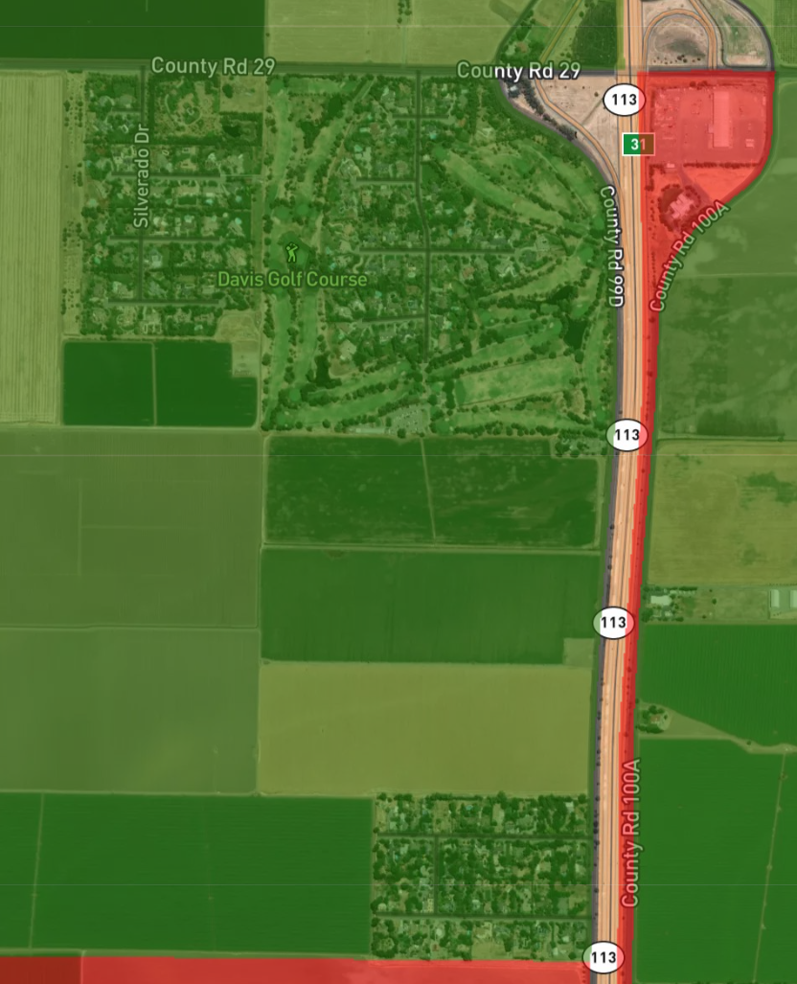

**Broadband Access MSR Determination:**

The CPUC map indicates fixed wireless technology is available from Cal.net Inc. at speeds up to 25/3 Mbps (download/upload speeds), however, Om Networks a local internet service provider based in Davis installed a fiber project in the North Davis Meadows community that provides at least 1 gig speeds, and apparently this was not included in the CPUC data online. Broadband adoption at 25/3 Mbps is reported to be between 60% and 80%, but it’s likely higher in the CSA due to its relative affluence.

**Recommendation(s):**

None.

|  |  |  |  |
| --- | --- | --- | --- |
| 7b. Status of Previous MSR Recommendations Any other matter related to effective or efficient service delivery, as required by commission policy. | | | |
|  | **Significant Issue** | **Potentially Significant** | **No Issue** |
| 1. *Are there any recommendations from the agency’s previous MSR that have not been implemented?* |  |  |  |

**Discussion:**

The 2016 MSR had several recommendations and most of them have been implemented.

| **2016 MSR Recommendations** | **2022 Status** |
| --- | --- |
| The County CSA Manager should conduct an analysis of the existing fee structure to ensure that fees continue to cover necessary costs of all services provided. In particular, there are no fees specific to the drainage, landscaping, and street lighting services. The cost of providing these services should be reviewed and fees set accordingly. | Done |
| Funding for the drainage, landscaping, and street lighting services should be tracked and accounted for separately in the North Davis Meadows CSA’s financial reports. | Done |
| The County CSA Manager should develop an annual drainage maintenance plan. The plan should include a schedule and a map to identify current conditions, critical locations, and problems such as timing in regard to wildlife or other considerations, and establish a regular maintenance schedule to ensure adequate maintenance occurs on an ongoing basis. | Done |
| The potential for outsourcing or transferring drainage and flood control services to the Yolo County Flood Control and Water Conservation District should be evaluated by the CSA Manager, in consultation with the advisory committee. | Done |
| The County should account for the North Davis Meadows Assessment District as a separate entity from the North Davis Meadows CSA to accurately represent where liability for payment of the debt lies. | Done |
| The CSA Manager should pursue an agreement with the City to bill North Davis Meadows residents directly for water services. | Done |

**Status of Previous MSR Recommendations Determination:**

Yolo County has implemented all of the 2016 MSR recommendations for the North Davis Meadows CSA.

# SPHERE OF INFLUENCE STUDY

On the basis of the Municipal Service Review:

Staff has reviewed the agency’s Sphere of Influence and recommends that a SOI Update is not necessary in accordance with Government Code Section 56425(g). Therefore, NO CHANGE to the agency’s SOI is recommended and SOI determinations HAVE NOT been made.

Staff has reviewed the agency’s Sphere of Influence and recommends that a SOI Update IS NECESSARY in accordance with Government Code Section 56425(g). Therefore, A CHANGE to the agency’s SOI is recommended and SOI determinations HAVE been made and are included in this MSR/SOI study.

1. CALAFCO Statewide DUCs Refined GIS Layer, RSG, Inc. December 10, 2021
2. Agreement No. 98-87.
3. Yolo County Financial Data INFOR reports
4. County of Yolo Resolution No. 22-61 regarding charges on the 2022-23 tax roll for CSAs
5. County Service Areas Government Code Sections 25210 – 25217.4
6. County of Yolo Agenda Quick Term Tracker module 9/13/2022
7. California Interactive Broadband Map, December 31, 2019 data