**Clinical Documentation Trainings – Autumn 2023**

**Specialty Mental Health Services**

* HHSA SMHS Outpatient Documentation Training – 10/13/2023

[HHSA Behavioral Health Quality Management SMHS Outpatient Documentation Training](https://www.youtube.com/watch?v=O3LFxfGVcC8) [10/13/2023 - YouTube](https://www.youtube.com/watch?v=O3LFxfGVcC8)

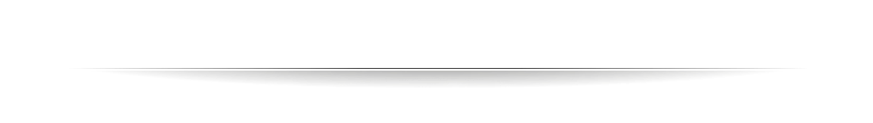

**Substance Use Disorder Services**

* SUD Outpatient and Intensive Outpatient Documentation Training – 10/27/2023

<https://yolocounty.zoom.us/rec/share/4AMB04rUsEJR9Ene8TyHdMTP_aaExxEQ9jVnRN5K12NX28aoi8f0QjZG_wRRtmwd.sOoebk3TGvxO3FiA>

* SUD Residential & Withdrawal Management Documentation Training – 11/3/2323

[https://yolocounty.zoom.us/rec/share/UxczvPEALGXdOqHVXkFXrIneN3l_rXnOvYWbboxtE7teN1S4iDMgjc5J99cYW8hd.-zqDfPboziLtFsmr](https://urldefense.com/v3/__https:/yolocounty.zoom.us/rec/share/UxczvPEALGXdOqHVXkFXrIneN3l_rXnOvYWbboxtE7teN1S4iDMgjc5J99cYW8hd.-zqDfPboziLtFsmr__;!!LiBSFpPBmXk!SolA8RzBP295MfkKWscC3dPbHBE5FTHoHzYSmBLeYYrkrA6UtHrAQlXSRWanAxXL1t-X_txh_KyiLRzgAkFlqjRIUa2zscK7$)