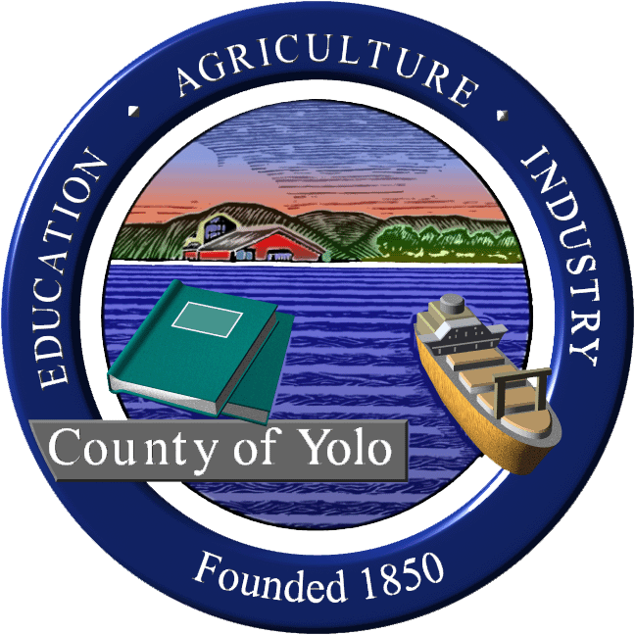
Yolo County Commission on Aging and Adult Services

Yolo County Health and Justice Building
600 A Street, 101 Room; Davis, CA 95616
Wednesday, November 1, 2023
9am - 11:00am

AGENDA

I. Welcome and Introductions Supervisor Jim Provenza

II. Review and Approve Minutes from Commission Members
October 4, 2023

III. Update on AAA4 Strength Assessment Task Force members
Recommendations

IV. Updates from DD/ID Caregiver Task Force Seth Brunner/Mary Nisson

V. Fall COVID vaccine information Yolo Healthy Aging Alliance team

VI. Update from City Aging Commissions

VII. Update from Partner Agencies
- Yolo Healthy Aging Alliance
- Agency on Aging-Area 4
- Resources for Independent Living

Public Comment: Opportunity for Community Members
members of the public to address the
Commission on subjects relating to
Commission business. The Commission
reserves the right to impose a reasonable
limit on time afforded to any topic or to
any individual speaker.

VI Announcements; Future Agenda Items Commission Members

Next Meeting: December 6, 2023

Adjournment

