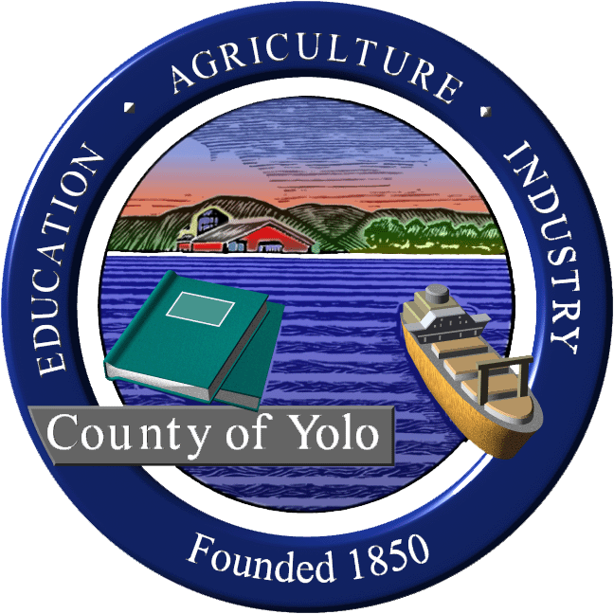
Yolo County Commission on Aging and Adult Services

***Yolo County Administration Building
625 Court Street, Conference Room # 106; Woodland, CA 95695***
Wednesday, March 17, 2010
8:30 a.m. - 10:00 a.m.

AGENDA

I. Welcome and Introductions Supervisor Jim Provenza

II. Review and Approve Minutes from Commission Members
2/24/10 Meeting

III. Budget Presentations Supervisor Provenza/
ADMH Craig Rothhammer & Christina Hill-Coillot
DESS Maryfrances Collins
Health Dr. Joseph Iser

IV. Public Comment: Opportunity for Community Members
members of the public to address the
Commission on subjects relating to
Commission business. The Commission
reserves the right to impose a reasonable
limit on time afforded to any topic or to
any individual speaker.

V Announcements; Future Agenda Items Commission Members

Next Meeting: April 28, 2010

Adjournment

Supervisor
Jim Provenza
Chair

Members:

Elaine Roberts Musser
Vice-Chair

Cass Sylvia
Dawn Myers Purkey
Deborah Francis
Mary Jane Large
Paula Driver Shimada
Yolanda Sue Gruwell
Davis Campbell
Elena Birch
Janice Bridge

