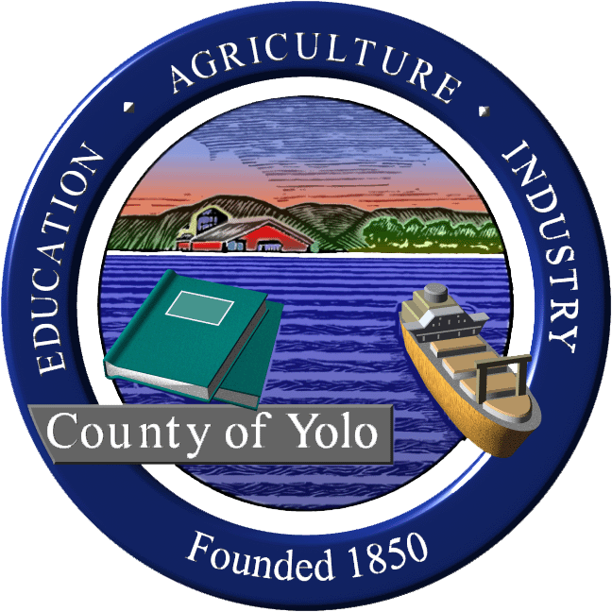
Yolo County Commission on Aging and Adult Services

Yolo County Health and Justice Building
600 A Street, Conference Room; Davis, CA 95616
Wednesday, April 28, 2010
8:30 a.m. - 10:00 a.m.

AGENDA

I. Welcome and Introductions Supervisor Jim Provenza

II. Review and Approve Minutes from Commission Members
2/24/10 and 3/17/10 Meeting

III. Update on Aging Summit Sheila Allen/
-Data Gathering Davis Campbell
- Event Planning

IV. County Budget Update Supervisor Jim Provenza

V. Public Comment: Opportunity for Community Members
members of the public to address the
Commission on subjects relating to
Commission business. The Commission
reserves the right to impose a reasonable
limit on time afforded to any topic or to
any individual speaker.

VI Announcements; Future Agenda Items Commission Members

Next Meeting: June 23, 2010 (TBD)

Adjournment

Supervisor
Jim Provenza
Chair

Members:

Elaine Roberts Musser
Vice-Chair

Cass Sylvia
Dawn Myers Purkey
Deborah Francis
Mary Jane Large
Paula Driver Shimada
Yolanda Sue Gruwell
Davis Campbell
Elena Birch
Janice Bridge

