Yolo County Commission on Aging and Adult Services

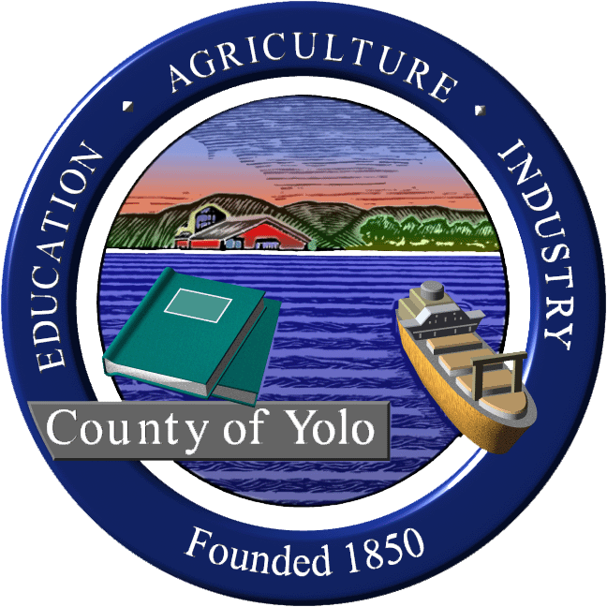
Wednesday, May 1, 2024
9am-11am
600 A Street, Room 101, Davis, CA

MINUTES

COMMISSIONERS PRESENT: Supervisor Jim Provenza (chair), Jim Bohon, Jim Daniel, Elaine Roberts Musser, Dawn Myers, Kevyne Baar, Rosey Ramsey, Regan Overholt, Laurie Haas
COMMISSIONERS ABSENT AND EXCUSED: Kim Britt, Dawn Myers, Sue Tarlton
GUESTS PRESENT: Jamie Johnson (Yolo Healthy Aging Alliance), Marisa Green (Branch Director Yolo County Adult and Aging), Cindy Perez (Yolo County CAO office)
GUESTS VIA VIDEO CONFERENCE: Kate Laddish (chair, Yolo IHSS Advisory Committee), Linda Ngichu (Resources for Independent Living), Sara Martinez (AAA4), Seth Brunner (Commissioner), Elizabeth Yeh, Rebekah Witten (Resources for Independent Living), Marisa Green (Yolo HHSA-Deputy Branch Director, Adult and Aging Branch), Nolan Sullivan (Yolo Co. Health and Human Services Agency Director)
STAFF PRESENT: Sheila Allen (Staff to Commission), Oliver Snow (Staff to Supervisor Provenza)

- Welcome and Introductions Welcome to Deputy Branch Director for Yolo County Adult and Aging Branch, Marisa Green. Marisa is a social worker and will be continuing to attend the commission going forward.

- Review and accept minutes 2/7/24, 3/13/24, 4/3/24 <deferred>
- Yolo County Strategic Plan 2024-2028 input (Cindi Perez, Yolo Co. CAO Office) To view plan: https://www.yolocounty.org/about-us/mission-values-strategic-plan
Cindi Perez from the Yolo Ca. CAO’s office has been working with the department heads to develop the priority areas and strategies. Now doing community outreach. Draft Strategic Plan will go to Board of Supervisors next week.
Have created 6 pillars including Collaborative Community (changed from “safe community”) to encompass more of how we work with other organization, governments and communities.
This is a 4-year Strategic Plan with regular check ins and updates so it is a living document. Fiscal review will happen annually.

Areas and strategies for Aging and Adult services include:
- CAO office – collaborate with advisory committees and community organizations such as Yolo Healthy Aging and AAA4 to have an aging summit to identify needs
- County Counsel- Advocacy for Public Guardian

HHSA-Collaborative Pillar- Strategy #10 – Action Step: Create a local aging and disable coordinating council. There is a concern that this will duplicate the work of the Yolo Co. Commission on Aging and Adult Services. Nolan response-not a front-line action group. Looking to model of homeless work with COC and HPAC. Would keep Commission as coordinating/policy and then a provider group. Looking to address the Direct Service gap.
Input:
- Yolo ADRC-Includes AAA4, RIL and YHAA--be sure to include them. There is a need for more navigators.
- Be sure to include Reinforce the Senior and Persons with Disabilities (don’t leave out disabilities part) throughout the document.
- Elaine Roberts Musser-Yolo County does a great job for services.
- Concern that older adults and persons with disabilities was not mentioned until deep in the document.
- Be sure to include the need for transportation.
- Be consistent and use term behavioral health (which includes substance use and mental health)
Comments and suggestions from this commission will be included in the draft going to the BOS next week. Sheila will work with Cindi to include.

- Partnership Healthplan and Dignity Health (Common Spirit Health) Contract Stalemate-Impact in Yolo County (Nolan Sullivan, Director Yolo Co. HHSA) Nolan provided background on Partnership Healthplan role as MediCal provider in 24 counties (our area to Oregon border). Dignity has had the contract with Partnership for many years for primary care in Yolo County. Kaiser has about 1000 people in Yolo County primarily foster youth. March 31 contract expired between Partnership and Dignity for 16,150 Yolo County MediCal recipients for primary care. Still no contract so by law Partnership has been working to move all of these people to other primary care providers, primarily through Communicare, WintersHealthcare. What can patients do? Continuity of Care for certain diagnosis such as cancer treatment, pregnancy, or participants in Yolo Adult Day Health Care. OK to receive Emergency Care at any hospital. 1-800-863-4155 primary care assignment. 800-809-1350 for care coordination. Mental/Behavioral health subcontracted through specialty so are continuing and no change. Specialty care should be able to continue.
Partnership submitted new offer 5 days ago, no response from Dignity yet.
Yolo County sent a letter to both Partnership and Dignity requesting both parties to enter into mediation.
Public Comment: Kate Laddish-persons with Medicare/MediCal will have continuity of care but were never notified but are eligible to continue with Dignity.

- Proposal to end AT&T landline service ad hoc report (Jim Bohon) Over 6000 public comments almost all are against this. Transcript from hearings is 788 pages long. Deadline for other providers to take this role are due today. In April, Santa Clara and San Mateo filed as party to the action in addition to San Francisco and more. FOLLOW UP: Should Yolo County apply to file as a party to the action? Jim will ask Eric May from Yolo County Counsel. Rural County Representatives of CA (RCRC) has already come out opposed. FOLLOW UP: Get some examples from IHSS and PA of people that could be at risk with this change.
- CPUC Decision Addressing AB205 Requirements for Electric Utilities (Jim Bohon) Very high fixed rates proposed. Late March with proposed finding and are not taking advice of utilities. Mandates fixed rate with 3 tiers based on income.
Hearing on May 9.
What about medical baseline customers?
Consumption rate will also be decreased some.
- Public Comment on items not on the agenda
Kate Laddish-She had previously requested to have SB1384 on the agenda for consideration of support. Will be on next agenda. Winters Commission on Aging was disbanded. Winters Senior Center is still trying to get this built. Not a representative from Winters at this time.
- Update from Partner Organizations
- Yolo Healthy Aging Alliance (Jamie Johnson) Completed townhalls. Advocacy Committee is building relationships more locally including rural. In August meeting in Winters and then Sept. in West Sacramento. Virtual Senior Advocacy Day for state on May 8. YHAA is participating in the Big Day of Giving tomorrow.
- Agency on Aging-Area 4-Participated in Yolo County townhalls and will be included in the Area Plan. Will provide the findings from the townhalls to the commission.
- Resources for Independent Living – also participated in the townhall meetings. Continuing with community living grants up to $5,000 (6 already provided in Yolo County). Have dramatically increased numbers served in Yolo County.

- Update from Local Aging Commissions
  - Davis (Jim Daniel) Davis still only has 4 members, the minimum needed for quorum. Note: the city counsel said that planning commission could not consider their input for a senior housing project. Hoping to address this at the next meeting.
  - Woodland (Regan Overholt) only 4 members, approved their yearly work plan. May is a senior resource event. This fall mental health wellness program. Making sure that seniors know that city has opportunities for support and assistance for seniors.

- Future Agenda Items
a-Annual report to Board of Supervisors
b-Wheelchair bill
c-Update from ID-DD Caregiver subcommittee

- Announcements
Jim Daniels-Recently stepped down his role on the AAA4 Advisory Council. We will be looking for a new person to represent Yolo County.
There are 2 at-large positions open and West Sacramento appointed position.
The Big Day of Giving is tomorrow.
Welcome to Marisa Green and we hope she can continue to join us.

- Next regular meeting Wednesday, June 5, 9am, 600 A Street, Room 101, Davis.

