Yolo County Commission on Aging and Adult Services

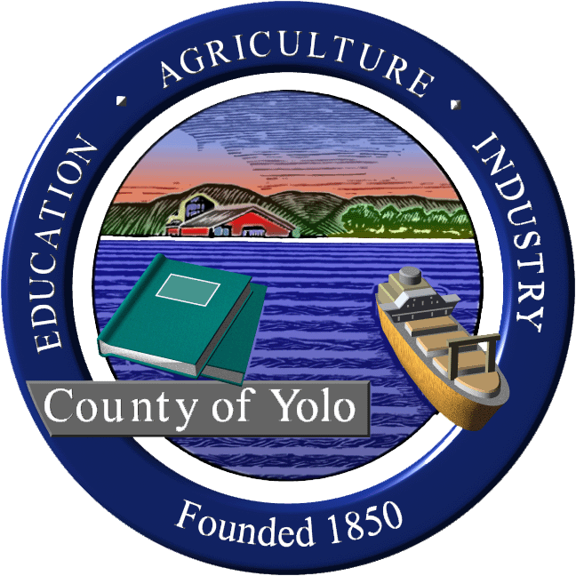
Wednesday, August 4, 2023
9am-11am
600 A Street, Room 101, Davis, CA

MINUTES

COMMISSIONERS PRESENT: Supervisor Jim Provenza (chair), Jim Bohon, Seth Brunner, Laurie Haas, Jim Daniels, Barbara Smith, Regan Overholt
COMMISSIONERS ABSENT AND EXCUSED: Dawn Myers, Kevyne Baar, Sue Tarlton, Elaine Roberts Musser, Kim Britt
GUESTS PRESENT: Jamie Johnson (Yolo Healthy Aging Alliance), Will Tift (AAA4), German Anyon (AAA4)
GUESTS VIA VIDEO CONFERENCE: Kate Laddish (chair, Yolo IHSS Advisory Committee), Mary Nisson (Developmental Disability Future Planning Group of Yolo County (DDFP-Yolo), Linda Ngichu (Resources for Independent Living), Brandi Bluell (Resources for Independent Living)
STAFF PRESENT: Sheila Allen (Staff to Commission)

1. Welcome and Introductions (Jim Provenza, Chair)
2. Review and accept minutes 8/2/23 MOTION: Move to accept by Regan Overholt, Jim Bohon 2nd, passed unanimously.
3. Agency on Aging-Area 4 Plan Update Input- Yolo Master Plan on Aging discussion and prioritization (Will Tift, Agency on Aging-Area 4)
AAA4 has a 3 step process: 1- Needs Assessment, 2-Area Plan, 3-RFPs for services. CDA uses a formula to calculate how much funding each AAA receives and the AAA4 governing board uses a similar formula to calculate how much each of the 7 counties receive.
Where we are in the area plan process now:
1-Stength Assessment (what is working); 2-Strategic Planning (opportunities); 3- Resource Development (partnerships and assistance with finding the funding both public and private)
Approach-utilize the CA Master Plan for Aging 5 bold goals as a structure which includes:
- Housing for all
- Health reimagined
- Inclusion and Equity
- Caregiving that Works
- Affordable Aging
Strength Report: Public hearings in the 7 counties. This is the #1 area the AAA4 representatives have asked to focused on in year 1 (Feb/Mar)
Discussion on Strengths:
Adult Day Health Program, Yolo Share for housing, the AAA-4 programs (Meals on Wheels, 211, legal services), YHAA programs (e.g.: STAR-Senior Technology, food truck, emergency kits, phone friends), YHAA Advocacy Committee including goals that address housing and transportation, County programs (e.g: APS, IHSS, Public Guardian), city services (senior centers and programs), Galileo Place, YoloCares.

Public Guardian-county agency that handles conservatorships for adults with no family. A strong program but insufficient funds. Case loads very high.

Next steps: Appoint committee: AAA4 Governing Board and Advisory Committee members plus Laurie Haas, Jamie Johnson, Kate Laddish and Barbara Smith.

Sheila will call meeting and they will discuss further the strengths and return to commission with recommendation for first year priority.

4. Future Agenda Items
a. Report from Subcommittee on Aging Caregivers of Adults with ID/DD
b. Update on Yolo Adult Day Health Center
c. Update on St. John’s Campus
d. Update from Emergency Prep Subcommittee

5. Updates from Partner Agencies
a. AAA4
b. RIL-Programs and education for disaster preparedness. Have been activated for PSPS events. They have a Community Living Fund to provide money for home improvements to allow person to continue to live in their home (Max. $5,000)
c. YHAA-continuing with ARP programs and Aging and Disability Resource Connection work. New Senior Resources Guides almost ready. Will be in English and Spanish.

6. Public Comment on items not on the agenda
Kate Laddish- Sept. 11-15 was Disability Voting Rights Week

9. Announcements
Kate Laddish-Today there will be a national test of the FEMA alert system at 11:20am.
Jim Provenza-The Board of Supervisor created a new board subcommittee on aging. Jim and Oscar Villegas were appointed.

10. Next regular meeting Wednesday, November 1, 2023, 9am, 600 A St., Davis

