Yolo County Commission on Aging and Adult Services

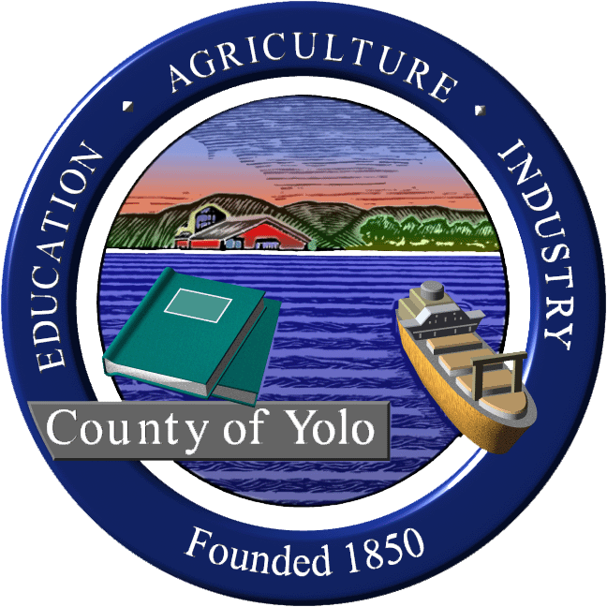
Wednesday, April 5, 2023
9am-11am
600 A St., Davis CA
(video conference available for public)

MINUTES

COMMISSIONERS PRESENT: Supervisor Jim Provenza (chair), Elaine Roberts Musser (vice chair), Sue Tarleton, Jim Bohon, Laurie Haas, Jim Daniel, Cheryl Sandoval, Dawn Myers, Seth Myers, Barbara Smith, Kevyne Baar, Kim Britt, Seth Brunner
COMMISSIONERS ABSENT AND EXCUSED: Delores Olivarez
GUESTS PRESENT: German Anyon (AAA4), Mary Nisson (Developmental Disability Future Planning Group of Yolo Co.-DDFP), Kate Laddish (In Home Supportive Services Advisory Committee, chair), John Decker (Alta Regional Center), Brandi Bluell (Resources for Independent Living (RIL) Executive Director), Rebekah Witten (RIL Program Manager), Elizabeth Yeh
STAFF PRESENT: Sheila Allen (Staff to Commission)

- Welcome and Introduction of new members (Supervisor Provenza)
- Barbara Smith District 1 West Sacramento
- K Kevyne Baar District 2 Davis resident

- Review and accept minutes 3/1/23 MOTION: Moved by Seth Brunner, Sue Tarlton 2nd, passed unanimously.

- Expansion of Adult Day Health Center update (Dawn Myers) 10 years ago the Yolo Co. Board of Supervisors identified that there was a need to expand. Still not there but making process. Daily rate from Partnership Health went up $15 per day. Have the funds for the renovation of space at St. John’s. St. John’s board has a new vision: Dementia Village model. Village of St. John’s will be new name. Yolo Adult Day Health will be on their campus. Still waiting for the lease from St. John’s board. Renovation could begin in June with an opening in Spring of 2024.
Galileo Place is a new Adult Day Care program in Davis and has 20 people enrolled and have capacity for 40. Commissioners asked to help get the word out about the program.

- Emergency Preparation Subcommittee update (Elaine Roberts Musser, chair)
Met with Kristin Weivoda, Yolo County Director of Office of Emergency Services (OES) who suggested an option to addressing the Access and Functional Needs list for emergencies. She can add a voluntary sign up as a part of Yolo Alert sign up feature that people can self-identify as needing help.
County Disaster Service Council is being re-started and will include tabletop exercises.
On website Kristin has already implemented posting all recent alerts on the website.
There continues to be issues related to jurisdiction and coordination.
Thanks to Kristin Weivoda for her willingness to collaborate with the subcommittee.

Emergency Prep Public Education Presentations-our commission subcommittee has created the curriculum and are providing the presenters. Emily Wu, a UCD Masters in Public Health student is interning with Yolo Healthy Aging and is taking lead with coordinating this educational series, enhancing the website, creating local information and resource brochures and creating a social media campaign as part of her master’s program.

5. Aging DD/ID Caregivers-Planning and Resources Task Force update (Seth Brunner/Mary Nisson co-chairs)
Town hall meeting for community input on issue of needs of aging caregivers of persons with Intellectual and Developmental Disabilities (ID/DD) planned for Wed. April 19, 5:30-7:30 at the Davis Library. It will have hybrid opportunities for input with in-person and Zoom link. Supervisor Provenza will provide an intro to Aging Commission and purpose of task force.
John Decker will talk about the new Alta Regional annual Individual Planning Program meetings-Coordinated Future Planning Initiation, Future Housing and Technology to support people to live independently. The majority of the time will be to hear from the public.

6. Support of Legislation that allow remote participation in Brown Act meetings. Current legislation introduced: SB411, AB817 and SB537 There is an interest in allowing advisory committees to meet remotely or in person. Elected bodies would continue to meet in person. MOTION: Move to support legislation that allows teleconferencing for advisory and appointed local government bodies. Moved by Elaine Roberts Musser, Jim Bohon passed unanimously.
7. Update from Yolo Healthy Aging Alliance (Sheila Allen, Interim Director) County American Rescue Plan programs continue through end of 2024 and include: Phone Friends, Rural Food Truck, Emergency Prep education and STAR-Senior Technology and Resource programs. Case Manager, Nancy Gifford is very busy. All are invited to the annual fundraiser on Sunday, April 16, 5p-7p at Galileo Place in Davis.
8. Update from Agency on Aging-Area 4 (German Anyon) Evaluations of funded partners is ongoing, RFP continues for caregiver support grants. The Yolo Aging and Disability partners including AAA4, RIL and YHAA have decided to not move forward at St. John’s campus, but being offered free space at Yolo Co. HHSA building for staff as we work on a permanent Aging and Disability Resource Connection location.
FOLLOW UP: Jim Daniel would like to serve on the AAA4 Advisory Committee. See where there is an opening.
9- Update from Resources for Independent Living (Brandi Bluell and Rebekah Witten) Recently activated again through PG&E for support due to storms-end of Feb. through March 24. Provided hotel vouchers for 2 families in Yolo County and many gift cards for food and gas for generators. Hiring for an assistive technology coordinator.

10- Future Agenda Items
a. AAA4 Plan Update (German will coordinate for best person to present)
b. Assisted Living Waiver (Laurie Haas can find appropriate speaker). Follow up with Aguiar-Curry office. Set to present at our May meeting. Check with Laurie. Yolo does not have this currently.
c. St. John’s Dementia Village presentation with video from their board.
d. Invite Dr. Sisson to talk to us regarding requiring masks at health care facilities.

11. Public Comment on items not on the agenda
Kate Laddish-State’s mask mandate in healthcare facilities ended on April 3rd. Yolo County is in alignment in state. There is a concern that Yolo is going along with it and should continue in healthcare facilities.
12. Announcements-April 22 Rotary fundraiser for non-profits

13. Next regular meeting Wednesday, May 3, 9am, 600 A Street, Room 101, Davis.

